UNITED STATES
SECURITIES AND EXCHANGE COMMISSION
Washington, D.C. 20549
FORM 10-Q
x QUARTERLY REPORT PURSUANT TO SECTION 13 OR 15(d) OF THE SECURITIES
EXCHANGE ACT OF 1934

For the quarterly period ended June 30, 2026

☐ TRANSITION REPORT PURSUANT TO SECTION 13 OR 15(d) OF THE SECURITIES
EXCHANGE ACT OF 1934

For the transition period from to
Commission File Number 0-16211
DENTSPLY SIRONA Inc.
(Exact name of registrant as specified in its charter)
Delaware |  |  |  |  |  | 39-1434669
(State or other jurisdiction of |  |  |  |  |  | (I.R.S. Employer
incorporation or organization) |  |  |  |  |  | Identification No.)
13320 Ballantyne Corporate Place, Charlotte, North Carolina |  |  |  |  |  | 28277-3607
(Address of principal executive offices) |  |  |  |  |  | (Zip Code)
(844) 848-0137
(Registrant’s telephone number, including area code)

Securities registered pursuant to Section 12(b) of the Act:
Title of each class |  |  | Trading Symbol |  |  | Name of each exchange on which registered
Common Stock, par value $.01 per share |  |  | XRAY |  |  | The Nasdaq Stock Market LLC

Indicate by check mark whether the registrant (1) has filed all reports required to be filed by Section 13 or 15(d) of the Securities Exchange Act of 1934 during the preceding 12 months (or for such shorter period that the registrant was required to file such reports), and (2) has been subject to such filing requirements for the past 90 days. Yes x No ☐

Indicate by check mark whether the registrant has submitted electronically every Interactive Data File required to be submitted pursuant to Rule 405 of Regulation S-T during the preceding 12 months (or for such shorter period that the registrant was required to submit such files). Yes x No ☐

Indicate by check mark whether the registrant is a large accelerated filer, an accelerated filer, a non-accelerated filer, a smaller reporting company, or an emerging growth company. See the definitions of “large accelerated filer,” “accelerated filer,” “smaller reporting company” and “emerging growth company” in Rule 12b-2 of the Exchange Act.
Large accelerated filer x |  |  | Accelerated filer ☐
Non-accelerated filer ☐ |  |  | Smaller reporting company ☐
 |  |  | Emerging growth company ☐
If an emerging growth company, indicate by check mark if the registrant has elected not to use the extended transition period for complying with any new or revised financial accounting standards provided pursuant to Section 13(a) of the Exchange Act. ☐

Indicate by check mark whether the registrant is a shell company (as defined in Rule 12b-2 of the Exchange Act).
Yes ☐ No x

Indicate the number of shares outstanding of each of the issuer’s classes of common stock, as of the latest practicable date: At July 24, 2026, DENTSPLY SIRONA Inc. had 199,353,876 shares of common stock outstanding.

DENTSPLY SIRONA Inc.

TABLE OF CONTENTS

PART I |  |  | FINANCIAL INFORMATION |  |  | Page
Item 1 |  |  | Financial Statements (unaudited) |  |  | 4
 |  |  | Consolidated Statements of Operations |  |  | 4
 |  |  | Consolidated Statements of Comprehensive Income (Loss) |  |  | 5
 |  |  | Consolidated Balance Sheets |  |  | 6
 |  |  | Consolidated Statements of Changes in Equity |  |  | 7
 |  |  | Consolidated Statements of Cash Flows |  |  | 8
 |  |  | Notes to Unaudited Interim Consolidated Financial Statements |  |  | 9
Item 2 |  |  | Management’s Discussion and Analysis of Financial Condition and Results of Operations |  |  | 34
Item 3 |  |  | Quantitative and Qualitative Disclosures About Market Risk |  |  | 43
Item 4 |  |  | Controls and Procedures |  |  | 43
PART II |  |  | OTHER INFORMATION
Item 1 |  |  | Legal Proceedings |  |  | 45
Item 1A |  |  | Risk Factors |  |  | 45
Item 2 |  |  | Unregistered Sales of Securities and Use of Proceeds |  |  | 45
Item 5 |  |  | Other Information |  |  | 45
Item 6 |  |  | Exhibits |  |  | 46
Signatures |  |  |  |  |  | 47

2

General

Unless otherwise stated herein or the context otherwise indicates, references throughout this Form 10-Q to “Dentsply Sirona,” or the “Company,” “we,” “us” or “our” refer to DENTSPLY SIRONA Inc., together with its subsidiaries on a consolidated basis.

Forward-Looking Statements and Associated Risks

All statements included or incorporated by reference in this Form 10-Q that do not directly and exclusively relate to historical facts constitute “forward-looking statements.” These statements represent current expectations and beliefs, and are subject to numerous assumptions, risks, uncertainties, and other factors that could cause actual results to differ materially from those described in such statements. Many of these factors are outside of our control, including those described in Part I, Item 1A, “Risk Factors” of the Company’s most recent Annual Report on Form 10-K, Part II, Item 1A, “Risk Factors” of the Company’s Quarterly Reports on Form 10-Q for any subsequent fiscal quarters, and any updating information or other factors which may be described in the Company’s other filings with the Securities and Exchange Commission (the “SEC”). No assurance can be given that any result, expectation, belief, goal or plan set forth in any forward-looking statement can or will be achieved, and readers are cautioned not to place undue reliance on such statements which speak only as of the date they are made. We do not undertake any obligation to update or release any revisions to any forward-looking statement or to report any events or circumstances after the date of this Form 10-Q or to reflect the occurrence of unanticipated events.

Investors should understand it is not possible to predict or identify all relevant risks and other factors which could cause actual results to differ materially from statements made on the basis of our current expectations and beliefs. As such, you should not consider the risks identified in the Company’s SEC filings to be a complete discussion of all potential risks or uncertainties associated with an investment in the Company.

3

PART I – FINANCIAL INFORMATION

Item 1 – Financial Statements

DENTSPLY SIRONA INC. AND SUBSIDIARIES
CONSOLIDATED STATEMENTS OF OPERATIONS
(in millions, except per share amounts)
(unaudited)
 |  |  | Three Months Ended June 30, |  |  |  |  |  |  |  |  |  |  |  | Six Months Ended June 30,
 |  |  | 2026 |  |  |  |  |  | 2025 |  |  |  |  |  | 2026 |  |  |  |  |  | 2025
Net sales |  |  | $ | 898 |  |  |  |  | $ | 936 |  |  |  |  | $ | 1,778 |  |  |  |  | $ | 1,815
Cost of products sold |  |  | 405 |  |  |  |  |  | 446 |  |  |  |  |  | 858 |  |  |  |  |  | 859
Gross profit |  |  | 493 |  |  |  |  |  | 490 |  |  |  |  |  | 920 |  |  |  |  |  | 956
Selling, general, and administrative expenses |  |  | 364 |  |  |  |  |  | 342 |  |  |  |  |  | 715 |  |  |  |  |  | 700
Research and development expenses |  |  | 45 |  |  |  |  |  | 37 |  |  |  |  |  | 89 |  |  |  |  |  | 73
Goodwill and intangible asset impairments |  |  | — |  |  |  |  |  | 235 |  |  |  |  |  | — |  |  |  |  |  | 235
Restructuring and other costs |  |  | 2 |  |  |  |  |  | 4 |  |  |  |  |  | 69 |  |  |  |  |  | 13
Operating income (loss) |  |  | 82 |  |  |  |  |  | (128) |  |  |  |  |  | 47 |  |  |  |  |  | (65)
Other income and expenses:
Interest expense, net |  |  | 22 |  |  |  |  |  | 24 |  |  |  |  |  | 46 |  |  |  |  |  | 43
Other (income) expense, net |  |  | (12) |  |  |  |  |  | 1 |  |  |  |  |  | (29) |  |  |  |  |  | 1
Income (loss) before income taxes |  |  | 72 |  |  |  |  |  | (153) |  |  |  |  |  | 30 |  |  |  |  |  | (109)
Provision (benefit) for income taxes |  |  | 36 |  |  |  |  |  | (109) |  |  |  |  |  | 4 |  |  |  |  |  | (84)
Net income (loss) |  |  | 36 |  |  |  |  |  | (44) |  |  |  |  |  | 26 |  |  |  |  |  | (25)
Less: Net (loss) income attributable to noncontrolling interest |  |  | (1) |  |  |  |  |  | 1 |  |  |  |  |  | (1) |  |  |  |  |  | —
Net income (loss) attributable to Dentsply Sirona |  |  | $ | 37 |  |  |  |  | $ | (45) |  |  |  |  | $ | 27 |  |  |  |  | $ | (25)
Earnings (loss) per common share attributable to Dentsply Sirona:
Basic |  |  | $ | 0.18 |  |  |  |  | $ | (0.22) |  |  |  |  | $ | 0.14 |  |  |  |  | $ | (0.13)
Diluted |  |  | $ | 0.18 |  |  |  |  | $ | (0.22) |  |  |  |  | $ | 0.14 |  |  |  |  | $ | (0.13)
Weighted average common shares outstanding:
Basic |  |  | 199.7 |  |  |  |  |  | 199.3 |  |  |  |  |  | 199.8 |  |  |  |  |  | 199.2
Diluted |  |  | 200.5 |  |  |  |  |  | 199.3 |  |  |  |  |  | 200.8 |  |  |  |  |  | 199.2

See accompanying Notes to Unaudited Interim Consolidated Financial Statements.

4

DENTSPLY SIRONA INC. AND SUBSIDIARIES
CONSOLIDATED STATEMENTS OF COMPREHENSIVE INCOME (LOSS)
(in millions)
(unaudited)
 |  |  | Three Months Ended June 30, |  |  |  |  |  |  |  |  |  |  |  | Six Months Ended June 30,
 |  |  | 2026 |  |  |  |  |  | 2025 |  |  |  |  |  | 2026 |  |  |  |  |  | 2025
Net income (loss) |  |  | $ | 36 |  |  |  |  | $ | (44) |  |  |  |  | $ | 26 |  |  |  |  | $ | (25)
Other comprehensive (loss) income, net of tax:
Foreign currency translation (loss) gain |  |  | (6) |  |  |  |  |  | 106 |  |  |  |  |  | (23) |  |  |  |  |  | 193
Net gain (loss) on derivative financial instruments |  |  | 5 |  |  |  |  |  | (88) |  |  |  |  |  | 6 |  |  |  |  |  | (104)
Total other comprehensive (loss) income, net of tax |  |  | (1) |  |  |  |  |  | 18 |  |  |  |  |  | (17) |  |  |  |  |  | 89
Total comprehensive income (loss) |  |  | 35 |  |  |  |  |  | (26) |  |  |  |  |  | 9 |  |  |  |  |  | 64
Less: Comprehensive (loss) income attributable to noncontrolling interests |  |  | (1) |  |  |  |  |  | 1 |  |  |  |  |  | (1) |  |  |  |  |  | —
Total comprehensive income (loss) attributable to Dentsply Sirona |  |  | $ | 36 |  |  |  |  | $ | (27) |  |  |  |  | $ | 10 |  |  |  |  | $ | 64

See accompanying Notes to Unaudited Interim Consolidated Financial Statements.

5

DENTSPLY SIRONA INC. AND SUBSIDIARIES
CONSOLIDATED BALANCE SHEETS
(in millions, except share and per share amounts)
(unaudited)
 |  |  | June 30, 2026 |  |  |  |  |  | December 31, 2025
Assets
Current Assets:
Cash and cash equivalents |  |  | $ | 239 |  |  |  |  | $ | 326
Accounts and notes receivable-trade, net |  |  | 620 |  |  |  |  |  | 688
Inventories, net |  |  | 665 |  |  |  |  |  | 642
Prepaid expenses and other current assets |  |  | 404 |  |  |  |  |  | 367
Total Current Assets |  |  | 1,928 |  |  |  |  |  | 2,023
Property, plant, and equipment, net |  |  | 845 |  |  |  |  |  | 861
Operating lease right-of-use assets, net |  |  | 129 |  |  |  |  |  | 139
Identifiable intangible assets, net |  |  | 870 |  |  |  |  |  | 974
Goodwill |  |  | 1,138 |  |  |  |  |  | 1,148
Other noncurrent assets |  |  | 294 |  |  |  |  |  | 284
Total Assets |  |  | $ | 5,204 |  |  |  |  | $ | 5,429
Liabilities and Equity
Current Liabilities:
Accounts payable |  |  | $ | 260 |  |  |  |  | $ | 300
Accrued liabilities |  |  | 664 |  |  |  |  |  | 700
Income taxes payable |  |  | 33 |  |  |  |  |  | 30
Notes payable and current portion of long-term debt |  |  | 228 |  |  |  |  |  | 313
Total Current Liabilities |  |  | 1,185 |  |  |  |  |  | 1,343
Long-term debt |  |  | 1,996 |  |  |  |  |  | 2,015
Operating lease liabilities |  |  | 88 |  |  |  |  |  | 93
Deferred income taxes |  |  | 79 |  |  |  |  |  | 94
Other noncurrent liabilities |  |  | 505 |  |  |  |  |  | 544
Total Liabilities |  |  | 3,853 |  |  |  |  |  | 4,089
Commitments and contingencies (Note 14)
Equity:
Preferred stock, $1.00 par value; 0.25 million shares authorized; no shares issued |  |  | — |  |  |  |  |  | —
Common stock, $0.01 par value; |  |  | 3 |  |  |  |  |  | 3
400.0 million shares authorized, and 264.5 million shares issued at June 30, 2026 and December 31, 2025
199.2 million and 199.6 million shares outstanding at June 30, 2026 and December 31, 2025
Capital in excess of par value |  |  | 6,619 |  |  |  |  |  | 6,644
Accumulated deficit |  |  | (1,537) |  |  |  |  |  | (1,564)
Accumulated other comprehensive loss |  |  | (656) |  |  |  |  |  | (639)
Treasury stock, at cost, 65.3 million and 64.9 million shares at June 30, 2026 and December 31, 2025, respectively |  |  | (3,078) |  |  |  |  |  | (3,105)
Total Dentsply Sirona Equity |  |  | 1,351 |  |  |  |  |  | 1,339
Noncontrolling interests |  |  | — |  |  |  |  |  | 1
Total Equity |  |  | 1,351 |  |  |  |  |  | 1,340
Total Liabilities and Equity |  |  | $ | 5,204 |  |  |  |  | $ | 5,429
See accompanying Notes to Unaudited Interim Consolidated Financial Statements.

6

DENTSPLY SIRONA INC. AND SUBSIDIARIES
CONSOLIDATED STATEMENTS OF CHANGES IN EQUITY
(in millions, except per share amounts)
(unaudited)
 |  |  | Common  Stock |  |  |  |  |  | Capital in  Excess of  Par Value |  |  |  |  |  | Accumulated  Deficit |  |  |  |  |  | Accumulated  Other  Comprehensive  Loss |  |  |  |  |  | Treasury  Stock |  |  |  |  |  | Total Dentsply Sirona  Equity |  |  |  |  |  | Noncontrolling  Interests |  |  |  |  |  | Total  Equity
Balance at December 31, 2025 |  |  | $ | 3 |  |  |  |  | $ | 6,644 |  |  |  |  | $ | (1,564) |  |  |  |  | $ | (639) |  |  |  |  | $ | (3,105) |  |  |  |  | $ | 1,339 |  |  |  |  | $ | 1 |  |  |  |  | $ | 1,340
Net loss |  |  | — |  |  |  |  |  | — |  |  |  |  |  | (10) |  |  |  |  |  | — |  |  |  |  |  | — |  |  |  |  |  | (10) |  |  |  |  |  | — |  |  |  |  |  | (10)
Other comprehensive (loss) income |  |  | — |  |  |  |  |  | — |  |  |  |  |  | — |  |  |  |  |  | (16) |  |  |  |  |  | — |  |  |  |  |  | (16) |  |  |  |  |  | — |  |  |  |  |  | (16)
Stock-based compensation expense |  |  | — |  |  |  |  |  | 8 |  |  |  |  |  | — |  |  |  |  |  | — |  |  |  |  |  | — |  |  |  |  |  | 8 |  |  |  |  |  | — |  |  |  |  |  | 8
Funding of employee stock purchase plan |  |  | — |  |  |  |  |  | (5) |  |  |  |  |  | — |  |  |  |  |  | — |  |  |  |  |  | 6 |  |  |  |  |  | 1 |  |  |  |  |  | — |  |  |  |  |  | 1
Restricted stock unit distributions |  |  | — |  |  |  |  |  | (31) |  |  |  |  |  | — |  |  |  |  |  | — |  |  |  |  |  | 27 |  |  |  |  |  | (4) |  |  |  |  |  | — |  |  |  |  |  | (4)
Balance at March 31, 2026 |  |  | $ | 3 |  |  |  |  | $ | 6,616 |  |  |  |  | $ | (1,574) |  |  |  |  | $ | (655) |  |  |  |  | $ | (3,072) |  |  |  |  | $ | 1,318 |  |  |  |  | $ | 1 |  |  |  |  | $ | 1,319
Net income (loss) |  |  | — |  |  |  |  |  |  |  |  |  |  |  | 37 |  |  |  |  |  | — |  |  |  |  |  | — |  |  |  |  |  | 37 |  |  |  |  |  | (1) |  |  |  |  |  | 36
Other comprehensive (loss) income |  |  | — |  |  |  |  |  | — |  |  |  |  |  | — |  |  |  |  |  | (1) |  |  |  |  |  | — |  |  |  |  |  | (1) |  |  |  |  |  | — |  |  |  |  |  | (1)
Stock-based compensation expense |  |  | — |  |  |  |  |  | 9 |  |  |  |  |  | — |  |  |  |  |  | — |  |  |  |  |  | — |  |  |  |  |  | 9 |  |  |  |  |  | — |  |  |  |  |  | 9
Treasury shares purchased |  |  | — |  |  |  |  |  | — |  |  |  |  |  | — |  |  |  |  |  | — |  |  |  |  |  | (12) |  |  |  |  |  | (12) |  |  |  |  |  | — |  |  |  |  |  | (12)
Restricted stock unit distributions |  |  | — |  |  |  |  |  | (6) |  |  |  |  |  | — |  |  |  |  |  | — |  |  |  |  |  | 6 |  |  |  |  |  | — |  |  |  |  |  | — |  |  |  |  |  | —
Balance at June 30, 2026 |  |  | $ | 3 |  |  |  |  | $ | 6,619 |  |  |  |  | $ | (1,537) |  |  |  |  | $ | (656) |  |  |  |  | $ | (3,078) |  |  |  |  | $ | 1,351 |  |  |  |  | $ | — |  |  |  |  | $ | 1,351

 |  |  | Common  Stock |  |  |  |  |  | Capital in  Excess of  Par Value |  |  |  |  |  | Accumulated Deficit |  |  |  |  |  | Accumulated  Other  Comprehensive  Loss |  |  |  |  |  | Treasury  Stock |  |  |  |  |  | Total Dentsply Sirona  Equity |  |  |  |  |  | Noncontrolling  Interests |  |  |  |  |  | Total  Equity
Balance at December 31, 2024 |  |  | $ | 3 |  |  |  |  | $ | 6,640 |  |  |  |  | $ | (835) |  |  |  |  | $ | (730) |  |  |  |  | $ | (3,136) |  |  |  |  | $ | 1,942 |  |  |  |  | $ | 1 |  |  |  |  | $ | 1,943
Net income (loss) |  |  | — |  |  |  |  |  | — |  |  |  |  |  | 20 |  |  |  |  |  | — |  |  |  |  |  | — |  |  |  |  |  | 20 |  |  |  |  |  | (1) |  |  |  |  |  | 19
Other comprehensive loss |  |  | — |  |  |  |  |  | — |  |  |  |  |  | — |  |  |  |  |  | 71 |  |  |  |  |  | — |  |  |  |  |  | 71 |  |  |  |  |  | — |  |  |  |  |  | 71
Stock-based compensation expense |  |  | — |  |  |  |  |  | 10 |  |  |  |  |  | — |  |  |  |  |  | — |  |  |  |  |  | — |  |  |  |  |  | 10 |  |  |  |  |  | — |  |  |  |  |  | 10
Funding of employee stock purchase plan |  |  | — |  |  |  |  |  | (3) |  |  |  |  |  | — |  |  |  |  |  | — |  |  |  |  |  | 5 |  |  |  |  |  | 2 |  |  |  |  |  | — |  |  |  |  |  | 2
Restricted stock unit distributions |  |  | — |  |  |  |  |  | (17) |  |  |  |  |  | — |  |  |  |  |  | — |  |  |  |  |  | 14 |  |  |  |  |  | (3) |  |  |  |  |  | — |  |  |  |  |  | (3)
Restricted stock unit dividends |  |  | — |  |  |  |  |  | 1 |  |  |  |  |  | (1) |  |  |  |  |  | — |  |  |  |  |  | — |  |  |  |  |  | — |  |  |  |  |  | — |  |  |  |  |  | —
Cash dividends declared ($0.16 per share) |  |  | — |  |  |  |  |  | — |  |  |  |  |  | (32) |  |  |  |  |  | — |  |  |  |  |  | — |  |  |  |  |  | (32) |  |  |  |  |  | — |  |  |  |  |  | (32)
Balance at March 31, 2025 |  |  | $ | 3 |  |  |  |  | $ | 6,631 |  |  |  |  | $ | (848) |  |  |  |  | $ | (659) |  |  |  |  | $ | (3,117) |  |  |  |  | $ | 2,010 |  |  |  |  | $ | — |  |  |  |  | $ | 2,010
Net loss |  |  | — |  |  |  |  |  | — |  |  |  |  |  | (45) |  |  |  |  |  | — |  |  |  |  |  | — |  |  |  |  |  | (45) |  |  |  |  |  | 1 |  |  |  |  |  | (44)
Other comprehensive income |  |  | — |  |  |  |  |  | — |  |  |  |  |  | — |  |  |  |  |  | 18 |  |  |  |  |  | — |  |  |  |  |  | 18 |  |  |  |  |  | — |  |  |  |  |  | 18
Stock-based compensation expense |  |  | — |  |  |  |  |  | 9 |  |  |  |  |  | — |  |  |  |  |  | — |  |  |  |  |  | — |  |  |  |  |  | 9 |  |  |  |  |  | — |  |  |  |  |  | 9
Restricted stock unit distributions |  |  | — |  |  |  |  |  | (2) |  |  |  |  |  | — |  |  |  |  |  | — |  |  |  |  |  | 2 |  |  |  |  |  | — |  |  |  |  |  | — |  |  |  |  |  | —
Cash dividends declared ($0.16 per share) |  |  | — |  |  |  |  |  | — |  |  |  |  |  | (32) |  |  |  |  |  | — |  |  |  |  |  | — |  |  |  |  |  | (32) |  |  |  |  |  | — |  |  |  |  |  | (32)
Balance at June 30, 2025 |  |  | $ | 3 |  |  |  |  | $ | 6,638 |  |  |  |  | $ | (925) |  |  |  |  | $ | (641) |  |  |  |  | $ | (3,115) |  |  |  |  | $ | 1,960 |  |  |  |  | $ | 1 |  |  |  |  | $ | 1,961

See accompanying Notes to Unaudited Interim Consolidated Financial Statements.

7

DENTSPLY SIRONA INC. AND SUBSIDIARIES
CONSOLIDATED STATEMENTS OF CASH FLOWS
(in millions)
(unaudited)
 |  |  | Six Months Ended June 30,
 |  |  | 2026 |  |  |  |  |  | 2025
Cash flows from operating activities:
Net income (loss) |  |  | $ | 26 |  |  |  |  | $ | (25)
Adjustments to reconcile net loss to net cash provided by operating activities:
Depreciation |  |  | 74 |  |  |  |  |  | 68
Amortization of intangible assets |  |  | 90 |  |  |  |  |  | 99
Goodwill asset impairment |  |  | — |  |  |  |  |  | 156
Indefinite-lived intangible asset impairment |  |  | — |  |  |  |  |  | 79
Deferred income taxes |  |  | (42) |  |  |  |  |  | (136)
Stock-based compensation expense |  |  | 17 |  |  |  |  |  | 19
Other non-cash (income) expense |  |  | (13) |  |  |  |  |  | 19
Gain on disposal of assets |  |  | (6) |  |  |  |  |  | —
Changes in operating assets and liabilities:
Accounts and notes receivable-trade, net |  |  | 56 |  |  |  |  |  | (31)
Inventories, net |  |  | (32) |  |  |  |  |  | (47)
Prepaid expenses and other current assets |  |  | (11) |  |  |  |  |  | 26
Other noncurrent assets |  |  | (2) |  |  |  |  |  | 1
Accounts payable |  |  | 16 |  |  |  |  |  | (10)
Accrued liabilities |  |  | (38) |  |  |  |  |  | (35)
Income taxes |  |  | 4 |  |  |  |  |  | (55)
Other noncurrent liabilities |  |  | — |  |  |  |  |  | (73)
Net cash provided by operating activities |  |  | 139 |  |  |  |  |  | 55
Cash flows from investing activities:
Capital expenditures |  |  | (96) |  |  |  |  |  | (51)
Cash received on derivative contracts |  |  | — |  |  |  |  |  | 1
Cash paid on derivative contracts |  |  | — |  |  |  |  |  | (2)
Net investment hedge settlements |  |  | (8) |  |  |  |  |  | —
Proceeds from sale of property, plant, and equipment |  |  | 5 |  |  |  |  |  | 1
Other investing activities |  |  | 7 |  |  |  |  |  | —
Net cash used in investing activities |  |  | (92) |  |  |  |  |  | (51)
Cash flows from financing activities:
Cash paid for treasury stock |  |  | (12) |  |  |  |  |  | —
Proceeds from 364-day bridge loan |  |  | — |  |  |  |  |  | 435
Repayment of 364-day bridge loan |  |  | — |  |  |  |  |  | (435)
Repayments on short-term borrowings |  |  | (50) |  |  |  |  |  | (413)
Cash dividends paid |  |  | (32) |  |  |  |  |  | (64)
Proceeds from long-term borrowings |  |  | — |  |  |  |  |  | 550
Repayments on long-term borrowings |  |  | (31) |  |  |  |  |  | (2)
Cash paid for deferred financing costs |  |  | — |  |  |  |  |  | (13)
Other financing activities, net |  |  | (5) |  |  |  |  |  | (3)
Net cash (used in) provided by financing activities |  |  | (130) |  |  |  |  |  | 55
Effect of exchange rate changes on cash and cash equivalents |  |  | (4) |  |  |  |  |  | 28
Net (decrease) increase in cash and cash equivalents |  |  | (87) |  |  |  |  |  | 87
Cash and cash equivalents at beginning of period |  |  | 326 |  |  |  |  |  | 272
Cash and cash equivalents at end of period |  |  | $ | 239 |  |  |  |  | $ | 359
Supplemental disclosures of cash flow information:
Interest paid, net of amounts capitalized |  |  | $ | 43 |  |  |  |  | $ | 43
Non-cash investing activities:
Property, plant and equipment in accounts payable at end of period |  |  | $ | 19 |  |  |  |  | $ | 25
Exchange of inventory for naming and other rights |  |  | $ | — |  |  |  |  | $ | 14
See accompanying Notes to Unaudited Interim Consolidated Financial Statements.

8

DENTSPLY SIRONA Inc. and Subsidiaries

NOTES TO UNAUDITED INTERIM CONSOLIDATED FINANCIAL STATEMENTS

NOTE 1 – BUSINESS AND BASIS OF PRESENTATION

Basis of Presentation

The accompanying unaudited interim consolidated financial statements have been prepared in accordance with accounting principles generally accepted in the United States of America (“US GAAP”) and the rules of the U.S. Securities and Exchange Commission (“SEC”). In the opinion of management, all adjustments (consisting only of normal recurring adjustments) considered necessary for a fair statement of the results for interim periods have been included. Certain prior period amounts have been reclassified to conform to current year presentation. Results for interim periods should not be considered indicative of results for a full year. These financial statements and related notes contain the accounts of DENTSPLY SIRONA Inc. and subsidiaries (“Dentsply Sirona” or the “Company”) on a consolidated basis and should be read in conjunction with the consolidated financial statements and notes included in the Company’s most recent Annual Report on Form 10-K for the year ended December 31, 2025, filed with the SEC on February 26, 2026 (the “2025 Form 10-K”). All significant intercompany accounts and transactions are eliminated in consolidation.

Use of Estimates

The preparation of financial statements in conformity with US GAAP requires management to make estimates and assumptions that affect the reported amounts of assets and liabilities and the disclosure of contingent assets and liabilities as of the date of the financial statements and the reported amounts of revenue and expense during the reporting period. Actual results could differ materially from those estimates.

Accounting Pronouncements Not Yet Adopted

In November 2024, the FASB issued ASU No. 2024-03, “Income Statement—Reporting Comprehensive Income—Expense Disaggregation Disclosures (Subtopic 220-40) Disaggregation of Income Statement Expenses,” which requires disaggregated disclosure of income statement expenses for public business entities (“PBEs”). In January 2025, the FASB issued ASU No. 2025-01 “Income Statement—Reporting Comprehensive Income—Expense Disaggregation Disclosures (Subtopic 220-40),” which clarified the effective date for ASU No. 2024-03. These amendments are intended to provide more information about types of expenses in commonly presented expense captions. The amendments in this update are effective for annual reporting periods beginning after December 15, 2026, and interim reporting periods within fiscal years beginning after December 15, 2027, and early adoption is permitted. The Company does not expect to adopt this ASU before the required effective date. This ASU contains new disclosure requirements and will not impact results of operations, financial position, or cash flow.

In September 2025, the FASB issued ASU No. 2025-06, “Intangibles - Goodwill and Other - Internal-Use Software (Subtopic 350-40),” which amends certain aspects of ASC 350-40 related to the accounting and disclosure of internally developed software costs. This amendment is intended to provide further guidance on how to evaluate whether the probable-to-complete recognition threshold has been met to capitalize costs for internal-use software. The amendments in this update are effective for annual reporting periods beginning after December 15, 2027, including interim reporting periods within those annual reporting periods. Early adoption is permitted in an interim or annual reporting period for which financial statements have not been issued or made available for issuance. Entities may apply the guidance prospectively, retrospectively, or via a modified prospective transition method. The Company is currently evaluating the impact on its consolidated financial statements and related disclosures.

In September 2025, the FASB issued ASU No. 2025-07, “Derivatives and Hedging (Topic 815) and Revenue from Contracts with Customers (Topic 606),” which refines the scope of the guidance on derivatives in ASC 815 and clarifies the guidance on share-based payments from a customer in ASC 606. The amendments in this update are effective for annual reporting periods beginning after December 15, 2026, including interim reporting periods within those annual reporting periods. Early adoption is permitted in an interim or annual reporting period for which financial statements have not been issued or made available for issuance. Entities may apply the guidance prospectively or on a modified retrospective basis. As of

9

June 30, 2026, the Company is not party to any arrangements that fall within the scope of this ASU. Accordingly, adoption of the ASU is not expected to have an impact on the Company’s consolidated financial statements or related disclosures at this time. The Company will continue to monitor its arrangements for applicability of the ASU in future periods.

In November 2025, the FASB issued ASU No. 2025-09, “Derivatives and Hedging (Topic 815),” which amends certain aspects of the hedge accounting guidance in ASC 815. The amendments are intended to more closely align hedge accounting with the economics of an entity’s risk management activities. The amendments in this update are effective for annual reporting periods beginning after December 15, 2026, including interim reporting periods within those annual reporting periods. Early adoption is permitted in any interim or annual period after the ASU’s issuance. Entities should apply the guidance prospectively. As of June 30, 2026, the Company is not party to any arrangements that fall within the scope of this ASU. Accordingly, adoption of the ASU is not expected to have an impact on the Company’s consolidated financial statements or related disclosures at this time. The Company will continue to monitor its arrangements for applicability of the ASU in future periods.

Seasonality

The Company’s business is subject to quarterly fluctuations in demand due to seasonality, which can impact the timing of the Company’s consolidated net sales, net income, and cash flows. Demand can fluctuate based on the timing of dental trade shows and variability in dental patient traffic, which can be exacerbated by seasonal or severe weather patterns. Some dental practices in certain countries may also delay purchasing equipment and restocking consumable products until year-end due to income tax benefits or for other financial planning reasons. In addition, the timing of holidays and vacations, particularly throughout Europe, may shift demand across quarters. Sales for the industry and the Company are generally stronger in the second and fourth quarters and weaker in the first and third quarters, due to the effects of the items noted above. Because of the seasonal nature of the Company’s business, the results of operations for any fiscal quarter will not necessarily be indicative of results to be expected for other quarters or a full fiscal year.

NOTE 2 - REVENUE RECOGNITION

Revenues are derived primarily from the sale of dental equipment and dental and healthcare consumable products. Revenues are measured as the amount of consideration the Company expects to receive in exchange for transferring goods or providing services.

Net sales disaggregated by product category were as follows:
 |  |  |  |  |  | Three Months Ended June 30, |  |  |  |  |  |  |  |  |  |  |  | Six Months Ended June 30,
(in millions) |  |  |  |  |  | 2026 |  |  |  |  |  | 2025 |  |  |  |  |  | 2026 |  |  |  |  |  | 2025
Equipment & Instruments |  |  |  |  |  | $ | 137 |  |  |  |  | $ | 136 |  |  |  |  | $ | 272 |  |  |  |  | $ | 270
CAD/CAM |  |  |  |  |  | 102 |  |  |  |  |  | 107 |  |  |  |  |  | 213 |  |  |  |  |  | 208
Connected Technology Solutions |  |  |  |  |  | 239 |  |  |  |  |  | 243 |  |  |  |  |  | $ | 485 |  |  |  |  | $ | 478
Essential Dental Solutions |  |  |  |  |  | 376 |  |  |  |  |  | 387 |  |  |  |  |  | $ | 726 |  |  |  |  | $ | 740
Orthodontics |  |  |  |  |  | 40 |  |  |  |  |  | 63 |  |  |  |  |  | $ | 85 |  |  |  |  | $ | 122
Implants & Prosthetics |  |  |  |  |  | 157 |  |  |  |  |  | 163 |  |  |  |  |  | 311 |  |  |  |  |  | 321
Orthodontic and Implant Solutions |  |  |  |  |  | 197 |  |  |  |  |  | 226 |  |  |  |  |  | $ | 396 |  |  |  |  | $ | 443
Wellspect Healthcare |  |  |  |  |  | 86 |  |  |  |  |  | 80 |  |  |  |  |  | $ | 171 |  |  |  |  | $ | 154
Total net sales |  |  |  |  |  | $ | 898 |  |  |  |  | $ | 936 |  |  |  |  | $ | 1,778 |  |  |  |  | $ | 1,815

The Company’s geographic regions for reporting net sales consist of countries in (i) North and South America (“Americas”), (ii) Europe, the Middle East, and Africa (“EMEA”), and (iii) Asia Pacific (“APAC”). Prior period net sales amounts have been recast to conform to the current period presentation, reflecting a shift to a regional geographic presentation,

10

which aligns with how the Company manages commercial activities and reports net sales internally. The change in regional geographic presentation was effective as of January 1, 2026. This change did not impact the Company’s consolidated financial statements.
Net sales disaggregated by geographic region were as follows:
 |  |  |  |  |  | Three Months Ended June 30, |  |  |  |  |  |  |  |  |  |  |  | Six Months Ended June 30,
(in millions) |  |  |  |  |  | 2026 |  |  |  |  |  | 2025 |  |  |  |  |  | 2026 |  |  |  |  |  | 2025
Americas |  |  |  |  |  | $ | 316 |  |  |  |  | $ | 354 |  |  |  |  | $ | 646 |  |  |  |  | $ | 718
EMEA |  |  |  |  |  | 452 |  |  |  |  |  | 450 |  |  |  |  |  | 887 |  |  |  |  |  | 857
APAC |  |  |  |  |  | 130 |  |  |  |  |  | 132 |  |  |  |  |  | 245 |  |  |  |  |  | 240
Total net sales |  |  |  |  |  | $ | 898 |  |  |  |  | $ | 936 |  |  |  |  | $ | 1,778 |  |  |  |  | $ | 1,815

Contract Assets and Liabilities

The Company does not typically have contract assets in the course of its business. Contract liabilities, which represent billings in excess of revenue recognized, are primarily related to deferred revenue associated with advanced billings for customer orthodontic treatments where the performance obligation has not yet been satisfied. The Company recorded deferred revenue of $71 million and $31 million in Accrued liabilities and Other noncurrent liabilities, respectively, in the Consolidated Balance Sheets at June 30, 2026. The Company recorded deferred revenue of $74 million and $33 million in Accrued liabilities and Other noncurrent liabilities, respectively, in the Consolidated Balance Sheets at December 31, 2025. During the three and six months ended June 30, 2026, the Company recognized approximately $14 million and $50 million of net sales, respectively, which were previously deferred as of December 31, 2025. During the three and six months ended June 30, 2025, the Company recognized approximately $29 million and $70 million of net sales, respectively, which were previously deferred as of December 31, 2024. The Company expects to recognize most of the remaining deferred revenue in net sales within the next twelve months.

Allowance for Doubtful Accounts

Accounts and notes receivable-trade, net are stated net of allowances for doubtful accounts and trade discounts, which were $12 million at June 30, 2026 and $12 million at December 31, 2025. For the three and six months ended June 30, 2026 and 2025, changes to the provision for doubtful accounts, including write-offs of accounts receivable that were previously reserved, were not significant. Changes to this provision are included in Selling, general, and administrative expenses in the Consolidated Statements of Operations.

NOTE 3 – STOCK-BASED COMPENSATION

The amounts of stock-based compensation expense recorded in the Company’s Consolidated Statements of Operations were as follows:
 |  |  |  |  |  | Three Months Ended June 30, |  |  |  |  |  |  |  |  |  |  |  | Six Months Ended June 30,
(in millions) |  |  |  |  |  | 2026 |  |  |  |  |  | 2025 |  |  |  |  |  | 2026 |  |  |  |  |  | 2025
Cost of products sold |  |  |  |  |  | $ | — |  |  |  |  | $ | — |  |  |  |  | $ | 1 |  |  |  |  | $ | 1
Selling, general, and administrative expense |  |  |  |  |  | 8 |  |  |  |  |  | 8 |  |  |  |  |  | 15 |  |  |  |  |  | 17
Research and development expense |  |  |  |  |  | 1 |  |  |  |  |  | 1 |  |  |  |  |  | 1 |  |  |  |  |  | 1
Total stock-based compensation expense |  |  |  |  |  | $ | 9 |  |  |  |  | $ | 9 |  |  |  |  | $ | 17 |  |  |  |  | $ | 19

11

NOTE 4 – COMPREHENSIVE LOSS

Changes in Accumulated other comprehensive income (loss) (“AOCI”), net of tax, by component for the six months ended June 30, 2026 and 2025 were as follows:
(in millions) |  |  |  |  |  | Foreign Currency Translation Loss |  |  |  |  |  | Gain (Loss) on Cash Flow Hedges |  |  |  |  |  | Gain (Loss) on Net Investment and Fair Value Hedges |  |  |  |  |  |  |  | Pension  Liability Loss |  |  |  |  |  | Total
Balance, net of tax, at December 31, 2025 |  |  |  |  |  | $ | (434) |  |  |  |  | $ | (7) |  |  |  |  | $ | (188) |  |  |  |  |  |  | $ | (10) |  |  |  |  | $ | (639)
Other comprehensive (loss) income before reclassifications and tax impact |  |  |  |  |  | (15) |  |  |  |  |  | — |  |  |  |  |  | 8 |  |  |  |  |  |  |  | — |  |  |  |  |  | (7)
Tax expense |  |  |  |  |  | (2) |  |  |  |  |  | — |  |  |  |  |  | (8) |  |  |  |  |  |  |  | — |  |  |  |  |  | (10)
Other comprehensive loss, net of tax, before reclassifications |  |  |  |  |  | (17) |  |  |  |  |  | — |  |  |  |  |  | — |  |  |  |  |  |  |  | — |  |  |  |  |  | (17)
Amounts reclassified from accumulated other comprehensive income (loss), net of tax |  |  |  |  |  | — |  |  |  |  |  | 1 |  |  |  |  |  | — |  |  |  |  |  |  |  | — |  |  |  |  |  | 1
Net (decrease) increase in other comprehensive loss |  |  |  |  |  | (17) |  |  |  |  |  | 1 |  |  |  |  |  | — |  |  |  |  |  |  |  | — |  |  |  |  |  | (16)
Balance, net of tax, at March 31, 2026 |  |  |  |  |  | $ | (451) |  |  |  |  | $ | (6) |  |  |  |  | $ | (188) |  |  |  |  |  |  | $ | (10) |  |  |  |  | $ | (655)
Other comprehensive income (loss) before reclassifications and tax impact |  |  |  |  |  | (1) |  |  |  |  |  | — |  |  |  |  |  | 7 |  |  |  |  |  |  |  | — |  |  |  |  |  | 6
Tax expense |  |  |  |  |  | (5) |  |  |  |  |  | — |  |  |  |  |  | (2) |  |  |  |  |  |  |  | — |  |  |  |  |  | (7)
Other comprehensive income (loss) before reclassifications and tax impact |  |  |  |  |  | (6) |  |  |  |  |  | — |  |  |  |  |  | 5 |  |  |  |  |  |  |  | — |  |  |  |  |  | (1)
Amounts reclassified from accumulated other comprehensive income (loss), net of tax |  |  |  |  |  | — |  |  |  |  |  | — |  |  |  |  |  | — |  |  |  |  |  |  |  | — |  |  |  |  |  | —
Net (decrease) increase in other comprehensive loss |  |  |  |  |  | (6) |  |  |  |  |  | — |  |  |  |  |  | 5 |  |  |  |  |  |  |  | — |  |  |  |  |  | (1)
Balance, net of tax, at June 30, 2026 |  |  |  |  |  | $ | (457) |  |  |  |  | $ | (6) |  |  |  |  | $ | (183) |  |  |  |  |  |  | $ | (10) |  |  |  |  | $ | (656)

12

(in millions) |  |  |  |  |  | Foreign Currency Translation Gain (Loss) |  |  |  |  |  | Loss on Cash Flow Hedges |  |  |  |  |  | Gain (Loss) on Net Investment and Fair Value Hedges |  |  |  |  |  |  |  | Pension  Liability Loss |  |  |  |  |  | Total
Balance, net of tax, at December 31, 2024 |  |  |  |  |  | $ | (619) |  |  |  |  | $ | (10) |  |  |  |  | $ | (70) |  |  |  |  |  |  | $ | (31) |  |  |  |  | $ | (730)
Other comprehensive income (loss) before reclassifications and tax impact |  |  |  |  |  | 75 |  |  |  |  |  | — |  |  |  |  |  | (21) |  |  |  |  |  |  |  | — |  |  |  |  |  | 54
Tax benefit |  |  |  |  |  | 12 |  |  |  |  |  | — |  |  |  |  |  | 5 |  |  |  |  |  |  |  | — |  |  |  |  |  | 17
Other comprehensive income (loss), net of tax, before reclassifications |  |  |  |  |  | 87 |  |  |  |  |  | — |  |  |  |  |  | (16) |  |  |  |  |  |  |  | — |  |  |  |  |  | 71
Amounts reclassified from accumulated other comprehensive income (loss), net of tax |  |  |  |  |  | — |  |  |  |  |  | — |  |  |  |  |  | — |  |  |  |  |  |  |  | — |  |  |  |  |  | —
Net increase (decrease) in other comprehensive loss |  |  |  |  |  | 87 |  |  |  |  |  | — |  |  |  |  |  | (16) |  |  |  |  |  |  |  | — |  |  |  |  |  | 71
Balance, net of tax, at March 31, 2025 |  |  |  |  |  | $ | (532) |  |  |  |  | $ | (10) |  |  |  |  | $ | (86) |  |  |  |  |  |  | $ | (31) |  |  |  |  | $ | (659)
Other comprehensive income (loss) before reclassifications and tax impact |  |  |  |  |  | 75 |  |  |  |  |  | — |  |  |  |  |  | (115) |  |  |  |  |  |  |  | — |  |  |  |  |  | (40)
Tax benefit |  |  |  |  |  | 31 |  |  |  |  |  | — |  |  |  |  |  | 27 |  |  |  |  |  |  |  | — |  |  |  |  |  | 58
Other comprehensive income (loss), net of tax, before reclassifications |  |  |  |  |  | 106 |  |  |  |  |  | — |  |  |  |  |  | (88) |  |  |  |  |  |  |  | — |  |  |  |  |  | 18
Amounts reclassified from accumulated other comprehensive income (loss), net of tax |  |  |  |  |  | — |  |  |  |  |  | — |  |  |  |  |  | — |  |  |  |  |  |  |  | — |  |  |  |  |  | —
Net increase (decrease) in other comprehensive loss |  |  |  |  |  | 106 |  |  |  |  |  | — |  |  |  |  |  | (88) |  |  |  |  |  |  |  | — |  |  |  |  |  | 18
Balance, net of tax, at June 30, 2025 |  |  |  |  |  | $ | (426) |  |  |  |  | $ | (10) |  |  |  |  | $ | (174) |  |  |  |  |  |  | $ | (31) |  |  |  |  | $ | (641)
At June 30, 2026 and December 31, 2025, the cumulative tax adjustments were $161 million and $178 million, respectively, primarily related to foreign currency translation adjustments.

The cumulative foreign currency translation adjustments included translation losses of $325 million and $289 million at June 30, 2026 and December 31, 2025, respectively, and cumulative losses on loans designated as hedges of net investments of $132 million and $145 million at June 30, 2026 and December 31, 2025, respectively.

Reclassifications out of AOCI to the Consolidated Statements of Operations for the three and six months ended June 30, 2026 and 2025 were not significant.

13

NOTE 5 – EARNINGS (LOSS) PER COMMON SHARE

The computations of basic and diluted earnings (loss) per common share were as follows:
Basic earnings (loss) per common share |  |  |  |  |  | Three Months Ended June 30, |  |  |  |  |  |  |  |  |  |  |  | Six Months Ended June 30,
(in millions, except per share amounts) |  |  |  |  |  | 2026 |  |  |  |  |  | 2025 |  |  |  |  |  | 2026 |  |  |  |  |  | 2025
Net income (loss) attributable to Dentsply Sirona |  |  |  |  |  | $ | 37 |  |  |  |  | $ | (45) |  |  |  |  | $ | 27 |  |  |  |  | $ | (25)
Weighted average common shares outstanding |  |  |  |  |  | 199.7 |  |  |  |  |  | 199.3 |  |  |  |  |  | 199.8 |  |  |  |  |  | 199.2
Basic earnings (loss) per common share |  |  |  |  |  | $ | 0.18 |  |  |  |  | $ | (0.22) |  |  |  |  | $ | 0.14 |  |  |  |  | $ | (0.13)
Diluted earnings (loss) per common share |  |  |  |  |  | Three Months Ended June 30, |  |  |  |  |  |  |  |  |  |  |  | Six Months Ended June 30,
(in millions, except per share amounts) |  |  |  |  |  | 2026 |  |  |  |  |  | 2025 |  |  |  |  |  | 2026 |  |  |  |  |  | 2025
Net income (loss) attributable to Dentsply Sirona |  |  |  |  |  | $ | 37 |  |  |  |  | $ | (45) |  |  |  |  | $ | 27 |  |  |  |  | $ | (25)
Weighted average common shares outstanding |  |  |  |  |  | 199.7 |  |  |  |  |  | 199.3 |  |  |  |  |  | 199.8 |  |  |  |  |  | 199.2
Incremental weighted average shares from assumed exercise of dilutive options from stock-based compensation awards |  |  |  |  |  | 0.8 |  |  |  |  |  | — |  |  |  |  |  | 1.0 |  |  |  |  |  | —
Total weighted average diluted shares outstanding |  |  |  |  |  | 200.5 |  |  |  |  |  | 199.3 |  |  |  |  |  | 200.8 |  |  |  |  |  | 199.2
Diluted earnings (loss) per common share |  |  |  |  |  | $ | 0.18 |  |  |  |  | $ | (0.22) |  |  |  |  | $ | 0.14 |  |  |  |  | $ | (0.13)
Weighted average shares excluded from diluted common shares outstanding due to reported net loss for the period |  |  |  |  |  | — |  |  |  |  |  | 0.5 |  |  |  |  |  | — |  |  |  |  |  | 0.7
Weighted average shares excluded from diluted common shares outstanding due to antidilutive nature |  |  |  |  |  | 11.9 |  |  |  |  |  | 5.7 |  |  |  |  |  | 10.3 |  |  |  |  |  | 4.6

On November 7, 2023, the Board of Directors approved an increase to the authorized share repurchase program of $1.0 billion. Share repurchases may be made through open market purchases, Rule 10b5-1 plans, accelerated share repurchases, privately negotiated transactions or other transactions in such amounts and at such times as the Company considers appropriate based upon prevailing market and business conditions and other factors. At June 30, 2026, the Company had authorization to repurchase $1.2 billion in shares of common stock remaining under the share repurchase program.

For the three and six months ended June 30, 2026, the Company repurchased approximately 1.3 million shares of common stock outstanding through open market purchases at a cost of $12 million.

NOTE 6 – SEGMENT INFORMATION

The Company has four operating segments, organized primarily by product, which are also the Company’s reportable segments. These are (i) Connected Technology Solutions, (ii) Essential Dental Solutions, (iii) Orthodontic and Implant Solutions, and (iv) Wellspect Healthcare. These operating segments are identified in accordance with how the Company’s chief operating decision maker (“CODM”) regularly reviews financial results and uses this information to evaluate the Company’s performance and allocate resources. The Company’s CODM is the Chief Executive Officer.

14

The Company’s reportable segment information was as follows:

 |  |  |  |  |  | Three Months Ended June 30,
(in millions) |  |  |  |  |  | 2026
 |  |  |  |  |  | Connected Technology Solutions |  |  |  |  |  | Essential Dental Solutions |  |  |  |  |  | Orthodontic and Implant Solutions |  |  |  |  |  | Wellspect Healthcare |  |  |  |  |  | Total
Net sales |  |  |  |  |  | $ | 239 |  |  |  |  | $ | 376 |  |  |  |  | $ | 197 |  |  |  |  | $ | 86 |  |  |  |  | $ | 898
Adjusted cost of products sold (a) |  |  |  |  |  | 148 |  |  |  |  |  | 119 |  |  |  |  |  | 86 |  |  |  |  |  | 36
Adjusted selling expenses (b) |  |  |  |  |  | 53 |  |  |  |  |  | 72 |  |  |  |  |  | 59 |  |  |  |  |  | 15
Adjusted general and administrative (“G&A”) expenses (b) |  |  |  |  |  | 20 |  |  |  |  |  | 20 |  |  |  |  |  | 18 |  |  |  |  |  | 8
Adjusted research and development (“R&D”) expenses (c) |  |  |  |  |  | 20 |  |  |  |  |  | 7 |  |  |  |  |  | 13 |  |  |  |  |  | 3
Segment adjusted operating income |  |  |  |  |  | $ | (2) |  |  |  |  | $ | 158 |  |  |  |  | $ | 21 |  |  |  |  | $ | 24 |  |  |  |  | $ | 201
Reconciling items (income) expense:
Unallocated corporate costs (d) |  |  |  |  |  |  |  |  |  |  |  |  |  |  |  |  |  |  |  |  |  |  |  |  |  |  |  |  |  | $ | 68
Interest expense, net |  |  |  |  |  |  |  |  |  |  |  |  |  |  |  |  |  |  |  |  |  |  |  |  |  |  |  |  |  | 22
Other income |  |  |  |  |  |  |  |  |  |  |  |  |  |  |  |  |  |  |  |  |  |  |  |  |  |  |  |  |  | (12)
Restructuring and other costs |  |  |  |  |  |  |  |  |  |  |  |  |  |  |  |  |  |  |  |  |  |  |  |  |  |  |  |  |  | 2
Amortization of intangibles |  |  |  |  |  |  |  |  |  |  |  |  |  |  |  |  |  |  |  |  |  |  |  |  |  |  |  |  |  | 48
Depreciation resulting from the fair value step-up of property, plant, and equipment from business combinations |  |  |  |  |  |  |  |  |  |  |  |  |  |  |  |  |  |  |  |  |  |  |  |  |  |  |  |  |  | 1
Income before income taxes |  |  |  |  |  |  |  |  |  |  |  |  |  |  |  |  |  |  |  |  |  |  |  |  |  |  |  |  |  | $ | 72
(a) Adjusted cost of products sold represents expenses adjusted to exclude intangible amortization expense, step-up depreciation expense, and other restructuring costs.
(b) Adjusted selling and adjusted G&A expenses represent expenses adjusted to exclude intangible amortization expense, other acquisition costs, step-up depreciation expense, and other restructuring costs.
(c) Adjusted R&D expenses represent expenses adjusted to exclude other restructuring costs.
(d) Unallocated corporate costs consist of general corporate expenses including corporate headcount costs, depreciation and amortization, certain professional service fees, and other operating costs which are not assigned to a specific segment.

15

 |  |  |  |  |  | Three Months Ended June 30,
(in millions) |  |  |  |  |  | 2025
 |  |  |  |  |  | Connected Technology Solutions |  |  |  |  |  | Essential Dental Solutions |  |  |  |  |  | Orthodontic and Implant Solutions |  |  |  |  |  | Wellspect Healthcare |  |  |  |  |  | Total
Net sales |  |  |  |  |  | $ | 243 |  |  |  |  | $ | 387 |  |  |  |  | $ | 226 |  |  |  |  | $ | 80 |  |  |  |  | $ | 936
Adjusted cost of products sold (a) |  |  |  |  |  | 140 |  |  |  |  |  | 138 |  |  |  |  |  | 98 |  |  |  |  |  | 33
Adjusted selling expenses (b) |  |  |  |  |  | 54 |  |  |  |  |  | 72 |  |  |  |  |  | 54 |  |  |  |  |  | 13
Adjusted G&A expenses (b) |  |  |  |  |  | 20 |  |  |  |  |  | 20 |  |  |  |  |  | 17 |  |  |  |  |  | 7
Adjusted R&D expenses (c) |  |  |  |  |  | 17 |  |  |  |  |  | 6 |  |  |  |  |  | 12 |  |  |  |  |  | 2
Segment adjusted operating income |  |  |  |  |  | $ | 12 |  |  |  |  | $ | 151 |  |  |  |  | $ | 45 |  |  |  |  | $ | 25 |  |  |  |  | $ | 233
Reconciling items (income) expense:
Unallocated corporate costs (d) |  |  |  |  |  |  |  |  |  |  |  |  |  |  |  |  |  |  |  |  |  |  |  |  |  |  |  |  |  | $ | 68
Interest expense, net |  |  |  |  |  |  |  |  |  |  |  |  |  |  |  |  |  |  |  |  |  |  |  |  |  |  |  |  |  | 24
Other income |  |  |  |  |  |  |  |  |  |  |  |  |  |  |  |  |  |  |  |  |  |  |  |  |  |  |  |  |  | 1
Goodwill and intangible asset impairments |  |  |  |  |  |  |  |  |  |  |  |  |  |  |  |  |  |  |  |  |  |  |  |  |  |  |  |  |  | 235
Restructuring and other costs |  |  |  |  |  |  |  |  |  |  |  |  |  |  |  |  |  |  |  |  |  |  |  |  |  |  |  |  |  | 4
Amortization of intangibles |  |  |  |  |  |  |  |  |  |  |  |  |  |  |  |  |  |  |  |  |  |  |  |  |  |  |  |  |  | 54
Loss before income taxes |  |  |  |  |  |  |  |  |  |  |  |  |  |  |  |  |  |  |  |  |  |  |  |  |  |  |  |  |  | $ | (153)
(a) Adjusted cost of products sold represents expenses adjusted to exclude intangible amortization expense, step-up depreciation expense, and other restructuring costs.
(b) Adjusted selling and adjusted G&A expenses represent expenses adjusted to exclude intangible amortization expense, other acquisition costs, step-up depreciation expense, and other restructuring costs.
(c) Adjusted R&D expenses represent expenses adjusted to exclude other restructuring costs.
(d) Unallocated corporate costs consist of general corporate expenses including corporate headcount costs, depreciation and amortization, certain professional service fees, and other operating costs which are not assigned to a specific segment.

16

 |  |  |  |  |  | Six Months Ended June 30,
(in millions) |  |  |  |  |  | 2026
 |  |  |  |  |  | Connected Technology Solutions |  |  |  |  |  | Essential Dental Solutions |  |  |  |  |  | Orthodontic and Implant Solutions |  |  |  |  |  | Wellspect Healthcare |  |  |  |  |  | Total
Net sales |  |  |  |  |  | $ | 485 |  |  |  |  | $ | 726 |  |  |  |  | $ | 396 |  |  |  |  | $ | 171 |  |  |  |  | $ | 1,778
​
Adjusted cost of products sold (a) |  |  |  |  |  | 304 |  |  |  |  |  | 251 |  |  |  |  |  | 190 |  |  |  |  |  | 73
Adjusted selling expenses (b) |  |  |  |  |  | 106 |  |  |  |  |  | 141 |  |  |  |  |  | 113 |  |  |  |  |  | 29
Adjusted G&A expenses (b) |  |  |  |  |  | 43 |  |  |  |  |  | 40 |  |  |  |  |  | 39 |  |  |  |  |  | 16
Adjusted R&D expenses (c) |  |  |  |  |  | 40 |  |  |  |  |  | 15 |  |  |  |  |  | 25 |  |  |  |  |  | 6
Segment adjusted operating income |  |  |  |  |  | $ | (8) |  |  |  |  | $ | 279 |  |  |  |  | $ | 29 |  |  |  |  | $ | 47 |  |  |  |  | $ | 347
Reconciling items (income) expense:
Unallocated corporate costs (d) |  |  |  |  |  |  |  |  |  |  |  |  |  |  |  |  |  |  |  |  |  |  |  |  |  |  |  |  |  | $ | 140
Interest expense, net |  |  |  |  |  |  |  |  |  |  |  |  |  |  |  |  |  |  |  |  |  |  |  |  |  |  |  |  |  | 46
Other income |  |  |  |  |  |  |  |  |  |  |  |  |  |  |  |  |  |  |  |  |  |  |  |  |  |  |  |  |  | (29)
Restructuring and other costs |  |  |  |  |  |  |  |  |  |  |  |  |  |  |  |  |  |  |  |  |  |  |  |  |  |  |  |  |  | 69
Amortization of intangibles |  |  |  |  |  |  |  |  |  |  |  |  |  |  |  |  |  |  |  |  |  |  |  |  |  |  |  |  |  | 90
Depreciation resulting from the fair value step-up of property, plant, and equipment from business combinations |  |  |  |  |  |  |  |  |  |  |  |  |  |  |  |  |  |  |  |  |  |  |  |  |  |  |  |  |  | 1
Income before income taxes |  |  |  |  |  |  |  |  |  |  |  |  |  |  |  |  |  |  |  |  |  |  |  |  |  |  |  |  |  | $ | 30
(a) Adjusted cost of products sold represents expenses adjusted to exclude intangible amortization expense, step-up depreciation expense, and other restructuring costs.
(b) Adjusted selling and adjusted G&A expenses represent expenses adjusted to exclude intangible amortization expense, other acquisition costs, step-up depreciation expense, and other restructuring costs.
(c) Adjusted R&D expenses represent expenses adjusted to exclude other restructuring costs.
(d) Unallocated corporate costs consist of general corporate expenses including corporate headcount costs, depreciation and amortization, certain professional service fees, and other operating costs which are not assigned to a specific segment.

17

 |  |  |  |  |  | Six Months Ended June 30,
(in millions) |  |  |  |  |  | 2025
 |  |  |  |  |  | Connected Technology Solutions |  |  |  |  |  | Essential Dental Solutions |  |  |  |  |  | Orthodontic and Implant Solutions |  |  |  |  |  | Wellspect Healthcare |  |  |  |  |  | Total
Net sales |  |  |  |  |  | $ | 478 |  |  |  |  | $ | 740 |  |  |  |  | $ | 443 |  |  |  |  | $ | 154 |  |  |  |  | $ | 1,815
Adjusted cost of products sold (a) |  |  |  |  |  | 275 |  |  |  |  |  | 262 |  |  |  |  |  | 191 |  |  |  |  |  | 60
Adjusted selling expenses (b) |  |  |  |  |  | 112 |  |  |  |  |  | 142 |  |  |  |  |  | 108 |  |  |  |  |  | 26
Adjusted G&A expenses (b) |  |  |  |  |  | 38 |  |  |  |  |  | 38 |  |  |  |  |  | 39 |  |  |  |  |  | 13
Adjusted R&D expenses (c) |  |  |  |  |  | 34 |  |  |  |  |  | 11 |  |  |  |  |  | 23 |  |  |  |  |  | 5
Segment adjusted operating income |  |  |  |  |  | $ | 19 |  |  |  |  | $ | 287 |  |  |  |  | $ | 82 |  |  |  |  | $ | 50 |  |  |  |  | $ | 438
Reconciling items (income) expense:
Unallocated corporate costs (d) |  |  |  |  |  |  |  |  |  |  |  |  |  |  |  |  |  |  |  |  |  |  |  |  |  |  |  |  |  | $ | 155
Interest expense, net |  |  |  |  |  |  |  |  |  |  |  |  |  |  |  |  |  |  |  |  |  |  |  |  |  |  |  |  |  | 43
Other expense (income), net |  |  |  |  |  |  |  |  |  |  |  |  |  |  |  |  |  |  |  |  |  |  |  |  |  |  |  |  |  | 1
Goodwill and intangible asset impairments |  |  |  |  |  |  |  |  |  |  |  |  |  |  |  |  |  |  |  |  |  |  |  |  |  |  |  |  |  | 235
Restructuring and other costs |  |  |  |  |  |  |  |  |  |  |  |  |  |  |  |  |  |  |  |  |  |  |  |  |  |  |  |  |  | 13
Amortization of intangibles |  |  |  |  |  |  |  |  |  |  |  |  |  |  |  |  |  |  |  |  |  |  |  |  |  |  |  |  |  | 99
Depreciation resulting from the fair value step-up of property, plant, and equipment from business combinations |  |  |  |  |  |  |  |  |  |  |  |  |  |  |  |  |  |  |  |  |  |  |  |  |  |  |  |  |  | 1
Loss before income taxes |  |  |  |  |  |  |  |  |  |  |  |  |  |  |  |  |  |  |  |  |  |  |  |  |  |  |  |  |  | $ | (109)
(a) Adjusted cost of products sold represents expenses adjusted to exclude intangible amortization expense, step-up depreciation expense, and other restructuring costs.
(b) Adjusted selling and adjusted G&A expenses represent expenses adjusted to exclude intangible amortization expense, other acquisition costs, step-up depreciation expense, and other restructuring costs.
(c) Adjusted R&D expenses represent expenses adjusted to exclude other restructuring costs.
(d) Unallocated corporate costs consist of general corporate expenses including corporate headcount costs, depreciation and amortization, certain professional service fees, and other operating costs which are not assigned to a specific segment.

Depreciation and Amortization
 |  |  |  |  |  | Three Months Ended June 30, |  |  |  |  |  |  |  |  |  |  |  | Six Months Ended June 30,
(in millions) |  |  |  |  |  | 2026 |  |  |  |  |  | 2025 |  |  |  |  |  | 2026 |  |  |  |  |  | 2025
Connected Technology Solutions |  |  |  |  |  | $ | 30 |  |  |  |  | $ | 46 |  |  |  |  | $ | 67 |  |  |  |  | $ | 89
Essential Dental Solutions |  |  |  |  |  | 8 |  |  |  |  |  | 8 |  |  |  |  |  | 16 |  |  |  |  |  | 17
Orthodontic and Implant Solutions |  |  |  |  |  | 36 |  |  |  |  |  | 23 |  |  |  |  |  | 58 |  |  |  |  |  | 42
Wellspect Healthcare |  |  |  |  |  | 5 |  |  |  |  |  | 5 |  |  |  |  |  | 11 |  |  |  |  |  | 7
All other (a) |  |  |  |  |  | 6 |  |  |  |  |  | 6 |  |  |  |  |  | 12 |  |  |  |  |  | 12
Total |  |  |  |  |  | $ | 85 |  |  |  |  | $ | 88 |  |  |  |  | $ | 164 |  |  |  |  | $ | 167
(a) Includes unallocated corporate costs for depreciation and amortization.

18

NOTE 7 – INVENTORIES

Inventories, net were as follows:
(in millions) |  |  |  |  |  | June 30, 2026 |  |  |  |  |  | December 31, 2025
Raw materials and supplies |  |  |  |  |  | $ | 177 |  |  |  |  | $ | 199
Work-in-process |  |  |  |  |  | 96 |  |  |  |  |  | 82
Finished goods |  |  |  |  |  | 392 |  |  |  |  |  | 361
Inventories, net |  |  |  |  |  | $ | 665 |  |  |  |  | $ | 642

The Company’s inventory reserve for excess and obsolete inventory was $91 million and $95 million at June 30, 2026 and December 31, 2025, respectively.

NOTE 8 – RESTRUCTURING AND OTHER COSTS

Restructuring and other costs were recorded in the Consolidated Statements of Operations as follows:
 |  |  |  |  |  | Three Months Ended June 30, |  |  |  |  |  |  |  |  |  |  |  | Six Months Ended June 30,
(in millions) |  |  |  |  |  | 2026 |  |  |  |  |  | 2025 |  |  |  |  |  | 2026 |  |  |  |  |  | 2025
Selling, general, and administrative expenses |  |  |  |  |  | — |  |  |  |  |  | — |  |  |  |  |  | — |  |  |  |  |  | 1
Restructuring and other costs |  |  |  |  |  | 2 |  |  |  |  |  | 4 |  |  |  |  |  | 69 |  |  |  |  |  | 13
Total restructuring and other costs |  |  |  |  |  | $ | 2 |  |  |  |  | $ | 4 |  |  |  |  | $ | 69 |  |  |  |  | $ | 14

Restructuring and other costs of $69 million recorded in the first six months of 2026 consisted primarily of employee severance benefits and other restructuring costs for various restructuring actions, including for the plan approved by the Board of Directors of the Company on February 24, 2026 (the “2026 Plan”).

With the 2026 Plan, the Company seeks to improve operational performance and drive stockholder value creation. As of June 30, 2026, the Company has incurred $57 million in non-recurring restructuring charges under the 2026 Plan, primarily related to severance payments, employee benefits, and employee transition. In total, the Company expects to incur non-recurring charges in the approximate range of $60 million to $65 million related to the 2026 Plan, the majority of which will be expensed and paid in cash in 2026 and 2027.

The liabilities associated with the Company’s restructuring plans are recorded in Accrued liabilities and Other noncurrent liabilities in the Consolidated Balance Sheets. Activity in the Company’s restructuring accruals at June 30, 2026 was as follows:

 |  |  |  |  |  |  |  | Severance
(in millions) |  |  |  |  |  |  |  | 2024 and Prior Plans |  |  |  |  |  | 2026 Plan |  |  |  |  |  | Other Actions |  |  |  |  |  | Total
Balance at December 31, 2025 |  |  |  |  |  |  |  | $ | 3 |  |  |  |  | $ | — |  |  |  |  | $ | 7 |  |  |  |  | $ | 10
Provisions |  |  |  |  |  |  |  | — |  |  |  |  |  | 59 |  |  |  |  |  | 10 |  |  |  |  |  | 69
Amounts applied |  |  |  |  |  |  |  | (2) |  |  |  |  |  | (15) |  |  |  |  |  | (4) |  |  |  |  |  | (21)
Change in estimates |  |  |  |  |  |  |  | — |  |  |  |  |  | (3) |  |  |  |  |  | (2) |  |  |  |  |  | (5)
Balance at June 30, 2026 |  |  |  |  |  |  |  | $ | 1 |  |  |  |  | $ | 41 |  |  |  |  | $ | 11 |  |  |  |  | $ | 53

19

 |  |  |  |  |  | Other Restructuring Costs
(in millions) |  |  |  |  |  | 2024 and Prior Plans |  |  |  |  |  | 2026 Plan |  |  |  |  |  | Other Actions |  |  |  |  |  | Total
Balance at December 31, 2025 |  |  |  |  |  | $ | — |  |  |  |  | $ | — |  |  |  |  | $ | 2 |  |  |  |  | $ | 2
Provisions |  |  |  |  |  | — |  |  |  |  |  | 1 |  |  |  |  |  | 4 |  |  |  |  |  | 5
Amounts applied |  |  |  |  |  | — |  |  |  |  |  | (1) |  |  |  |  |  | (3) |  |  |  |  |  | (4)
Balance at June 30, 2026 |  |  |  |  |  | $ | — |  |  |  |  | $ | — |  |  |  |  | $ | 3 |  |  |  |  | $ | 3
The cumulative amounts for the provisions and adjustments and amounts applied for all the plans by segment were as follows:
(in millions) |  |  |  |  |  | December 31, 2025 |  |  |  |  |  | Provisions |  |  |  |  |  | Amounts  Applied |  |  |  |  |  | Change in Estimates |  |  |  |  |  | June 30, 2026
Connected Technology Solutions |  |  |  |  |  | $ | 1 |  |  |  |  | $ | 24 |  |  |  |  | $ | (4) |  |  |  |  | $ | (2) |  |  |  |  | $ | 19
Essential Dental Solutions |  |  |  |  |  | 4 |  |  |  |  |  | 19 |  |  |  |  |  | (10) |  |  |  |  |  | (3) |  |  |  |  |  | 10
Orthodontic and Implant Solutions |  |  |  |  |  | 3 |  |  |  |  |  | 20 |  |  |  |  |  | (7) |  |  |  |  |  | 1 |  |  |  |  |  | 17
Wellspect Healthcare |  |  |  |  |  | 2 |  |  |  |  |  | 5 |  |  |  |  |  | — |  |  |  |  |  | (1) |  |  |  |  |  | 6
All Other |  |  |  |  |  | 2 |  |  |  |  |  | 6 |  |  |  |  |  | (4) |  |  |  |  |  | — |  |  |  |  |  | 4
Total |  |  |  |  |  | $ | 12 |  |  |  |  | $ | 74 |  |  |  |  | $ | (25) |  |  |  |  | $ | (5) |  |  |  |  | $ | 56

NOTE 9 – FINANCIAL INSTRUMENTS AND DERIVATIVES

Derivative Instruments and Hedging Activities

The Company’s activities expose it to a variety of market risks, which primarily include the risks related to the effects of changes in foreign currency exchange rates and interest rates. These financial exposures are monitored and managed by the Company as part of its overall risk management program. The objective of this risk management program is to reduce the volatility that these market risks may have on the Company’s operating results and cash flows. The Company employs derivative financial instruments to hedge certain anticipated transactions, firm commitments, or assets and liabilities denominated in foreign currencies. Additionally, the Company utilizes interest rate swaps to convert fixed rate debt into variable rate debt or vice versa. The Company does not hold derivative instruments for trading or speculative purposes.

The following summarizes the notional amounts of hedges of net investments, fair value hedges, and derivative instruments not designated as hedges for accounting purposes by derivative instrument type at June 30, 2026 and the notional amounts expected to mature during the next 12 months.

20

(in millions) |  |  |  |  |  | Aggregate Notional Amount |  |  |  |  |  | Aggregate Notional Amount Maturing within 12 Months
Hedges of Net Investments
Foreign exchange forward contracts |  |  |  |  |  | $ | 765 |  |  |  |  | $ | 147
Cross currency basis swaps |  |  |  |  |  | 1,405 |  |  |  |  |  | —
Total derivative instruments designated as hedges of net investments |  |  |  |  |  | $ | 2,170 |  |  |  |  | $ | 147
Fair Value Hedges
Interest rate swaps |  |  |  |  |  | $ | 150 |  |  |  |  | $ | —
Total derivative instruments designated as fair value hedges |  |  |  |  |  | $ | 150 |  |  |  |  | $ | —
Derivative Instruments not Designated as Hedges
Foreign exchange forward contracts |  |  |  |  |  | $ | 980 |  |  |  |  | $ | 980
Total derivative instruments not designated as hedges |  |  |  |  |  | $ | 980 |  |  |  |  | $ | 980

Hedges of Net Investments in Foreign Operations

The Company has significant investments in foreign subsidiaries. The net assets of these subsidiaries are exposed to volatility in foreign currency exchange rates. The Company employs both derivative and non-derivative financial instruments to hedge a portion of these exposures. The derivative instruments consist of foreign exchange forward contracts and cross-currency basis swaps. The non-derivative instruments consist of foreign currency-denominated debt held at the parent company level. Translation gains and losses related to the net assets of the foreign subsidiaries are offset by gains and losses in the aforementioned instruments, which are designated as hedges of net investments, and the intrinsic value changes in these instruments are recorded on AOCI, net of tax effects. The time value component of the derivative instrument’s fair value is amortized on a straight-line basis and recognized in Other (income) expense, net in the Consolidated Statements of Operations over the term of the hedge. Cash flows associated with these instruments are generally presented within investing activities in the Consolidated Statements of Cash Flows. However, cash flows attributable to other-than-insignificant financing elements are presented within financing activities.
The fair value of the foreign currency exchange forward contracts and cross-currency basis swaps is the estimated amount the Company would receive or pay at the reporting date, taking into account the effective interest rates and foreign exchange rates. The effective portion of the change in the value of these derivatives is recorded in AOCI, net of tax effects.
In January 2026, the Company settled Swiss franc foreign exchange forward contracts designated as net investment hedges with an aggregate notional amount of 100 million Swiss francs, resulting in a net cash payment of approximately $7 million. The effective portion of the hedge was recognized in AOCI. The Company subsequently entered into Swiss franc foreign exchange forward contracts with an aggregate notional amount of 200 million Swiss francs that are designated as net investment hedges and mature through October 2029. These contracts include excluded components, primarily forward points, for which gains and losses are recognized in earnings as incurred and presented within the operating activities section of the Consolidated Statement of Cash Flows.

Derivative Instruments Not Designated as Hedges

The Company enters into derivative instruments with the intent to partially mitigate the foreign exchange revaluation risk associated with recorded assets and liabilities that are denominated in a non-functional currency. The Company primarily uses foreign exchange forward contracts to hedge these risks. The gains and losses on these derivative transactions offset the gains and losses generated by the revaluation of the underlying non-functional currency balances and are recorded in Other (income) expense, net in the Consolidated Statements of Operations. Any cash flows associated with these instruments are included in operating activities in the Consolidated Statements of Cash Flows.

Derivative Instrument Activity

21

The effects of derivative hedging instruments on the Consolidated Statements of Operations and Consolidated Statements of Comprehensive Loss were as follows:
 |  |  |  |  |  | Three Months Ended June 30,
 |  |  |  |  |  | 2026 |  |  |  |  |  |  |  |  |  |  |  |  |  |  |  |  |  |  |  | 2025
(in millions) |  |  |  |  |  | Cost of products sold |  |  |  |  |  | Interest expense, net |  |  |  |  |  | Other (income) expense, net |  |  |  |  |  |  |  | Cost of products sold |  |  |  |  |  | Interest expense, net |  |  |  |  |  | Other (income) expense, net
Total amounts of line items presented in the Statement of Operations in which the effects of cash flow, net investment or fair value hedges are recorded |  |  |  |  |  | $ | 405 |  |  |  |  | $ | 22 |  |  |  |  | $ | (12) |  |  |  |  |  |  | $ | 446 |  |  |  |  | $ | 24 |  |  |  |  | $ | 1
(Gain) loss on Hedges of Net Investment
Cross currency basis swaps |  |  |  |  |  | $ | — |  |  |  |  | $ | — |  |  |  |  | $ | (10) |  |  |  |  |  |  | $ | — |  |  |  |  | $ | — |  |  |  |  | $ | (2)
Foreign exchange forward contracts |  |  |  |  |  | — |  |  |  |  |  | — |  |  |  |  |  | (7) |  |  |  |  |  |  |  | — |  |  |  |  |  | — |  |  |  |  |  | (6)
(Gain) loss on Fair Value Hedges:
Interest rate swaps |  |  |  |  |  | $ | — |  |  |  |  | $ | 2 |  |  |  |  | $ | — |  |  |  |  |  |  | $ | — |  |  |  |  | $ | 2 |  |  |  |  | $ | —
Foreign exchange forward contracts |  |  |  |  |  | — |  |  |  |  |  | — |  |  |  |  |  | — |  |  |  |  |  |  |  | — |  |  |  |  |  | — |  |  |  |  |  | —
(Gain) loss on Derivative Instruments not Designated as Hedges
Foreign exchange forward contracts |  |  |  |  |  | $ | — |  |  |  |  | $ | — |  |  |  |  | $ | (3) |  |  |  |  |  |  | $ | — |  |  |  |  | $ | — |  |  |  |  | $ | 13
 |  |  |  |  |  | Amount of Gain or (Loss) Recognized in AOCI |  |  |  |  |  |  |  |  |  |  |  |  |  |  |  |  |  | Amount of Gain or (Loss) Reclassified from AOCI into Income
 |  |  |  |  |  | Three Months Ended June 30, |  |  |  |  |  |  |  |  |  |  |  | Consolidated Statements of Operations Location |  |  |  |  |  | Three Months Ended June 30,
(in millions) |  |  |  |  |  | 2026 |  |  |  |  |  | 2025 |  |  |  |  |  |  |  |  |  |  |  | 2026 |  |  |  |  |  |  |  | 2025
Hedges of Net Investments
Cross currency basis swaps |  |  |  |  |  | $ | 2 |  |  |  |  | $ | (24) |  |  |  |  | Other expense (income), net |  |  |  |  |  | $ | — |  |  |  |  |  |  | $ | —
Foreign exchange forward contracts |  |  |  |  |  | 5 |  |  |  |  |  | (91) |  |  |  |  |  | Other expense (income), net |  |  |  |  |  | — |  |  |  |  |  |  |  | —

22

 |  |  |  |  |  | Six Months Ended
 |  |  |  |  |  | 2026 |  |  |  |  |  |  |  |  |  |  |  |  |  |  |  |  |  |  |  | 2025
(in millions) |  |  |  |  |  | Cost of products sold |  |  |  |  |  | Interest expense, net |  |  |  |  |  | Other expense (income), net |  |  |  |  |  |  |  | Cost of products sold |  |  |  |  |  | Interest expense, net |  |  |  |  |  | Other expense (income), net
Total amounts of line items presented in the Statement of Operations in which the effects of cash flow, net investment or fair value hedges are recorded |  |  |  |  |  | $ | 858 |  |  |  |  | $ | 46 |  |  |  |  | $ | (29) |  |  |  |  |  |  | $ | 859 |  |  |  |  | $ | 43 |  |  |  |  | $ | 1
(Gain) loss on Hedges of Net Investment
Cross currency basis swaps |  |  |  |  |  | $ | — |  |  |  |  | $ | — |  |  |  |  | $ | (21) |  |  |  |  |  |  | $ | — |  |  |  |  | $ | — |  |  |  |  | $ | (2)
Foreign exchange forward contracts |  |  |  |  |  | — |  |  |  |  |  | — |  |  |  |  |  | (12) |  |  |  |  |  |  |  | — |  |  |  |  |  | — |  |  |  |  |  | (12)
(Gain) loss on Fair Value Hedges:
Interest rate swaps |  |  |  |  |  | $ | — |  |  |  |  | $ | 3 |  |  |  |  | $ | — |  |  |  |  |  |  | $ | — |  |  |  |  | $ | 3 |  |  |  |  | $ | —
Foreign exchange forward contracts |  |  |  |  |  | — |  |  |  |  |  | — |  |  |  |  |  | — |  |  |  |  |  |  |  | — |  |  |  |  |  | — |  |  |  |  |  | —
(Gain) loss on Derivative Instruments not Designated as Hedges
Foreign exchange forward contracts |  |  |  |  |  | $ | — |  |  |  |  | $ | — |  |  |  |  | $ | (5) |  |  |  |  |  |  | $ | — |  |  |  |  | $ | — |  |  |  |  | $ | 12

 |  |  |  |  |  | Amount of Gain or (Loss) Recognized in AOCI |  |  |  |  |  |  |  |  |  |  |  |  |  |  |  |  |  | Amount of Gain or (Loss) Reclassified from AOCI into Income
 |  |  |  |  |  | Six Months Ended |  |  |  |  |  |  |  |  |  |  |  | Consolidated Statements of Operations Location |  |  |  |  |  | Six Months Ended
(in millions) |  |  |  |  |  | 2026 |  |  |  |  |  | 2025 |  |  |  |  |  |  |  |  |  |  |  | 2026 |  |  |  |  |  |  |  | 2025
Hedges of Net Investments
Cross currency basis swaps |  |  |  |  |  | $ | 4 |  |  |  |  | $ | (29) |  |  |  |  | Other expense (income), net |  |  |  |  |  | $ | — |  |  |  |  |  |  | $ | —
Foreign exchange forward contracts |  |  |  |  |  | 11 |  |  |  |  |  | (107) |  |  |  |  |  | Other expense (income), net |  |  |  |  |  | — |  |  |  |  |  |  |  | —

23

Consolidated Balance Sheets Location of Derivative Fair Values

The fair value and the financial statement presentation of the Company’s derivatives in the Consolidated Balance Sheets were as follows:
 |  |  |  |  |  | June 30, 2026
(in millions) |  |  |  |  |  | Prepaid Expenses and Other Current Assets |  |  |  |  |  | Other Noncurrent Assets |  |  |  |  |  | Accrued Liabilities |  |  |  |  |  | Other Noncurrent Liabilities
Designated as Hedges:
Foreign exchange forward contracts |  |  |  |  |  | $ | — |  |  |  |  | $ | 5 |  |  |  |  | $ | 7 |  |  |  |  | $ | 20
Interest rate swaps |  |  |  |  |  | — |  |  |  |  |  | — |  |  |  |  |  | 4 |  |  |  |  |  | 11
Cross currency basis swaps |  |  |  |  |  | 43 |  |  |  |  |  | — |  |  |  |  |  | — |  |  |  |  |  | 70
Total |  |  |  |  |  | $ | 43 |  |  |  |  | $ | 5 |  |  |  |  | $ | 11 |  |  |  |  | $ | 101
Not Designated as Hedges:
Foreign exchange forward contracts |  |  |  |  |  | $ | 12 |  |  |  |  | $ | — |  |  |  |  | $ | 22 |  |  |  |  | $ | —
Total |  |  |  |  |  | $ | 12 |  |  |  |  | $ | — |  |  |  |  | $ | 22 |  |  |  |  | $ | —
 |  |  |  |  |  | December 31, 2025
(in millions) |  |  |  |  |  | Prepaid Expenses and Other Current Assets |  |  |  |  |  | Other Noncurrent Assets |  |  |  |  |  | Accrued Liabilities |  |  |  |  |  | Other Noncurrent Liabilities
Designated as Hedges:
Foreign exchange forward contracts |  |  |  |  |  | $ | — |  |  |  |  | $ | — |  |  |  |  | $ | 21 |  |  |  |  | $ | 40
Interest rate swaps |  |  |  |  |  | — |  |  |  |  |  | — |  |  |  |  |  | 3 |  |  |  |  |  | 11
Cross currency basis swaps |  |  |  |  |  | 42 |  |  |  |  |  | — |  |  |  |  |  | — |  |  |  |  |  | 73
Total |  |  |  |  |  | $ | 42 |  |  |  |  | $ | — |  |  |  |  | $ | 24 |  |  |  |  | $ | 124
Not Designated as Hedges:
Foreign exchange forward contracts |  |  |  |  |  | $ | 8 |  |  |  |  | $ | — |  |  |  |  | $ | 6 |  |  |  |  | $ | —
Total |  |  |  |  |  | $ | 8 |  |  |  |  | $ | — |  |  |  |  | $ | 6 |  |  |  |  | $ | —

Balance Sheet Offsetting

Substantially all of the Company’s derivative contracts are subject to netting arrangements, whereby the right to offset occurs in the event of default or termination in accordance with the terms of the arrangements with the counterparty. While these contracts contain the enforceable right to offset through netting arrangements with the same counterparty, the Company elects to present them on a gross basis in the Consolidated Balance Sheets.

24

Offsetting of financial assets and liabilities under netting arrangements at June 30, 2026 was as follows:
 |  |  |  |  |  |  |  |  |  |  |  |  |  |  |  |  |  |  |  |  |  |  |  | Gross Amounts Not Offset in the Consolidated Balance Sheets
(in millions) |  |  |  |  |  | Gross Amounts Recognized |  |  |  |  |  | Gross Amount Offset in the Consolidated Balance Sheets |  |  |  |  |  | Net Amounts Presented in the Consolidated Balance Sheets |  |  |  |  |  | Financial Instruments |  |  |  |  |  | Cash Collateral Received/Pledged |  |  |  |  |  | Net Amount
Assets
Foreign exchange forward contracts |  |  |  |  |  | $ | 17 |  |  |  |  | $ | — |  |  |  |  | $ | 17 |  |  |  |  | $ | (17) |  |  |  |  | $ | — |  |  |  |  | $ | —
Cross currency basis swaps |  |  |  |  |  | 43 |  |  |  |  |  | — |  |  |  |  |  | 43 |  |  |  |  |  | (43) |  |  |  |  |  | — |  |  |  |  |  | —
Total assets |  |  |  |  |  | $ | 60 |  |  |  |  | $ | — |  |  |  |  | $ | 60 |  |  |  |  | $ | (60) |  |  |  |  | $ | — |  |  |  |  | $ | —
Liabilities
Foreign exchange forward contracts |  |  |  |  |  | $ | 49 |  |  |  |  | $ | — |  |  |  |  | $ | 49 |  |  |  |  | $ | (20) |  |  |  |  | $ | — |  |  |  |  | $ | 29
Interest rate swaps |  |  |  |  |  | 15 |  |  |  |  |  | — |  |  |  |  |  | 15 |  |  |  |  |  | (3) |  |  |  |  |  | — |  |  |  |  |  | 12
Cross currency basis swaps |  |  |  |  |  | 70 |  |  |  |  |  | — |  |  |  |  |  | 70 |  |  |  |  |  | (37) |  |  |  |  |  | — |  |  |  |  |  | 33
Total liabilities |  |  |  |  |  | $ | 134 |  |  |  |  | $ | — |  |  |  |  | $ | 134 |  |  |  |  | $ | (60) |  |  |  |  | $ | — |  |  |  |  | $ | 74

Offsetting of financial assets and liabilities under netting arrangements at December 31, 2025 was as follows:
 |  |  |  |  |  |  |  |  |  |  |  |  |  |  |  |  |  |  |  |  |  |  |  | Gross Amounts Not Offset in the Consolidated Balance Sheets
(in millions) |  |  |  |  |  | Gross Amounts Recognized |  |  |  |  |  | Gross Amounts Offset in the Consolidated Balance Sheets |  |  |  |  |  | Net Amounts Presented in the Consolidated Balance Sheets |  |  |  |  |  | Financial Instruments |  |  |  |  |  | Cash Collateral Received/Pledged |  |  |  |  |  | Net Amount
Assets
Foreign exchange forward contracts |  |  |  |  |  | $ | 8 |  |  |  |  | $ | — |  |  |  |  | $ | 8 |  |  |  |  | $ | (8) |  |  |  |  | $ | — |  |  |  |  | $ | —
Cross currency basis swaps |  |  |  |  |  | 42 |  |  |  |  |  | — |  |  |  |  |  | 42 |  |  |  |  |  | (42) |  |  |  |  |  | — |  |  |  |  |  | —
Total assets |  |  |  |  |  | $ | 50 |  |  |  |  | $ | — |  |  |  |  | $ | 50 |  |  |  |  | $ | (50) |  |  |  |  | $ | — |  |  |  |  | $ | —
Liabilities
Foreign exchange forward contracts |  |  |  |  |  | $ | 67 |  |  |  |  | $ | — |  |  |  |  | $ | 67 |  |  |  |  | $ | (18) |  |  |  |  | $ | — |  |  |  |  | $ | 49
Commodity contracts
Interest rate swaps |  |  |  |  |  | 14 |  |  |  |  |  | — |  |  |  |  |  | 14 |  |  |  |  |  | — |  |  |  |  |  | — |  |  |  |  |  | 14
Cross currency basis swaps |  |  |  |  |  | 73 |  |  |  |  |  | — |  |  |  |  |  | 73 |  |  |  |  |  | (32) |  |  |  |  |  | — |  |  |  |  |  | 41
Total liabilities |  |  |  |  |  | $ | 154 |  |  |  |  | $ | — |  |  |  |  | $ | 154 |  |  |  |  | $ | (50) |  |  |  |  | $ | — |  |  |  |  | $ | 104

25

NOTE 10 – FAIR VALUE MEASUREMENT

The estimated fair and carrying values of the Company’s total debt were $2,159 million and $2,224 million, respectively, at June 30, 2026. At December 31, 2025, the estimated fair and carrying values were $2,217 million and $2,329 million, respectively. The fair value of long-term debt is determined by discounting future cash flows using interest rates available at June 30, 2026 and December 31, 2025 and interest rates for companies with similar credit ratings for issuances with similar terms and maturities. It is considered a Level 2 fair value measurement for disclosure purposes.

Assets and liabilities measured at fair value on a recurring basis

The Company’s financial assets and liabilities set forth by level within the fair value hierarchy that were accounted for at fair value on a recurring basis were as follows:
 |  |  |  |  |  | June 30, 2026
(in millions) |  |  |  |  |  | Total |  |  |  |  |  | Level 1 |  |  |  |  |  | Level 2 |  |  |  |  |  | Level 3
Assets
Interest rate swap asset related to long-term debt |  |  |  |  |  | $ | 15 |  |  |  |  | $ | — |  |  |  |  | $ | 15 |  |  |  |  | $ | —
Cross currency basis swaps |  |  |  |  |  | $ | 43 |  |  |  |  | $ | — |  |  |  |  | $ | 43 |  |  |  |  | $ | —
Foreign exchange forward contracts |  |  |  |  |  | $ | 17 |  |  |  |  | $ | — |  |  |  |  | $ | 17 |  |  |  |  | $ | —
Total assets |  |  |  |  |  | $ | 75 |  |  |  |  | $ | — |  |  |  |  | $ | 75 |  |  |  |  | $ | —
Liabilities
Interest rate swaps |  |  |  |  |  | $ | 15 |  |  |  |  | $ | — |  |  |  |  | $ | 15 |  |  |  |  | $ | —
Cross currency basis swaps |  |  |  |  |  | 70 |  |  |  |  |  | — |  |  |  |  |  | 70 |  |  |  |  |  | —
Foreign exchange forward contracts |  |  |  |  |  | 49 |  |  |  |  |  | — |  |  |  |  |  | 49 |  |  |  |  |  | —
Total liabilities |  |  |  |  |  | $ | 134 |  |  |  |  | $ | — |  |  |  |  | $ | 134 |  |  |  |  | $ | —
 |  |  |  |  |  | December 31, 2025
(in millions) |  |  |  |  |  | Total |  |  |  |  |  | Level 1 |  |  |  |  |  | Level 2 |  |  |  |  |  | Level 3
Assets
Interest rate swap asset related to long-term debt |  |  |  |  |  | $ | 14 |  |  |  |  | $ | — |  |  |  |  | $ | 14 |  |  |  |  | $ | —
Foreign exchange forward contracts |  |  |  |  |  | 8 |  |  |  |  |  | — |  |  |  |  |  | 8 |  |  |  |  |  | —
Total assets |  |  |  |  |  | $ | 22 |  |  |  |  | $ | — |  |  |  |  | $ | 22 |  |  |  |  | $ | —
Liabilities
Interest rate swaps |  |  |  |  |  | $ | 14 |  |  |  |  | $ | — |  |  |  |  | $ | 14 |  |  |  |  | $ | —
Cross currency basis swaps |  |  |  |  |  | 31 |  |  |  |  |  | — |  |  |  |  |  | 31 |  |  |  |  |  | —
Foreign exchange forward contracts |  |  |  |  |  | 67 |  |  |  |  |  | — |  |  |  |  |  | 67 |  |  |  |  |  | —
Total liabilities |  |  |  |  |  | $ | 112 |  |  |  |  | $ | — |  |  |  |  | $ | 112 |  |  |  |  | $ | —

Derivative valuations are based on observable inputs to the valuation model including interest rates, foreign currency exchange rates, and credit risks.

There were no transfers between fair value measurement levels during the six months ended June 30, 2026.

NOTE 11 – INCOME TAXES

The effective tax rates for the three months ended June 30, 2026 and 2025 were 50.0% and 71.2%, respectively. The effective tax rates for the six months ended June 30, 2026 and 2025 were 13.8% and 76.9%, respectively. The decrease in the effective tax rate is primarily driven by impairments which were recorded in the three and six months ended June 30, 2025, as well as changes in valuation allowances in 2025 and 2026.

26

NOTE 12 – FINANCING ARRANGEMENTS

The Company has a five-year senior unsecured multi-currency revolving facility, for an aggregate principal amount of $700 million, that expires on May 12, 2028. The Company also has a $700 million commercial paper program. The $700 million multi-currency revolving credit facility serves as a back-up to the commercial paper facility, resulting in an aggregate of $700 million as the total available credit under the commercial paper facility and the multi-currency revolving credit facility. The Company had $35 million in outstanding borrowings under the commercial paper facility at June 30, 2026 and $82 million in outstanding borrowings under the commercial paper facility at December 31, 2025, and the Company had no outstanding borrowings under the multi-currency revolving credit facility at June 30, 2026 and December 31, 2025. The Company also has access to $18 million in uncommitted short-term financing available under lines of credit from various financial institutions, which is reduced by other outstanding short-term borrowings of less than $1 million.

At June 30, 2026, the weighted-average interest rate for short-term debt was 4.6%.

At June 30, 2026, the Company had $683 million of borrowings available under lines of credit, including lines available under its short-term arrangements and revolving credit facility.

In February 2026, the Company repaid in full €26 million aggregate principal amount of its 2.1% private placement notes upon their scheduled maturity. The repayment was funded with available cash. No amounts were outstanding under these notes at June 30, 2026. The repayment is reflected in cash flows used in financing activities for the six months ended June 30, 2026.

The Company’s private placement notes and revolving credit facility contain financial covenants, including maximum Total Leverage Ratio and maximum Senior Leverage Ratio requirements. At June 30, 2026, the Company was in compliance with all of its covenants.

Interest expense, net includes interest income of $4 million and $3 million for the three months ended June 30, 2026 and 2025, respectively. Interest expense, net includes interest income of $6 million and $7 million for the six months ended June 30, 2026 and 2025, respectively. Interest income primarily relates to interest-bearing cash and cash equivalents and, for the three and six months ended June 30, 2026, includes approximately $2 million worth of interest associated with tariff refunds.

NOTE 13 – GOODWILL AND INTANGIBLE ASSETS

The Company’s policy is to assess goodwill and indefinite-lived intangible assets for impairment annually as of April 1, with more frequent assessments if events or changes in circumstances indicate a given asset might be impaired. For the April 1, 2026 annual goodwill impairment assessment, the Company performed a qualitative assessment for Essential Dental Solutions and Wellspect Healthcare, the two reporting units with goodwill balances. Based on the totality of the factors considered, the Company concluded that the fair value of each reporting unit was expected to exceed its carrying amount and no goodwill impairment charges were recognized.

Indefinite-lived intangible assets were assessed either through a computation of fair value using an income approach, specifically a relief from royalty method for acquired trade names and trademarks, or through a qualitative assessment for in-process research and development (“R&D”). The Company’s significant assumptions in the relief from royalty method include, but were not limited to, discount rates (ranging from 12% to 16%), revenue growth rates (including perpetual growth rates) and royalty rates, all of which were determined using the judgment of management. These assumptions for indefinite-lived intangible asset tests were developed in consideration of current market conditions and future expectations which include, but are not limited to, impact from competition and new product developments. Based on these assessments, the Company concluded that the fair values of its indefinite-lived intangible assets exceeded their respective carrying values, and therefore no impairment charges were recognized as a result of the annual impairment testing performed as of April 1, 2026.

There is a risk of future impairment charges if there is a decline in the fair value of the reporting units or indefinite-lived intangible assets as a result of, among other things, actual financial results that are lower than forecasts, an adverse change in valuation assumptions, a decline in equity valuations, increases in interest rates, or changes in the use of intangible assets. There can be no assurance that the Company’s future asset impairment testing will not result in a material charge to earnings.

27

A reconciliation of changes in the Company’s goodwill by reportable segment is as follows:

(in millions) |  |  |  |  |  |  |  |  |  | Connected Technology Solutions |  |  |  |  |  | Essential Dental Solutions |  |  |  |  |  | Orthodontic and Implant Solutions |  |  |  |  |  | Wellspect Healthcare |  |  |  |  |  | Total
Balance at December 31, 2025
Goodwill |  |  |  |  |  |  |  |  |  | $ | 291 |  |  |  |  | $ | 860 |  |  |  |  | $ | 1,298 |  |  |  |  | $ | 288 |  |  |  |  | $ | 2,737
Accumulated impairment losses |  |  |  |  |  |  |  |  |  | (291) |  |  |  |  |  | — |  |  |  |  |  | (1,298) |  |  |  |  |  | — |  |  |  |  |  | (1,589)
Goodwill, net at December 31, 2025 |  |  |  |  |  |  |  |  |  | — |  |  |  |  |  | 860 |  |  |  |  |  | — |  |  |  |  |  | 288 |  |  |  |  |  | 1,148
Translation |  |  |  |  |  |  |  |  |  | — |  |  |  |  |  | (6) |  |  |  |  |  | — |  |  |  |  |  | (4) |  |  |  |  |  | (10)
Impairment |  |  |  |  |  |  |  |  |  | — |  |  |  |  |  | — |  |  |  |  |  | — |  |  |  |  |  | — |  |  |  |  |  | —
Goodwill, net at June 30, 2026 |  |  |  |  |  |  |  |  |  | $ | — |  |  |  |  | $ | 854 |  |  |  |  | $ | — |  |  |  |  | $ | 284 |  |  |  |  | $ | 1,138
Accumulated impairment losses at  June 30, 2026 |  |  |  |  |  |  |  |  |  | (291) |  |  |  |  |  | — |  |  |  |  |  | (1,298) |  |  |  |  |  | — |  |  |  |  |  | (1,589)

Identifiable definite-lived and indefinite-lived intangible assets were as follows:

 |  |  |  |  |  | June 30, 2026 |  |  |  |  |  |  |  |  |  |  |  |  |  |  |  |  |  | December 31, 2025
(in millions) |  |  |  |  |  | Gross  Carrying  Amount |  |  |  |  |  | Accumulated  Amortization |  |  |  |  |  | Net  Carrying  Amount |  |  |  |  |  | Gross  Carrying  Amount |  |  |  |  |  | Accumulated  Amortization |  |  |  |  |  | Net  Carrying  Amount
Developed technology and patents |  |  |  |  |  | $ | 1,749 |  |  |  |  | $ | (1,359) |  |  |  |  | $ | 390 |  |  |  |  | $ | 1,783 |  |  |  |  | $ | (1,334) |  |  |  |  | $ | 449
Trade names and trademarks |  |  |  |  |  | 83 |  |  |  |  |  | (78) |  |  |  |  |  | 5 |  |  |  |  |  | 84 |  |  |  |  |  | (79) |  |  |  |  |  | 5
Licensing agreements |  |  |  |  |  | 40 |  |  |  |  |  | (27) |  |  |  |  |  | 13 |  |  |  |  |  | 42 |  |  |  |  |  | (29) |  |  |  |  |  | 13
Customer relationships |  |  |  |  |  | 1,082 |  |  |  |  |  | (868) |  |  |  |  |  | 214 |  |  |  |  |  | 1,098 |  |  |  |  |  | (847) |  |  |  |  |  | 251
Total definite-lived |  |  |  |  |  | 2,954 |  |  |  |  |  | (2,332) |  |  |  |  |  | 622 |  |  |  |  |  | 3,007 |  |  |  |  |  | (2,289) |  |  |  |  |  | 718
Indefinite-lived trade names and trademarks |  |  |  |  |  | $ | 243 |  |  |  |  | $ | — |  |  |  |  | $ | 243 |  |  |  |  | $ | 251 |  |  |  |  | $ | — |  |  |  |  | $ | 251
In-process R&D |  |  |  |  |  | 5 |  |  |  |  |  | — |  |  |  |  |  | 5 |  |  |  |  |  | 5 |  |  |  |  |  | — |  |  |  |  |  | 5
Total indefinite-lived |  |  |  |  |  | 248 |  |  |  |  |  | — |  |  |  |  |  | 248 |  |  |  |  |  | 256 |  |  |  |  |  | — |  |  |  |  |  | 256
Total identifiable intangible assets |  |  |  |  |  | $ | 3,202 |  |  |  |  | $ | (2,332) |  |  |  |  | $ | 870 |  |  |  |  | $ | 3,263 |  |  |  |  | $ | (2,289) |  |  |  |  | $ | 974

During the second quarter of 2026, following updates to the Company’s technology strategy made during the quarter, management reassessed the remaining useful life of the developed technology intangible asset associated with the Byte acquisition. Based on the expected migration of certain functionality to the DS Core platform, management concluded that the remaining period over which the asset is expected to provide economic benefit had shortened. Accordingly, the Company revised the asset’s remaining useful life, and its remaining carrying value is being amortized through February 2028. The revision was accounted for prospectively as a change in accounting estimate and increased amortization expense by approximately $14 million during the quarter ended June 30, 2026.

28

NOTE 14 – COMMITMENTS AND CONTINGENCIES

Contingencies

On June 2, 2022, the Company was named as a defendant in a putative class action filed in the U.S. District Court for the Southern District of Ohio captioned City of Miami General Employees’ & Sanitation Employees’ Retirement Trust v. Casey, Jr. et al., No. 2:22-cv-02371, and on July 28, 2022, the Company was named as a defendant in a putative class action filed in the U.S. District Court for the Southern District of New York (the “SDNY Court”) captioned San Antonio Fire and Police Pension Fund v. Dentsply Sirona Inc. et al., No. 1:22-cv-06339 (together, the “Securities Litigation”). The complaints in the Securities Litigation are substantially similar and both allege that, during the period from June 9, 2021 through May 9, 2022, the Company, Mr. Donald M. Casey Jr., the Company’s former Chief Executive Officer, and Mr. Jorge Gomez, the Company’s former Chief Financial Officer, violated U.S. securities laws by, among other things, making materially false and misleading statements or omissions, including regarding the manner in which the Company recognized revenue tied to distributor rebate and incentive programs. On March 27, 2023, the Court in the Southern District of Ohio ordered the transfer of the putative class action to the SDNY Court. On June 1, 2023, the SDNY Court consolidated the two separate actions under case No. 1:22-cv-06339 and appointed as lead plaintiffs for the putative class the City of Birmingham Retirement and Relief System, the El Paso Firemen & Policemen’s Pension Fund, and the Wayne County Employees’ Retirement System (collectively, the “Lead Plaintiffs”). Lead Plaintiffs filed an amended class action complaint on July 28, 2023 (the “Amended Complaint”). In addition to asserting the same claims against the Company, Mr. Casey, and Mr. Gomez, the Amended Complaint added the Company’s former Chief Accounting Officer, Mr. Ranjit S. Chadha, as a defendant (collectively, “Defendants”). On October 10, 2023, Defendants filed a motion to dismiss the Amended Complaint. Lead Plaintiffs opposed the motion. On May 1, 2024, the SDNY Court granted the motion to dismiss as to Mr. Chadha and granted in part and denied in part the motion to dismiss as to the Company, Mr. Casey, and Mr. Gomez. The Company’s answer to the Amended Complaint was filed on May 21, 2024. On November 15, 2024, Lead Plaintiffs filed a motion to certify the matter as a class action, to appoint Lead Plaintiffs as class representatives, and to appoint class counsel. Defendants opposed the motion. On July 10, 2025, the SDNY Court granted Lead Plaintiffs’ motion for class certification, appointed the Lead Plaintiffs as class representatives, and appointed counsel for Lead Plaintiffs as class counsel. On November 3, 2025, Defendants and Lead Plaintiffs cross-moved for partial summary judgment. The motions for partial summary judgment were fully briefed on January 19, 2026. The Company has recognized a liability as of June 30, 2026, with an offsetting insurance receivable, resulting in no impact to the Consolidated Statements of Operations in the three and six months ended June 30, 2026.

Separately, on July 13, 2023, Company stockholder George Presura filed a stockholder derivative suit in the Delaware Court of Chancery captioned George Presura, Derivatively on Behalf of Nominal Defendant Dentsply Sirona Inc. v. Donald M. Casey Jr. et al. and Dentsply Sirona, Inc., No. 2023-0708-NAC (the “Presura Derivative Litigation”). The complaint, filed derivatively on behalf of the Company, asserts claims against current and former members of the Company’s Board of Directors and current and former executive officers, including Messrs. Casey and Gomez. The derivative complaint in this case contains allegations similar to those in the Securities Litigation, and it alleges that during the period from June 9, 2021 through July 13, 2023, various of the defendants breached fiduciary duties, committed corporate waste, and misappropriated information to conduct insider trading by making materially false and misleading statements or omissions regarding the Company’s recognition of revenue tied to distributor rebate and incentive programs and distributor inventory levels. On August 4, 2023, the Delaware Court of Chancery stayed the Presura Derivative Litigation until the earlier of public announcement of a settlement of the Securities Litigation or resolution of the pending motion to dismiss in the Securities Litigation.

Additionally, on March 26, 2024, Company stockholder Calvin Snee filed a stockholder derivative suit in the Delaware Court of Chancery captioned Calvin Snee, derivatively on behalf of Dentsply Sirona Inc. v. Donald M. Casey Jr., et al. and Dentsply Sirona Inc, No. 2024-0308 (the “Snee Derivative Litigation”). The complaint, filed derivatively on behalf of the Company, asserts claims against current and former members of the Company’s Board of Directors and current and former executive officers, including Messrs. Casey and Gomez. The derivative complaint in this case contains allegations similar to those in the Presura Derivative Litigation and the Securities Litigation, and it alleges that beginning in 2021, various of the defendants breached fiduciary duties, misappropriated information to conduct insider trading, and were unjustly enriched by making materially false and misleading statements or omissions regarding the Company’s recognition of revenue tied to distributor rebate and incentive programs and distributor inventory levels.

On May 2, 2024, the Delaware Court of Chancery issued an order consolidating and staying the Presura Derivative Litigation and Snee Derivative Litigation.

On July 19, 2024, Company stockholder Frank Manfre filed a stockholder derivative suit in the Delaware Court of Chancery captioned Frank Manfre, derivatively on behalf of nominal defendant Dentsply Sirona Inc. v. Donald M. Casey Jr. et

29

al. and Dentsply Sirona Inc., No. 2024-0763 (the “Manfre Derivative Litigation”). The complaint asserts claims against current and former members of the Company’s Board of Directors and current and former executive officers, including Messrs. Casey and Gomez. The complaint in this case contains allegations similar to those in the Snee Derivative Litigation, the Presura Derivative Litigation, and the Securities Litigation, and it alleges that beginning in 2021, various of the defendants breached fiduciary duties, misappropriated information to conduct insider trading, and were unjustly enriched by making materially false and misleading statements or omissions regarding the Company’s recognition of revenue tied to distributor rebate and incentive programs and distributor inventory levels.

On September 19, 2024, the Delaware Court of Chancery issued an order consolidating and staying the Manfre Derivative Litigation, Presura Derivative Litigation, and Snee Derivative Litigation.

On November 26, 2024, the Company was named as a defendant in a putative class action filed in the SDNY Court captioned North Collier Fire Control and Rescue District Firefighters’ Retirement Plan v. Dentsply Sirona Inc., et al., No. 1:24-cv-09083 (the “North Collier Action”). On December 18, 2024, the Company was named as a defendant in a putative class action filed in the SDNY Court captioned Calvin v. Dentsply Sirona Inc., et al., No. 1:24-cv-09764 (the “Calvin Action”), and on December 19, 2024, the Company was named as a defendant in a putative class action filed in the SDNY Court captioned Key West Police & Fire Pension Fund v. Dentsply Sirona Inc., et al., No. 1:24-cv-09819 (the “Key West Action”). The complaints in these three cases allege that, for different alleged class periods over the period from May 6, 2021 through November 6, 2024, the Company and certain then-current and former officers violated U.S. securities laws by, among other things, making materially false and misleading statements or omissions, including regarding the performance of the Company’s Byte aligners business, following the Company’s acquisition of Byte LLC in December 2020. On February 21, 2025, the SDNY Court entered an order consolidating the North Collier Action, the Calvin Action, and the Key West Action under the caption In re Dentsply Sirona, Inc. Securities Litigation, No. 24-cv-9083 (the “2024 Securities Litigation”), and appointed lead plaintiffs and lead counsel for the consolidated case. An amended complaint was filed on May 9, 2025 naming the Company and Simon Campion, Glenn Coleman, Andreas Frank, Erania Brackett, Neeraj Gunsagar, Donald Casey, and Jorge Gomez as defendants and alleging a class period that runs from January 4, 2021 through February 26, 2025. On July 8, 2025, the Company and the individual defendants filed motions to dismiss the amended complaint. On January 16, 2026, the SDNY Court granted the motion to dismiss as to Mr. Gomez and granted in part and denied in part the motions to dismiss as to the Company and all other defendants.

On February 26, 2026, counsel for Mr. Casey filed a notice with the SDNY Court indicating that Mr. Casey was recently deceased. On April 7, 2026, the Company and the remaining individual defendants answered the amended complaint. The action is currently in fact discovery.

Separately, on March 18, 2025, Company stockholder Kevin O’Connor filed a stockholder derivative suit in the SDNY Court captioned Kevin O’Connor, derivatively on behalf of Dentsply Sirona Inc. v. Simon D. Campion, et al. and Dentsply Sirona Inc., No. 1:25-cv-02246 (the “O’Connor Derivative Litigation”). The complaint, filed derivatively on behalf of the Company, asserts claims against current and former members of the Company’s Board of Directors and then-current and former executive officers. The derivative complaint in this case contains allegations similar to those in the 2024 Securities Litigation, and it alleges that during the period from December 1, 2022 through November 6, 2024, various of the defendants breached fiduciary duties by, among other things, causing or allowing the Company to issue or make materially false and misleading statements concerning the Company’s financial condition and business operations as related to the acquisition of Byte LLC.

Additionally, on April 9, 2025, Company stockholder William Andreotti filed a stockholder derivative suit in the SDNY Court captioned William Andreotti, Derivatively on Behalf of Dentsply Sirona, Inc. v. Simon D. Campion, et al. and Dentsply Sirona, Inc., No. 1:25-cv-02931 (the “Andreotti Derivative Litigation”). The complaint, filed derivatively on behalf of the Company, asserts claims against current and former members of the Company’s Board of Directors and then-current and former executive officers. The derivative complaint in this case contains allegations similar to those in the O’Connor Derivative Litigation and the 2024 Securities Litigation, and it alleges that beginning on December 1, 2022, various of the defendants breached fiduciary duties and were unjustly enriched by disseminating or approving materially false and misleading statements or omissions related to the acquisition of Byte LLC.

On April 29, 2025, the SDNY Court issued an order consolidating and staying the O’Connor Derivative Litigation and the Andreotti Derivative Litigation.

On February 24, 2026, Company stockholder Derrick Chua filed a stockholder derivative suit in the U.S. District Court for the Western District of North Carolina captioned Derrick Chua, derivatively on behalf of Dentsply Sirona Inc. v. Simon D. Campion, et al. and Dentsply Sirona Inc., No. 3:26-cv-00148. The complaint, filed derivatively on behalf of the Company,

30

asserts claims against current and former members of the Company’s Board of Directors and former executive officers. The derivative complaint in this case contains allegations similar to those in the O’Connor Derivative Litigation, the Andreotti Derivative Litigation, and the 2024 Securities Litigation, and it alleges that during the period from December 1, 2022 through November 6, 2024, various of the defendants violated federal securities laws and breached fiduciary duties by, among other things, causing the Company to repurchase its stock at prices that were artificially inflated due to alleged misrepresentations.

On March 21, 2023, Mr. Carlo Gobbetti filed a claim in the Milan Chamber of Arbitration against Dentsply Sirona Italia S.r.l. (“DSI”), Italy, a wholly owned subsidiary of the Company, seeking a total of €28 million for the alleged failure to pay a portion of the purchase price pursuant to a Share Purchase Agreement, dated October 8, 2012 (the “SPA”), in which Sirona Dental Systems, S.r.l., which at the time of execution of the SPA was a wholly-owned subsidiary of Sirona Dental Systems, Inc., acquired all of the shares of MHT S.p.A., an Italian corporation, from Mr. Gobbetti, and various other sellers. Sirona Dental Systems S.r.l. merged into Dentsply Italia S.r.l. in 2018 (the surviving entity is now DSI). Under the SPA, a portion of the purchase price equal to €7 million was required to be deposited into an escrow account (the “Escrow Account”) and released to Mr. Gobbetti and the other sellers upon the satisfaction of certain conditions, including the delivery by July 2013 of a new prototype of an MHT S.p.A. camera which had to meet certain specifications. In connection with the closing of the share purchase transaction, the SPA was supplemented by a Facility Agreement, also dated October 8, 2012 (the “FA”), which specifically set out the mechanics of payment and release of the proceeds of the Escrow Account. The Austrian notary public, Mr. Gottfried Schachinger, acting as escrow agent, Mr. Gobbetti, and SIRONA Holdings GmbH, an affiliate of Sirona Dental Systems, Inc. which paid the €7 million into the Escrow Account, were parties to the FA. The FA is subject to Austrian law and to the jurisdiction of the Court of Salzburg in Austria.

Mr. Gobbetti claims that he is entitled to receive the €7 million outstanding balance of the purchase price under the SPA, plus €21 million for damages incurred as a consequence of the failure to make the payment. Mr. Gobbetti claims that he has a right to receive the full purchase price under the SPA even if the conditions set out in the SPA to deliver a prototype of the MHT S.p.A. camera by July 2013 were not met. On May 15, 2023, DSI filed its initial statement of defense denying that Mr. Gobbetti and the other sellers were entitled to receive the funds deposited in the Escrow Account and further disputing the allegations. Following the constitution of the arbitral tribunal, hearings were held on September 13, 2023 and January 19, 2024, to illustrate and discuss the positions of the parties. The parties also developed their arguments in several rounds of defensive briefs. The final submissions were completed on April 15, 2024, and the final hearing for discussion took place on May 8, 2024. On July 22, 2024, the arbitral tribunal rejected all of Mr. Gobbetti’s claims, ruling that the Company had met its contractual obligations under the SPA, particularly regarding the balance of the purchase price. The arbitral tribunal also dismissed Mr. Gobbetti’s claims in tort and those pertaining to the FA for lack of jurisdiction and lack of capacity for the Company to be sued. The arbitral tribunal observed that such claims should have been brought against SIRONA Holdings GmbH, which is a party to the FA but not to the SPA, before the Court of Salzburg in Austria based on the jurisdictional clause of the FA.

Mr. Gobbetti appealed the ruling of the arbitral tribunal on December 2, 2024 before the Court of Appeals of Milan, Italy (the “Court of Appeals”) arguing that the ruling is null and void. According to Mr. Gobbetti, the arbitral tribunal did not grant him appropriate defense rights under the Italian Civil Code and did not fully address the merits of his claims, despite acknowledging jurisdiction. Mr. Gobbetti asked the Court of Appeals to directly sentence DSI to pay the €7 million, plus damages of €21 million and interest accruing until the time of payment. On April 17, 2025, DSI filed its statement of defense, asking the Court of Appeals to reject Mr. Gobbetti’s appeal and confirm the arbitral award in its entirety. A final discussion hearing took place before the Court of Appeals on March 4, 2026, and on May 26, 2026, the Court of Appeals announced its decision in which it rejected Mr. Gobbetti’s appeal and ordered him to pay legal costs to DSI based on an official Italian legal tariff. On July 28, 2026, DSI served the decision of the Court of Appeals on Gobbetti, who will have until October 27, 2026 to appeal to the Supreme Court of Cassation, the highest court of appeal.

Except as noted above, no specific amounts of damages have been alleged in these lawsuits. The Company will continue to incur legal fees in connection with these pending cases, including expenses for the reimbursement of legal fees of present and former officers and directors under indemnification obligations. The expense of continuing to defend such litigation may be significant. The Company intends to defend these lawsuits vigorously, although the Company may elect to settle certain litigation matters, but there can be no assurance that the Company will be successful in any defense or that matters can be settled on terms favorable to the Company. If any of the lawsuits are decided adversely, the Company may be liable for significant damages directly or under its indemnification obligations, which could adversely affect the Company’s business, results of operations and cash flows. At this stage, the Company has accrued losses which are deemed probable, along with related insurance receivables, but the Company is unable to assess whether any incremental material loss or adverse effect is reasonably possible as a result of these lawsuits or estimate the range of any potential loss.

31

The Internal Revenue Service (“IRS”) is conducting an examination of the Company’s U.S. federal income tax returns for the tax years 2015 and 2016. The Company received a Notice of Proposed Adjustment in April 2023 and a Revenue Agent Report in January 2024 from the IRS examination team proposing an adjustment related to an internal reorganization completed in 2016 with respect to the integration of certain operations of Sirona Dental Systems, Inc. following its acquisition in 2016. Although the proposed adjustment does not result in any additional federal income tax liability for the internal reorganization, if sustained, the proposed adjustment would result in the Company owing additional federal income taxes on a distribution of $451 million related to a stock redemption that occurred after the internal reorganization was completed in 2016. The proposed adjustment, if sustained, would also result in a loss of foreign tax credits carried forward to later tax years. The Company believes that it accurately reported the federal income tax consequences of the internal restructuring and stock redemption in its tax returns and in April 2024, submitted an administrative protest with the IRS Independent Office of Appeals contesting the examination team’s proposed adjustments. The IRS examination team provided the Company with a rebuttal to the Company’s administrative protest during August 2024 and informed the Company that the dispute would be forwarded to the IRS Independent Office of Appeals.

The General Public Prosecutor’s Office Frankfurt am Main is investigating a series of intercompany loans implemented in 2016 and 2017 as part of the post-merger integration activities of DENTSPLY International Inc. and Sirona Dental Systems, Inc. The Company is cooperating with the investigation. The Company believes that the transactions at issue complied with all applicable German laws. No charges have been filed against the Company or any individuals. Concurrent with the investigation, the Company is also under audit in Germany for fiscal years 2014 through 2021, a portion of which overlaps with the period and subject of investigation. The final resolution of these matters remains uncertain. An unfavorable outcome could have a material adverse effect on our financial condition, results of operations, and cash flows.

The Company intends to vigorously defend its positions and pursue related appeals in the above-described pending matters and believes it is more likely than not that its positions will be sustained, although the Company may elect to settle certain matters. Unless otherwise disclosed herein, the Company has not accrued losses for these matters because the Company does not believe the risk of loss is probable and cannot estimate the range of any potential loss with any reasonable degree of accuracy.

In addition to the matters disclosed above, the Company is, from time to time, subject to a variety of litigation and similar proceedings incidental to its business. These legal matters primarily involve claims for damages arising out of the use of the Company’s products and services and claims relating to intellectual property matters including patent infringement, employment matters, tax matters, commercial disputes, competition, sales, and trading practices, personal injury, and insurance coverage. The Company may also become subject to lawsuits as a result of past or future acquisitions or as a result of liabilities retained from, or representations, warranties or indemnities provided in connection with, divested businesses. Some of these lawsuits may include claims for punitive and consequential, as well as compensatory, damages. Except as otherwise noted, the Company generally cannot predict what the eventual outcome of the above-described pending matters will be, what the timing of the ultimate resolution of these matters will be, or what the eventual loss, fines or penalties related to each pending matter may be. Based upon the Company’s experience, current information, and applicable law, it does not believe that these proceedings and claims will have a material adverse effect on its consolidated results of operations, financial position, or liquidity. However, in the event of unexpected further developments, it is possible that the ultimate resolution of these matters, or other similar matters, if unfavorable, may be materially adverse to the Company’s business, financial condition, results of operations, or liquidity.

While the Company maintains general, product, property, workers’ compensation, automobile, cargo, aviation, crime, fiduciary, cyber, and directors’ and officers’ liability insurance up to certain limits that cover certain of these claims, this insurance may be insufficient or unavailable to cover such losses. In addition, while the Company believes it is entitled to indemnification from third parties for some of these claims, these rights may also be insufficient or unavailable to cover such losses.

32

Commitments

Purchase Commitments

The Company has certain non-cancelable future commitments primarily related to long-term supply contracts for key components and raw materials. At June 30, 2026, non-cancelable purchase commitments were as follows:

(in millions)
2026 |  |  |  |  |  | $ | 68
2027 |  |  |  |  |  | 69
2028 |  |  |  |  |  | 40
2029 |  |  |  |  |  | —
2030 |  |  |  |  |  | —
Thereafter |  |  |  |  |  | —
Total |  |  |  |  |  | $ | 177
The above information should be read in conjunction with Part II, Item 7 “Contractual Obligations” and Part II, Item 8, Note 21, Commitments and Contingencies, in the 2025 Form 10-K.

The table above includes commitments with a cloud services provider supporting the Company’s digital platform which requires minimum cumulative purchases totaling $58 million through 2028.

Off-Balance Sheet Arrangements

As of June 30, 2026, the Company had no material off-balance sheet arrangements that have, or are reasonably likely to have, a current or future material effect on the Company’s consolidated financial condition, results of operations, liquidity, capital expenditures or capital resources other than certain items disclosed in the sections above.

Indemnification

In the normal course of business to facilitate sales of the Company’s products and services, the Company indemnifies certain parties, including customers, vendors, lessors, services providers, and others, with respect to certain matters, including, but not limited to, services to be provided by or for the Company, and intellectual property infringement claims made by third parties. In addition, the Company has entered into indemnification agreements with its current and former directors and officers that will require the Company, among other things, to indemnify them against certain liabilities that may arise by reason of their status or service as directors or officers. Several of these agreements limit the time within which an indemnification claim can be made and the amount of the claim.

It is not possible to make a reasonable estimate of the maximum potential amount of indemnification under these indemnification agreements due to the unique facts and circumstances involved in the various matters which give rise to indemnification claims and the particular terms of each agreement. However, to the extent that valid indemnification claims arise in the future, future payments by the Company could be significant and could have a material adverse effect on the Company’s results of operations or cash flows in a particular period.

33

Item 2 – Management’s Discussion and Analysis of Financial Condition and Results of Operations

Information included in or incorporated by reference in this Form 10-Q, and other filings with the SEC and the Company’s press releases or other public statements, contains or may contain forward-looking statements. Please refer to the discussion under the header “Forward-Looking Statements and Associated Risks” in the forepart of this Form 10-Q.

Company Profile

DENTSPLY SIRONA Inc. (“Dentsply Sirona” or the “Company”), is the world’s largest diversified manufacturer of professional dental products and technologies, with a 139-year history of innovation and service to the dental industry and a vision of improving oral health and continence care globally. Dentsply Sirona develops, manufactures, and markets comprehensive solutions, including technologically advanced dental equipment supported by cloud-enabled software solutions as well as dental products and healthcare consumable products in urology and enterology under a strong portfolio of world-class brands. Dentsply Sirona’s innovative products provide high-quality, effective, and connected solutions to advance patient care and deliver better, safer, and faster dentistry. Dentsply Sirona’s worldwide headquarters is located in Charlotte, North Carolina. The Company’s shares of common stock are listed in the United States on the Nasdaq stock market under the symbol XRAY.

BUSINESS
Segment Descriptions

Connected Technology Solutions (“CTS”)

This segment includes the design, manufacture, and sales of the Company’s dental technology and equipment products. These products include the Equipment & Instruments and CAD/CAM product categories. Dental CAD/CAM technologies are products designed for dental professionals to support numerous digital workflows for procedures such as dental restorations through integrations with DS Core, our cloud-based platform.

Essential Dental Solutions (“EDS”)

This segment includes the development, manufacture, and sales of the Company’s value-added endodontic, restorative, and preventive consumable products and small equipment used by dental professionals for the treatment of patients. Offerings in this segment also include specialized treatment products including products used in the creation of dental appliances.

Orthodontic and Implant Solutions (“OIS”)

This segment includes the design, manufacture, and sales of the Company’s various digital implant systems and innovative dental implant products, digital dentures, and digital orthodontic solutions. Offerings in this segment also include application of our digital services and technology, including those provided by DS Core, our cloud-based platform.

Wellspect Healthcare (“Wellspect”)

This segment includes the design, manufacture, and sales of the Company’s innovative continence care solutions for both urinary and bowel management. Wellspect Healthcare is a leading global manufacturer and provider of innovative medical devices, including catheters to help people suffering from urinary retention and advanced irrigation systems to help people suffering from chronic or severe constipation, which combine a high degree of user convenience, clinical effectiveness and connectivity into one smart system.

The impact of global economic conditions

Various headwinds are expected to weigh on global growth for the remainder of 2026, due in large part to increasing uncertainties related to global trade policies and inflation. Changes in trade policy, supply chain constraints, higher energy costs, labor shortages, and geopolitical tensions have all contributed to the risk of higher inflation and general economic uncertainty across the industry and the regions in which the Company operates.

The challenging macroeconomic conditions have impacted consumer confidence, the ability and willingness of clinicians to obtain financing to purchase equipment, and consumer discretionary spending for elective procedures, leading to adverse impacts on the Company’s results of operations, particularly in the United States. The Company has taken actions to attempt to mitigate the effects of challenging macroeconomic conditions and may take further actions in the future.

34

Recent tariff policies

As disclosed in Part I, Item 1A, “Risk Factors,” of our Annual Report on Form 10-K for the fiscal year ended December 31, 2025 (the “2025 Form 10-K”), the Company’s business is subject to risks related to, among other factors, tariffs and other trade protection measures put in place by the United States and other countries. The U.S. government has implemented and could further implement various tariffs on the importation of certain goods from certain countries, a number of which are or may be applicable to the Company’s supply chain, operations, and sales. Tariffs enacted or proposed by the Trump Administration, together with retaliatory tariffs imposed by other countries, could make it significantly more difficult or costly for the Company to import certain products or materials to the United States, or export products or materials from the United States to other countries. Further, these tariffs remain subject to evolving modifications and court challenges. Currently, a small portion of the products, materials, and components used in our products are imported from China, and a significant number of dental technology and equipment products that we sell in the United States are manufactured in Europe. Europe is also a significant market for sales of our products, including certain consumable products made in the United States, while sales in China represent less than 5% of the Company’s global sales on an annual basis. During the second quarter of 2026, the Company received approximately $44 million of refunds for its prior payment of U.S. tariffs imposed under the International Emergency Economic Powers Act ("IEEPA") on goods imported into the U.S. following legal and regulatory developments affecting the administration of those tariffs. While these refunds favorably impacted the Company’s results of operations and cash flows during the quarter, the future effect of tariffs and trade policies on the Company’s business remains uncertain. We continue to monitor and evaluate the ongoing and potential impacts on our supply chain, costs, net sales, and profitability of the tariffs, changes in trade policy, whether implemented or proposed, and court rulings on the legality of certain tariffs. We have executed actions and continue to evaluate additional strategies to mitigate such impacts, including competitive pricing strategies to offset tariffs and evaluating alternative sourcing options to minimize products sourced from high tariff rate countries, both for existing products and to support new product development. It is difficult to predict with reasonable certainty the impact on our results of operations and customers’ demand for our products from incremental tariffs, changes in trade policy, and related court rulings. For additional information, see Part I, Item 1A, “Risk Factors” in our 2025 Form 10-K.

The impact of geopolitical conflicts

Geopolitical conflicts are expected to continue to shape market dynamics and pose general threats to financial stability in affected regions, including ongoing tensions from the conflicts in the Middle East and the Russia-Ukraine conflict. Overall, the Company’s operations in Israel, Russia, and Ukraine have not been materially impacted by these conflicts.

The Company’s operations in Israel consist of two manufacturing facilities for implants products, with one site in northern Israel and one site in southern Israel, both of which remain open and continue to operate normally. For the six months ended June 30, 2026, net sales of products produced at these sites comprised approximately 3% of our consolidated net sales and approximately 15% of the net sales of the Orthodontic and Implant Solutions segment. Net assets within Israel totaled $130 million as of June 30, 2026, consisting primarily of acquired technology, property, plant and equipment, inventory, and cash associated with our operations in the country.

In February 2022, because of the invasion of Ukraine by Russia, the United States, the European Union, and certain other countries imposed economic sanctions on certain Russian financial institutions and businesses and export controls on the export of certain products to Russia. Due to the medical nature of our products, the current sanctions and export controls have not materially restricted our ability to continue selling many of our products to customers located in Russia. For the six months ended June 30, 2026, net sales in Russia and Ukraine were approximately 3% of our consolidated net sales, and net assets in these countries were $99 million as of June 30, 2026. These net assets include $57 million of cash and cash equivalents held within Russia as of June 30, 2026, as well as inventory and trade accounts receivable. Due to currency control measures imposed by the Russian government, which include restrictions on the ability of companies to repatriate or otherwise remit cash from their Russian-based operations to locations outside of Russia, we continue to be limited in our ability to transfer this cash balance out of Russia without incurring substantial costs. Additionally, beginning in September 2024, as a result of further restrictions by European financial institutions on receiving payments from Russia, our capacity to receive intercompany payments for the delivery of our products into Russia has been partially reduced, which further limits our ability to use cash received from sales in Russia for our general purposes.

Distribution arrangements
We expect changes in the Company’s distribution model, including a reduced emphasis on distributor-held inventory, will likely increase variability in ordering patterns and contribute to fluctuations in net sales and operating income.

35

RESULTS OF OPERATIONS, THREE AND SIX MONTHS ENDED JUNE 30, 2026 COMPARED TO THREE AND SIX MONTHS ENDED JUNE 30, 2025

Net Sales

The Company presents net sales comparing the current year periods to the prior year periods. In addition, the Company also presents changes in net sales on a constant currency basis, which is a Non-GAAP measure. The Company defines “constant currency” as the reported net sales adjusted for the impact of foreign currency changes, which is calculated by translating current period net sales using the comparable prior period’s currency exchange rates.

Constant currency is an important internal measure for the Company, and its senior management receives a monthly analysis of operating results that includes constant currency. The performance of the Company is measured on this metric along with other performance metrics.

The Company discloses changes in constant currency to allow investors to evaluate the performance of the Company’s operations exclusive of the impact of foreign currency changes that may impact the comparability of results from period to period and may not be indicative of past or future performance of the normal operations of the Company. The Company believes that this supplemental information is helpful in understanding underlying net sales trends. The Company’s measure of constant currency may differ from those used by other companies and should not be considered in isolation from, or as a substitute for, measures of financial performance prepared in accordance with accounting principles generally accepted in the United States of America (“US GAAP”).

The Company’s geographic regions for reporting net sales consist of countries in (i) North and South America (“Americas”), (ii) Europe, the Middle East, and Africa (“EMEA”), and (iii) Asia Pacific (“APAC”). Prior period net sales amounts have been recast to conform to the current period presentation, reflecting a shift to a regional geographic presentation, which aligns with how the Company manages commercial activities and reports net sales internally. The change in regional geographic presentation was effective as of January 1, 2026. This change did not impact the Company’s consolidated financial statements.

Net Sales by Segment

Net sales by segment and percentage changes in net sales as reported and on a constant currency basis were as follows:

 |  |  |  |  |  |  |  |  |  |  |  |  |  |  | Percentage Change
Net Sales by Segment |  |  | (in millions, except percentages) |  |  |  |  |  |  |  |  |  |  |  | Three Months Ended June 30,  2026 vs. 2025
 |  |  |  |  |  |  |  |  |  |  |  |  |  |  |  |  |  |  |  |  |  |  |  | Americas |  |  |  |  |  |  |  |  | EMEA |  |  |  |  |  |  |  |  | APAC
 |  |  | 2026 |  |  |  |  |  | 2025 |  |  |  |  |  | As Reported1 |  |  | Constant Currency1 |  |  |  |  |  | As Reported |  |  | Constant Currency |  |  |  |  |  | As Reported |  |  | Constant Currency |  |  |  |  |  | As Reported |  |  | Constant Currency
Connected Technology Solutions |  |  | $ | 239 |  |  |  |  | $ | 243 |  |  |  |  | (1.5)% |  |  | (3.8)% |  |  |  |  |  | (7.5)% |  |  | (9.4)% |  |  |  |  |  | (2.1)% |  |  | (5.7)% |  |  |  |  |  | 8.8% |  |  | 9.5%
Essential Dental Solutions |  |  | 376 |  |  |  |  |  | 387 |  |  |  |  |  | (2.7)% |  |  | (5.0)% |  |  |  |  |  | (2.2)% |  |  | (3.0)% |  |  |  |  |  | (3.9)% |  |  | (8.0)% |  |  |  |  |  | 0.2% |  |  | (0.8)%
Orthodontic and Implant Solutions |  |  | 197 |  |  |  |  |  | 226 |  |  |  |  |  | (13.2)% |  |  | (14.9)% |  |  |  |  |  | (27.1)% |  |  | (27.6)% |  |  |  |  |  | 2.0% |  |  | (1.5)% |  |  |  |  |  | (14.9)% |  |  | (15.6)%
Wellspect Healthcare |  |  | 86 |  |  |  |  |  | 80 |  |  |  |  |  | 7.1% |  |  | 3.8% |  |  |  |  |  | (22.5)% |  |  | (20.9)% |  |  |  |  |  | 11.9% |  |  | 7.8% |  |  |  |  |  | 9.6% |  |  | 15.2%
Total |  |  | $ | 898 |  |  |  |  | $ | 936 |  |  |  |  | (4.1)% |  |  | (6.3)% |  |  |  |  |  | (10.7)% |  |  | (11.6)% |  |  |  |  |  | 0.2% |  |  | (3.6)% |  |  |  |  |  | (1.0)% |  |  | (1.2)%
(1) Constant currency sales are a Non-GAAP measure in which the reported net sales are adjusted for the impact of foreign currency changes, which is calculated by translating current period net sales using the comparable prior period’s currency exchange rates. The foreign currency impact is the only reconciling item between as reported and constant currency sales.

36

 |  |  |  |  |  |  |  |  |  |  |  |  |  |  | Percentage Change
Net Sales by Segment |  |  | (in millions, except percentages) |  |  |  |  |  |  |  |  |  |  |  | Six Months Ended June 30,  2026 vs. 2025
 |  |  |  |  |  |  |  |  |  |  |  |  |  |  |  |  |  |  |  |  |  |  |  | Americas |  |  |  |  |  |  |  |  | EMEA |  |  |  |  |  |  |  |  | APAC
 |  |  | 2026 |  |  |  |  |  | 2025 |  |  |  |  |  | As Reported1 |  |  | Constant Currency1 |  |  |  |  |  | As Reported |  |  | Constant Currency |  |  |  |  |  | As Reported |  |  | Constant Currency |  |  |  |  |  | As Reported |  |  | Constant Currency
Connected Technology Solutions |  |  | $ | 485 |  |  |  |  | $ | 478 |  |  |  |  | 1.4% |  |  | (3.3)% |  |  |  |  |  | (2.5)% |  |  | (4.9)% |  |  |  |  |  | 2.3% |  |  | (5.6)% |  |  |  |  |  | 6.2% |  |  | 5.3%
Essential Dental Solutions |  |  | 726 |  |  |  |  |  | 740 |  |  |  |  |  | (1.8)% |  |  | (6.0)% |  |  |  |  |  | (4.7)% |  |  | (5.8)% |  |  |  |  |  | (1.2)% |  |  | (9.1)% |  |  |  |  |  | 7.9% |  |  | 5.2%
Orthodontic and Implant Solutions |  |  | 396 |  |  |  |  |  | 443 |  |  |  |  |  | (10.7)% |  |  | (14.2)% |  |  |  |  |  | (25.4)% |  |  | (25.9)% |  |  |  |  |  | 4.5% |  |  | (3.0)% |  |  |  |  |  | (9.3)% |  |  | (11.1)%
Wellspect Healthcare |  |  | 171 |  |  |  |  |  | 154 |  |  |  |  |  | 10.8% |  |  | 3.6% |  |  |  |  |  | (13.1)% |  |  | (11.0)% |  |  |  |  |  | 14.9% |  |  | 6.0% |  |  |  |  |  | 10.8% |  |  | 13.0%
Total |  |  | $ | 1,778 |  |  |  |  | $ | 1,815 |  |  |  |  | (2.1)% |  |  | (6.5)% |  |  |  |  |  | (10.0)% |  |  | (11.1)% |  |  |  |  |  | 3.4% |  |  | (4.6)% |  |  |  |  |  | 2.3% |  |  | 0.5%
(1) Constant currency sales are a Non-GAAP measure in which the reported net sales are adjusted for the impact of foreign currency changes, which is calculated by translating current period net sales using the comparable prior period’s currency exchange rates. The foreign currency impact is the only reconciling item between as reported and constant currency sales.

Total net sales

The net sales decrease on a constant currency basis for the three months ended June 30, 2026 was driven by lower volumes of OIS products in all regions primarily due to the absence of the Byte business in the Americas, lower volumes of CTS products in the Americas, lower volumes of EDS products in EMEA, and unfavorable pricing in EMEA and APAC across all segments. The decrease was partially offset by favorable pricing in the Americas, higher volumes of CTS products in APAC, and higher volumes of Wellspect products driven by new product introductions.

The net sales decrease on a constant currency basis for the six months ended June 30, 2026 was driven by lower volumes in the Americas across all products, including the absence of the Bye business, lower volumes of EDS and OIS products in EMEA, and unfavorable pricing of CTS products in EMEA. The decrease was partially offset by favorable pricing in the Americas and higher volumes of Wellspect products primarily driven by new product introductions.

Connected Technology Solutions

The net sales decrease on a constant currency basis for the three months ended June 30, 2026 was driven by lower volumes of CAD/CAM products in the Americas and unfavorable pricing in EMEA. The decrease was partially offset by higher volumes of CAD/CAM products in APAC. CAD/CAM products held by distributors in the three months ended June 30, 2026 decreased approximately $20 million from March 31, 2026, compared to a decrease of approximately $19 million in the three months ended June 30, 2025 from March 31, 2025. Imaging products held by distributors in the three months ended June 30, 2026 decreased approximately $8 million from March 31, 2026, compared to a decrease of approximately $5 million in the three months ended June 30, 2025 from March 31, 2025.

The net sales decrease on a constant currency basis for the six months ended June 30, 2026 was driven by lower volumes in the Americas and unfavorable pricing in EMEA. The decrease was partially offset by higher volumes in EMEA and CAD/CAM products in APAC. CAD/CAM products held by distributors in the six months ended June 30, 2026 decreased approximately $11 million from December 31, 2025, compared to a decrease of approximately $16 million in the six months ended June 30, 2025 from December 31, 2024. Imaging products held by distributors in the six months ended June 30, 2026 decreased approximately $7 million from December 31, 2025, compared to an increase of approximately $1 million in the six months ended June 30, 2025 compared to December 31, 2024.

Distributor inventory levels for both CAD/CAM and imaging products at June 30, 2026 remain below historical averages.

37

Essential Dental Solutions

The net sales decrease on a constant currency basis for the three months ended June 30, 2026 was driven by increased promotional activity in the Americas and lower volumes in restorative products. The decrease was partially offset by higher volumes of preventative products in the Americas and higher volumes of endodontic products in APAC. The decrease in volumes in EMEA was, in part, a result of volumes of products sold by distributors to retail customers exceeding volumes of products sold to distributors. We are unable to quantify the impact to net sales for the three months ended June 30, 2026. Changes in inventory levels held by EMEA distributors are expected to impact the amount and timing of net sales in future periods.

The net sales decrease on a constant currency basis for the six months ended June 30, 2026 was driven by lower volumes in EMEA and the Americas. The decrease was partially offset by favorable pricing in the Americas and higher volumes in APAC. The decrease in volumes in EMEA was, in part, a result of volumes of products sold to retail customers exceeding inventory volumes of products sold to distributors. We are unable to quantify the impact to net sales for the six months ended June 30, 2026. Changes in inventory levels held by EMEA distributors are expected to impact the amount and timing of net sales in future periods.

Orthodontic and Implant Solutions

The net sales decrease on a constant currency basis for the three and six months ended June 30, 2026 was driven by the absence of net sales of Byte products in 2026 and lower volumes of implant products.

Wellspect Healthcare

The net sales increase on a constant currency basis for the three and six months ended June 30, 2026 was driven by higher product volumes in EMEA and the benefit from new product introductions.

Gross Profit
 |  |  |  |  |  | Three Months Ended June 30, |  |  |  |  |  |  |  |  |  |  |  |  |  |  |  |  |  |  |  |  |  |  |  | Six Months Ended June 30,
(in millions, except percentages) |  |  |  |  |  | 2026 |  |  |  |  |  | 2025 |  |  |  |  |  | $ Change |  |  |  |  |  | % Change |  |  |  |  |  | 2026 |  |  |  |  |  | 2025 |  |  |  |  |  | $ Change |  |  |  |  |  | % Change
Gross profit |  |  |  |  |  | $ | 493 |  |  |  |  | $ | 490 |  |  |  |  | $ | 3 |  |  |  |  | 0.6 |  | % |  |  |  | $ | 920 |  |  |  |  | $ | 956 |  |  |  |  | $ | (36) |  |  |  |  | (3.8 |  | %)
Gross profit as a percentage of net sales |  |  |  |  |  | 54.9 |  | % |  |  |  | 52.4 |  | % |  |  |  | 250 bps |  |  |  |  |  |  |  |  |  |  |  | 51.7 |  | % |  |  |  | 52.7 |  | % |  |  |  | (100) bps

Percentages are based on actual values and may not reconcile due to rounding.

The increase in gross profit as a percentage of net sales for the three months ended June 30, 2026 was driven by tariff refunds and favorable foreign currency impacts. The increase was partially offset by lower volumes in the OIS and EDS segments, unfavorable product mix, higher expenses related to tariffs, and the unfavorable pricing as noted in the Net Sales by Segment section.

The decrease in gross profit as a percentage of net sales for the six months ended June 30, 2026 was driven by lower volumes as noted in the Net Sales by Segment section and unfavorable product mix. The decrease was partially offset by favorable foreign currency impacts and tariff refunds.

38

Operating Expenses
 |  |  |  |  |  | Three Months Ended June 30, |  |  |  |  |  |  |  |  |  |  |  |  |  |  |  |  |  |  |  |  |  |  |  | Six Months Ended June 30,
(in millions, except percentages) |  |  |  |  |  | 2026 |  |  |  |  |  | 2025 |  |  |  |  |  | $ Change |  |  |  |  |  | % Change |  |  |  |  |  | 2026 |  |  |  |  |  | 2025 |  |  |  |  |  | $ Change |  |  |  |  |  | % Change
Selling, general, and administrative (“SG&A”) expenses |  |  |  |  |  | $ | 364 |  |  |  |  | $ | 342 |  |  |  |  | $ | 22 |  |  |  |  | 6.7 |  | % |  |  |  | $ | 715 |  |  |  |  | $ | 700 |  |  |  |  | $ | 15 |  |  |  |  | 2.2 |  | %
Research and development (“R&D”) expenses |  |  |  |  |  | 45 |  |  |  |  |  | 37 |  |  |  |  |  | 8 |  |  |  |  |  | 20.3 |  | % |  |  |  | 89 |  |  |  |  |  | 73 |  |  |  |  |  | 16 |  |  |  |  |  | 21.1 |  | %
Goodwill and intangible asset impairments |  |  |  |  |  | — |  |  |  |  |  | 235 |  |  |  |  |  | (235) |  |  |  |  |  | NM |  |  |  |  |  | — |  |  |  |  |  | 235 |  |  |  |  |  | (235) |  |  |  |  |  | NM
Restructuring and other costs |  |  |  |  |  | 2 |  |  |  |  |  | 4 |  |  |  |  |  | (2) |  |  |  |  |  | NM |  |  |  |  |  | 69 |  |  |  |  |  | 13 |  |  |  |  |  | 56 |  |  |  |  |  | NM
SG&A as a percentage of net sales |  |  |  |  |  | 40.6 |  | % |  |  |  | 36.5 |  | % |  |  |  | 410 bps |  |  |  |  |  |  |  |  |  |  |  | 40.2 |  | % |  |  |  | 38.6 |  | % |  |  |  | 160 bps
R&D as a percentage of net sales |  |  |  |  |  | 5.0 |  | % |  |  |  | 4.0 |  | % |  |  |  | 100 bps |  |  |  |  |  |  |  |  |  |  |  | 5.0 |  | % |  |  |  | 4.0 |  | % |  |  |  | 100 bps
Percentages are based on actual values and may not reconcile due to rounding.
NM - Not meaningful

Selling, General, and Administrative Expenses

The increase in SG&A expenses for both the three and six months ended June 30, 2026 was primarily driven by unfavorable foreign currency impacts. The increase was partially offset by the benefits of restructuring actions, as well as lower professional services and advertising costs.

Research and Development Expenses

For the three and six months ended June 30, 2026, R&D expenses increased as the Company is increasing allocation of capital to R&D, primarily focused on expanding DS Core to support digital workflows across the Company’s product portfolio and accelerating key projects in all segments. The Company expects a level of investment in R&D of approximately 5% of annual net sales in 2026.

Restructuring and Other Costs

The Company recorded restructuring and other costs of $2 million and $69 million for the three and six months ended June 30, 2026, and $4 million and $13 million for the three and six months ended June 30, 2025. The expenses in 2026 consisted primarily of severance costs in conjunction with the restructuring plan announced on February 26, 2026. The expenses in 2025 primarily consisted of costs in connection with furthering the execution of various restructuring initiatives announced in prior years.

39

Segment Adjusted Operating Income (loss)
 |  |  |  |  |  | Three Months Ended June 30, |  |  |  |  |  |  |  |  |  |  |  |  |  |  |  |  |  |  |  |  |  |  |  | Six Months Ended June 30,
(in millions, except percentages)(a) |  |  |  |  |  | 2026 |  |  |  |  |  | 2025 |  |  |  |  |  | $ Change |  |  |  |  |  | % Change |  |  |  |  |  | 2026 |  |  |  |  |  | 2025 |  |  |  |  |  | $ Change |  |  |  |  |  | % Change
Connected Technology Solutions |  |  |  |  |  | $ | (2) |  |  |  |  | $ | 12 |  |  |  |  | $ | (14) |  |  |  |  | (120.8) |  | % |  |  |  | $ | (8) |  |  |  |  | $ | 19 |  |  |  |  | $ | (27) |  |  |  |  | (142.1 |  | %)
Essential Dental Solutions |  |  |  |  |  | 158 |  |  |  |  |  | 151 |  |  |  |  |  | 7 |  |  |  |  |  | 4.1 |  | % |  |  |  | 279 |  |  |  |  |  | 287 |  |  |  |  |  | $ | (8) |  |  |  |  | (2.5 |  | %)
Orthodontic and Implant Solutions |  |  |  |  |  | 21 |  |  |  |  |  | 45 |  |  |  |  |  | (24) |  |  |  |  |  | (53.1 |  | %) |  |  |  | 29 |  |  |  |  |  | 82 |  |  |  |  |  | $ | (53) |  |  |  |  | (64.9 |  | %)
Wellspect Healthcare |  |  |  |  |  | 24 |  |  |  |  |  | 25 |  |  |  |  |  | (1) |  |  |  |  |  | (1.7 |  | %) |  |  |  | 47 |  |  |  |  |  | 50 |  |  |  |  |  | $ | (3) |  |  |  |  | (7.3 |  | %)
Percentages are based on actual values and may not reconcile due to rounding.
(a) See Note 6, Segment Information, in the Notes to Unaudited Consolidated Financial Statements in Part I, Item 1 of this Form 10-Q for a reconciliation from segment adjusted operating income to consolidated US GAAP income.

Connected Technology Solutions

The decrease in segment adjusted operating income for the three months ended June 30, 2026 is due to lower net sales volumes, unfavorable product mix and unfavorable pricing, partially offset by tariff refunds and lower warranty costs.

The decrease in segment adjusted operating income for the six months ended June 30, 2026 is due to unfavorable product mix, lower volumes, and unfavorable pricing. The decrease was partially offset by tariff refunds.

Essential Dental Solutions

The increase in segment adjusted operating income for the three months ended June 30, 2026 is due to tariff refunds, favorable pricing, and favorable headcount costs. The increase was partially offset by lower net sales volumes.

The decrease in segment adjusted operating income for the six months ended June 30, 2026 is due to lower net sales volumes. The decrease was partially offset by tariff refunds and favorable pricing.

Orthodontic and Implant Solutions

The decrease in segment adjusted operating income for the three months ended June 30, 2026 is due to lower net sales volumes, unfavorable pricing, and unfavorable product mix. The decrease was partially offset by tariff refunds and lower professional service costs.

The decrease in segment adjusted operating income for the six months ended June 30, 2026 is due to lower net sales volumes and unfavorable product mix. The decrease was partially offset by lower professional services costs, tariff refunds, and favorable foreign currency impacts.

Wellspect Healthcare

The decrease in segment adjusted operating income for the three months ended June 30, 2026 is due to a one time write-off resulting from a change in manufacturing process. The decrease was partially offset by new products and favorable foreign currency impacts.

The decrease in segment adjusted operating income for the six months ended June 30, 2026 is due to unfavorable product mix and a one time write-off resulting from a change in manufacturing process. The decrease was partially offset by new products and favorable foreign currency impacts.

40

Other Income and Expense
 |  |  |  |  |  | Three Months Ended June 30, |  |  |  |  |  |  |  |  |  |  |  |  |  |  |  |  |  |  |  |  |  |  |  | Six Months Ended June 30,
(in millions, except percentages) |  |  |  |  |  | 2026 |  |  |  |  |  | 2025 |  |  |  |  |  | $ Change |  |  |  |  |  | % Change |  |  |  |  |  | 2026 |  |  |  |  |  | 2025 |  |  |  |  |  | $ Change |  |  |  |  |  | % Change
Interest expense, net |  |  |  |  |  | $ | 22 |  |  |  |  | $ | 24 |  |  |  |  | $ | (2) |  |  |  |  | (6.2 |  | %) |  |  |  | $ | 46 |  |  |  |  | $ | 43 |  |  |  |  | $ | 3 |  |  |  |  | 8.0 |  | %
Other (income) expense, net |  |  |  |  |  | (12) |  |  |  |  |  | 1 |  |  |  |  |  | (13) |  |  |  |  |  | NM |  |  |  |  |  | (29) |  |  |  |  |  | 1 |  |  |  |  |  | (30) |  |  |  |  |  | NM
Net interest and other expense (income) |  |  |  |  |  | $ | 10 |  |  |  |  | $ | 25 |  |  |  |  | $ | (15) |  |  |  |  |  |  |  |  |  |  | $ | 17 |  |  |  |  | $ | 44 |  |  |  |  | $ | (27)
Percentages are based on actual values and may not reconcile due to rounding.
NM - Not meaningful

Interest expense, net

Interest expense, net for the three months ended June 30, 2026 decreased compared to the three months ended June 30, 2025 primarily due to lower average debt balances and higher interest income, primarily attributable to the interest income related to tariff refunds.

Interest expense, net for the six months ended June 30, 2026 increased compared to the six months ended June 30, 2025 primarily due to higher borrowing costs experienced during the first quarter of 2026.

Other (income) expense, net

Other (income) expense, net for the three and six months ended June 30, 2026 compared to the three and six months ended June 30, 2025 is as follows:
 |  |  |  |  |  | Three Months Ended June 30, |  |  |  |  |  |  |  |  |  |  |  |  |  |  |  |  |  | Six Months Ended June 30,
(in millions, except percentages) |  |  |  |  |  | 2026 |  |  |  |  |  | 2025 |  |  |  |  |  | $ Change |  |  |  |  |  | 2026 |  |  |  |  |  | 2025 |  |  |  |  |  | $ Change
Foreign exchange (loss) gains |  |  |  |  |  | $ | (13) |  |  |  |  | $ | 1 |  |  |  |  | $ | (14) |  |  |  |  | $ | (26) |  |  |  |  | $ | — |  |  |  |  | $ | (26)
Defined benefit pension plan expenses |  |  |  |  |  | 1 |  |  |  |  |  | 2 |  |  |  |  |  | (1) |  |  |  |  |  | 3 |  |  |  |  |  | 3 |  |  |  |  |  | —
Other non-operating (income) expense |  |  |  |  |  | — |  |  |  |  |  | (2) |  |  |  |  |  | 2 |  |  |  |  |  | (6) |  |  |  |  |  | (2) |  |  |  |  |  | (4)
Other (income) expense, net |  |  |  |  |  | $ | (12) |  |  |  |  | $ | 1 |  |  |  |  | $ | (13) |  |  |  |  | $ | (29) |  |  |  |  | $ | 1 |  |  |  |  | $ | (30)

Income Taxes and Net Income
 |  |  |  |  |  | Three Months Ended June 30, |  |  |  |  |  |  |  |  |  |  |  |  |  |  |  |  |  | Six Months Ended June 30,
(in millions, except percentages) |  |  |  |  |  | 2026 |  |  |  |  |  | 2025 |  |  |  |  |  | $ Change |  |  |  |  |  | 2026 |  |  |  |  |  | 2025 |  |  |  |  |  | $ Change
(Benefit) provision for income taxes |  |  |  |  |  | $ | 36 |  |  |  |  | $ | (109) |  |  |  |  | $ | 145 |  |  |  |  | $ | 4 |  |  |  |  | $ | (84) |  |  |  |  | $ | 88
Effective income tax rate |  |  |  |  |  | 50.0 |  | % |  |  |  | 71.2 |  | % |  |  |  |  |  |  |  |  |  | 13.8 |  | % |  |  |  | 76.9 |  | %
Net income (loss) attributable to Dentsply Sirona |  |  |  |  |  | $ | 37 |  |  |  |  | $ | (45) |  |  |  |  | $ | 82 |  |  |  |  | $ | 27 |  |  |  |  | $ | (25) |  |  |  |  | $ | 52
Diluted earnings (loss) per common share |  |  |  |  |  | $ | 0.18 |  |  |  |  | $ | (0.22) |  |  |  |  |  |  |  |  |  |  | $ | 0.14 |  |  |  |  | $ | (0.13)
Percentages are based on actual values and may not reconcile due to rounding.

Provision for income taxes

The effective tax rates for the three months ended June 30, 2026 and 2025 were 50.0% and 71.2%, respectively. The effective tax rates for the six months ended June 30, 2026 and 2025 were 13.8% and 76.9%, respectively. The decrease in the effective tax rate is primarily driven by impairments recorded in the three and six months ended June 30, 2025, along with associated changes in valuation allowances.

41

CRITICAL ACCOUNTING POLICIES AND ESTIMATES

There have been no material changes to the critical accounting policies and estimates disclosed in the 2025 Form 10-K.

LIQUIDITY AND CAPITAL RESOURCES

 |  |  |  |  |  | Six Months Ended June 30,
(in millions) |  |  |  |  |  | 2026 |  |  |  |  |  | 2025 |  |  |  |  |  | $ Change
Cash provided by (used in):
Operating activities |  |  |  |  |  | $ | 139 |  |  |  |  | $ | 55 |  |  |  |  | $ | 84
Investing activities |  |  |  |  |  | (92) |  |  |  |  |  | (51) |  |  |  |  |  | (41)
Financing activities |  |  |  |  |  | (130) |  |  |  |  |  | 55 |  |  |  |  |  | (185)
Effect of exchange rate changes on cash and cash equivalents |  |  |  |  |  | (4) |  |  |  |  |  | 28 |  |  |  |  |  | (32)
Net increase (decrease) in cash and cash equivalents |  |  |  |  |  | $ | (87) |  |  |  |  | $ | 87 |  |  |  |  | $ | (174)

Cash provided by operating activities increased compared to the six months ended June 30, 2025, driven by higher net income, which included $44 million related to tariff refunds received from the U.S. government, lower accounts receivable, and higher accounts payable. At June 30, 2026, the number of days for sales outstanding in accounts receivable decreased by 1 day to 61 days as compared to 62 days at December 31, 2025, and the number of days of sales in inventory increased by 5 days to 136 days at June 30, 2026 as compared to 131 days at December 31, 2025. Cash provided by operating activities was favorably impacted by the receipt of tariff refunds during the six months ended June 30, 2026.

Cash used in investing activities increased compared to the six months ended June 30, 2025, primarily driven by higher capital expenditures. The Company estimates capital expenditures to be in the range of approximately $140 million to $160 million for the full year 2026 and expects these investments to include expenses for supply chain equipment upgrades and capacity expansion to support product innovation, expenses associated with DS Core enhancements, and expenses for the new global ERP system.

Cash used in financing activities increased compared to the six months ended June 30, 2025 as the prior-year period included cash inflows provided by the issuance of $550 million of long-term borrowings, a portion of which was used to repay the 364-day bridge loan and other short-term borrowings. The increase is also driven by repayments on long-term borrowings and share repurchases, partially offset by lower dividends paid.

On November 7, 2023, the Board of Directors approved an increase to the authorized share repurchase program of $1.0 billion. At June 30, 2026, $1.2 billion of authorization remains available for future share repurchases. For the three and six months ended June 30, 2026, the Company repurchased approximately 1.3 million outstanding shares of common stock through open market purchases at a cost of approximately $12 million. Additional share repurchases, if any, may be made through open market purchases, Rule 10b5-1 plans, accelerated share repurchases, privately negotiated transactions, or other transactions in such amounts and at such times as the Company considers appropriate based upon prevailing market and business conditions and other factors.

On February 23, 2026, the Company’s Board of Directors eliminated the declaration of quarterly dividends on the Company’s common stock starting in the quarter ending March 31, 2026.

At June 30, 2026, the Company had $683 million of borrowings available under lines of credit, including lines available under its short-term arrangements and revolving credit facility. The Company’s borrowing capacity includes a $700 million multi-currency credit facility which expires in May 2028. The Company also has access to an aggregate $700 million under a U.S. dollar commercial paper facility. The $700 million revolver serves as a back-up to the commercial paper facility, thus the total available credit under the commercial paper facility and the multi-currency revolving credit facility in the aggregate is $700 million. The Company had $35 million in outstanding borrowings under the commercial paper facility at June 30, 2026, resulting in $665 million remaining available under the revolving credit and commercial paper facilities. The Company also has access to $18 million in uncommitted short-term financing under lines of credit from various financial institutions, the availability of which is reduced by other short-term borrowings. The lines of credit have no major restrictions and are provided

42

under demand notes between the Company and the lending institutions. At June 30, 2026, the Company had less than $1 million outstanding under short-term borrowing arrangements.

The Company’s revolving credit facility and senior notes contain certain covenants relating to the Company’s operations and financial condition. At June 30, 2026, the Company was in compliance with these covenants.

The Company expects on an ongoing basis to be able to finance operating cash requirements, capital expenditures, and debt service from the current cash, cash equivalents, cash flows from operations and amounts available under its existing borrowing facilities.

The cash held by foreign subsidiaries for permanent reinvestment is generally used to finance the subsidiaries’ operating activities and future foreign investments. The Company has the ability to repatriate cash to the United States, which could result in an adjustment to the tax liability for foreign withholding taxes, foreign and/or U.S. state income taxes, and the impact of foreign currency movements. At June 30, 2026, management believed that sufficient liquidity was available in the United States and expects this to continue for the next twelve months. The Company has repatriated and expects to continue repatriating certain funds from its non-U.S. subsidiaries that are not needed to finance local operations. Repatriation activities both performed and contemplated to date have not resulted in, and are not expected to result in, any significant incremental tax liability to the Company.

The Company continues to review its debt portfolio and may refinance additional debt or add debt in the near term based on strategic capital management. The Company believes there is sufficient liquidity available for the next twelve months.

Restructuring Plans

On February 24, 2026, the Company’s Board of Directors approved a new restructuring plan (the “2026 Plan”) to improve operational performance and drive stockholder value creation. As of June 30, 2026, the Company has incurred $57 million in non-recurring restructuring charges and paid out approximately $16 million under the 2026 Plan since its inception, primarily related to employee severance payments, benefits, and other transition costs. In total, the Company expects to incur non-recurring charges in the approximate range of $60 million to $65 million related to the 2026 Plan, the majority of which will be expensed and paid in cash in 2026 and 2027. The 2026 Plan is anticipated to result in approximately $120 million in annualized cost savings. The Company intends to reinvest a portion of the anticipated savings in targeted return-to-growth initiatives, including investments in accelerated innovation, clinical education, and sales team education focused on connected dentistry.

NEW ACCOUNTING PRONOUNCEMENTS

Refer to Part I, Item 1, Note 1, Business and Basis of Presentation, in the Notes to Unaudited Consolidated Financial Statements of this Form 10-Q for a discussion of recent accounting pronouncements.

Item 3 – Quantitative and Qualitative Disclosures about Market Risk

There have been no material changes from the information provided in Part II, Item 7A, “Quantitative and Qualitative Disclosures About Market Risk,” in our 2025 Form 10-K.

Item 4 – Controls and Procedures

Conclusion Regarding the Effectiveness of Disclosure Controls and Procedures

The Company’s management, with the participation of the Company’s Chief Executive Officer and Chief Financial Officer, evaluated the effectiveness of the Company’s disclosure controls and procedures (as defined in Rules 13a-15(e) and 15d-15(e) under the Securities Exchange Act of 1934, as amended) as of the end of the period covered by this report. Based on that evaluation, the Chief Executive Officer and Chief Financial Officer concluded that the Company’s disclosure controls and procedures, as of the end of the period covered by this report, were effective to provide reasonable assurance that the information required to be disclosed by the Company in reports filed or submitted under the Securities Exchange Act of 1934, as amended, is recorded, processed, summarized, and reported within the time periods specified in the SEC’s rules and forms and that it is accumulated and communicated to management, including the Chief Executive Officer and Chief Financial Officer, as appropriate to allow timely decisions regarding required disclosure.

Changes in Internal Control Over Financial Reporting

43

The Company has committed to a multi-year project to implement a new ERP system using a global platform. The implementation is underway and is expected to continue to occur in phases over the next several years. In connection with the ERP implementation, we are updating and will continue to update our internal control over financial reporting, as necessary, to accommodate modifications to our business processes and accounting procedures.

Except with respect to the continued implementation of the new ERP system, there have been no changes in our internal control over financial reporting during the three and six months ended June 30, 2026 that have materially affected, or are reasonably likely to materially affect, our internal control over financial reporting. We will continue to evaluate any further changes that could materially affect, or are reasonably likely to materially affect, our internal control over financial reporting over the course of the implementation of the new ERP system and other related systems.

44

PART II – OTHER INFORMATION

Item 1 – Legal Proceedings

Refer to Part I, Item 1, Note 14 Commitments and Contingencies, in the Notes to Unaudited Consolidated Financial Statements of this Form 10-Q.

Item 1A – Risk Factors

There have been no material changes to the risk factors as disclosed in Part I, Item 1A, “Risk Factors” in the Company’s 2025 Form 10-K.

Item 2 – Unregistered Sales of Securities and Use of Proceeds

On November 7, 2023, the Board of Directors approved an increase to the authorized share repurchase program of $1.0 billion. At June 30, 2026, the Company had authorization to repurchase $1.2 billion in shares of common stock remaining under the share repurchase program.
During the three months ended June 30, 2026, the Company had the following activity with respect to the share repurchase program:
(in millions, except per share amounts) |  |  |  |  |  | Total Number of Shares Purchased |  |  |  |  |  | Average Price Paid Per Share |  |  |  |  |  | Total Number of Shares Purchased as Part of Publicly Announced Plans or Programs |  |  |  |  |  | Approximate Dollar Value of Shares that May yet be Purchased Under the Share Repurchase Program (a)
Period
April 1, 2026 to April 30, 2026 |  |  |  |  |  | — |  |  |  |  |  | — |  |  |  |  |  | — |  |  |  |  |  | $ | 1,190
May 1, 2026 to May 31, 2026 |  |  |  |  |  | 1.3 |  |  |  |  |  | $ | 9.94 |  |  |  |  | 1.3 |  |  |  |  |  | $ | 1,177
June 1, 2026 to June 30, 2026 |  |  |  |  |  | — |  |  |  |  |  | — |  |  |  |  |  | — |  |  |  |  |  | $ | 1,177

Item 5 - Other Information

Rule 10b5-1 Trading Plans

During the three months ended June 30, 2026, none of the Company’s directors or executive officers (as defined in Rule 16a-1(f) under the Exchange Act) adopted or terminated any contract, instruction or written plan for the purchase or sale of Company securities that was intended to satisfy the affirmative defense conditions of Rule 10b5-1(c) or any “non-Rule 10b5-1 trading arrangement” as defined in Item 408(c) of Regulation S-K.

45

Item 6 – Exhibits
Exhibit Number |  |  |  |  |  | Description
10.1 |  |  |  |  |  | Amendment No. 2 to the DENTSPLY SIRONA Inc. 2024 Omnibus Incentive Plan* (1)
10.2 |  |  |  |  |  | Offer Letter between DENTSPLY SIRONA Inc. and John C. Fortson, entered into as of May 30, 2026* (2)
10.3 |  |  |  |  |  | Non-Employee Director Compensation Policy, effective June 3, 2026* (Filed herewith)
10.4 |  |  |  |  |  | Form of Share-Settled Restricted Share Unit Agreement (Director) under the DENTSPLY SIRONA Inc. 2024 Omnibus Incentive Plan* (Filed herewith)
10.5 |  |  |  |  |  | Form of Option Agreement (Director) under the DENTSPLY SIRONA Inc. 2024 Omnibus Incentive Plan* (Filed herewith)
31.1 |  |  |  |  |  | Section 302 Certification Statement of the Chief Executive Officer (Filed herewith)
31.2 |  |  |  |  |  | Section 302 Certification Statement of the Chief Financial Officer (Filed herewith)
32 |  |  |  |  |  | Section 906 Certification Statements (Furnished herewith)
101.INS |  |  |  |  |  | XBRL Instance Document - the instance document does not appear in the Interactive Data File because its XBRL tags are embedded within the Inline XBRL document
101.SCH |  |  |  |  |  | XBRL Taxonomy Extension Schema Document
101.CAL |  |  |  |  |  | XBRL Taxonomy Extension Calculation Linkbase Document
101.DEF |  |  |  |  |  | XBRL Taxonomy Extension Definition Linkbase Document
101.LAB |  |  |  |  |  | XBRL Extension Labels Linkbase Document
101.PRE |  |  |  |  |  | XBRL Taxonomy Extension Presentation Linkbase Document
104 |  |  |  |  |  | Cover Page Interactive Data File (formatted as Inline XBRL and contained in Exhibit 101)
*Management contract or compensatory plan.
(1) Incorporated by reference to Appendix A of the Company’s 2026 Proxy Statement dated April 23, 2026, File no. 0-16211.
(2) Incorporated by reference to exhibit included in the Company’s Form 8-K dated June 11, 2026, File no. 0-16211.

46

Signatures

Pursuant to the requirements of the Securities Exchange Act of 1934, as amended, the Company has duly caused this report to be signed on its behalf by the undersigned hereunto duly authorized.

DENTSPLY SIRONA Inc.
/s/ |  |  | Daniel T. Scavilla |  |  |  |  |  | August 6, 2026
 |  |  | Daniel T. Scavilla |  |  |  |  |  | Date
 |  |  | President and Chief Executive Officer
 |  |  | (Principal Executive Officer)
/s/ |  |  | John C. Fortson |  |  |  |  |  | August 6, 2026
 |  |  | John C. Fortson |  |  |  |  |  | Date
 |  |  | Executive Vice President and Chief Financial Officer
 |  |  | (Principal Financial Officer)

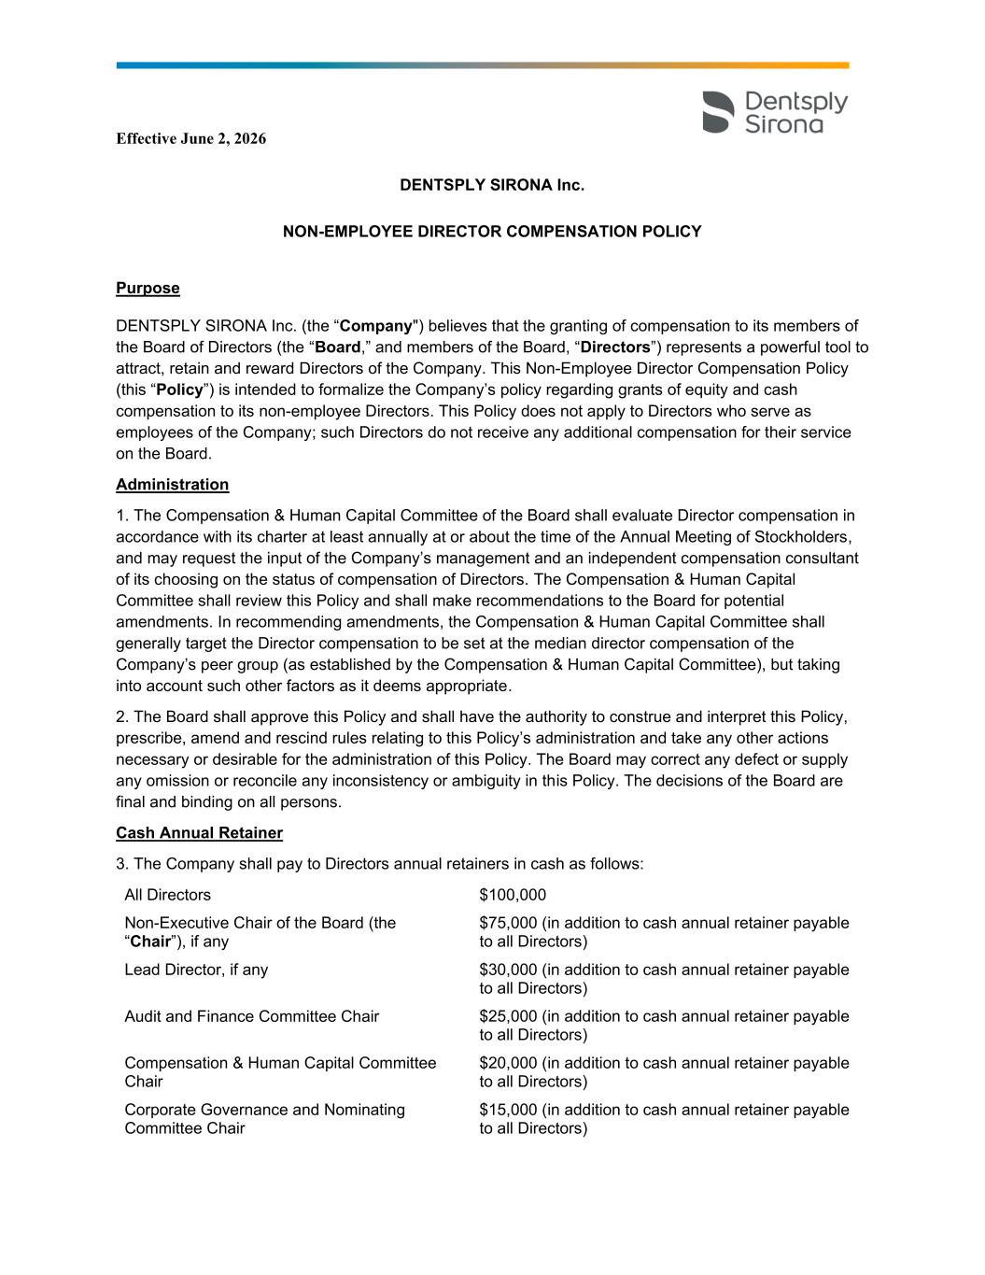

47
Effective June 2, 2026 DENTSPLY SIRONA Inc. NON-EMPLOYEE DIRECTOR COMPENSATION POLICY Purpose DENTSPLY SIRONA Inc. (the “Company") believes that the granting of compensation to its members of the Board of Directors (the “Board,” and members of the Board, “Directors”) represents a powerful tool to attract, retain and reward Directors of the Company. This Non-Employee Director Compensation Policy (this “Policy”) is intended to formalize the Company’s policy regarding grants of equity and cash compensation to its non-employee Directors. This Policy does not apply to Directors who serve as employees of the Company; such Directors do not receive any additional compensation for their service on the Board. Administration 1. The Compensation & Human Capital Committee of the Board shall evaluate Director compensation in accordance with its charter at least annually at or about the time of the Annual Meeting of Stockholders, and may request the input of the Company’s management and an independent compensation consultant of its choosing on the status of compensation of Directors. The Compensation & Human Capital Committee shall review this Policy and shall make recommendations to the Board for potential amendments. In recommending amendments, the Compensation & Human Capital Committee shall generally target the Director compensation to be set at the median director compensation of the Company’s peer group (as established by the Compensation & Human Capital Committee), but taking into account such other factors as it deems appropriate. 2. The Board shall approve this Policy and shall have the authority to construe and interpret this Policy, prescribe, amend and rescind rules relating to this Policy’s administration and take any other actions necessary or desirable for the administration of this Policy. The Board may correct any defect or supply any omission or reconcile any inconsistency or ambiguity in this Policy. The decisions of the Board are final and binding on all persons. Cash Annual Retainer 3. The Company shall pay to Directors annual retainers in cash as follows: All Directors $100,000 Non-Executive Chair of the Board (the “Chair”), if any $75,000 (in addition to cash annual retainer payable to all Directors) Lead Director, if any $30,000 (in addition to cash annual retainer payable to all Directors) Audit and Finance Committee Chair $25,000 (in addition to cash annual retainer payable to all Directors) Compensation & Human Capital Committee Chair $20,000 (in addition to cash annual retainer payable to all Directors) Corporate Governance and Nominating Committee Chair $15,000 (in addition to cash annual retainer payable to all Directors)

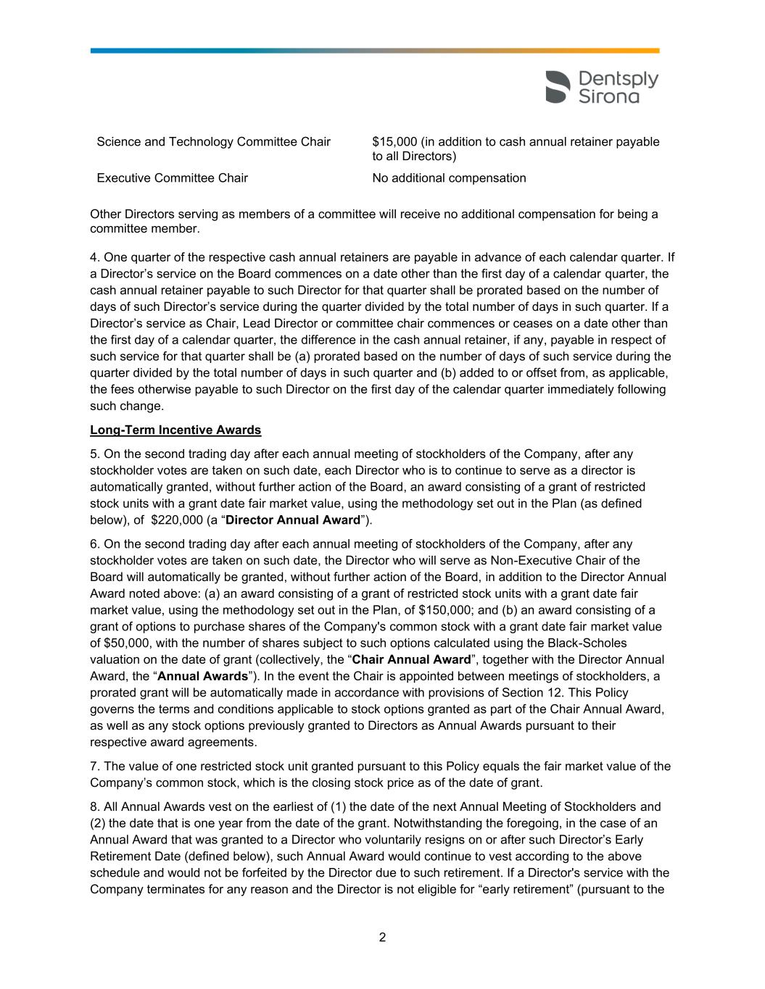
2 Science and Technology Committee Chair $15,000 (in addition to cash annual retainer payable to all Directors) Executive Committee Chair No additional compensation Other Directors serving as members of a committee will receive no additional compensation for being a committee member. 4. One quarter of the respective cash annual retainers are payable in advance of each calendar quarter. If a Director’s service on the Board commences on a date other than the first day of a calendar quarter, the cash annual retainer payable to such Director for that quarter shall be prorated based on the number of days of such Director’s service during the quarter divided by the total number of days in such quarter. If a Director’s service as Chair, Lead Director or committee chair commences or ceases on a date other than the first day of a calendar quarter, the difference in the cash annual retainer, if any, payable in respect of such service for that quarter shall be (a) prorated based on the number of days of such service during the quarter divided by the total number of days in such quarter and (b) added to or offset from, as applicable, the fees otherwise payable to such Director on the first day of the calendar quarter immediately following such change. Long-Term Incentive Awards 5. On the second trading day after each annual meeting of stockholders of the Company, after any stockholder votes are taken on such date, each Director who is to continue to serve as a director is automatically granted, without further action of the Board, an award consisting of a grant of restricted stock units with a grant date fair market value, using the methodology set out in the Plan (as defined below), of $220,000 (a “Director Annual Award”). 6. On the second trading day after each annual meeting of stockholders of the Company, after any stockholder votes are taken on such date, the Director who will serve as Non-Executive Chair of the Board will automatically be granted, without further action of the Board, in addition to the Director Annual Award noted above: (a) an award consisting of a grant of restricted stock units with a grant date fair market value, using the methodology set out in the Plan, of $150,000; and (b) an award consisting of a grant of options to purchase shares of the Company's common stock with a grant date fair market value of $50,000, with the number of shares subject to such options calculated using the Black-Scholes valuation on the date of grant (collectively, the “Chair Annual Award”, together with the Director Annual Award, the “Annual Awards”). In the event the Chair is appointed between meetings of stockholders, a prorated grant will be automatically made in accordance with provisions of Section 12. This Policy governs the terms and conditions applicable to stock options granted as part of the Chair Annual Award, as well as any stock options previously granted to Directors as Annual Awards pursuant to their respective award agreements. 7. The value of one restricted stock unit granted pursuant to this Policy equals the fair market value of the Company’s common stock, which is the closing stock price as of the date of grant. 8. All Annual Awards vest on the earliest of (1) the date of the next Annual Meeting of Stockholders and (2) the date that is one year from the date of the grant. Notwithstanding the foregoing, in the case of an Annual Award that was granted to a Director who voluntarily resigns on or after such Director’s Early Retirement Date (defined below), such Annual Award would continue to vest according to the above schedule and would not be forfeited by the Director due to such retirement. If a Director's service with the Company terminates for any reason and the Director is not eligible for “early retirement” (pursuant to the

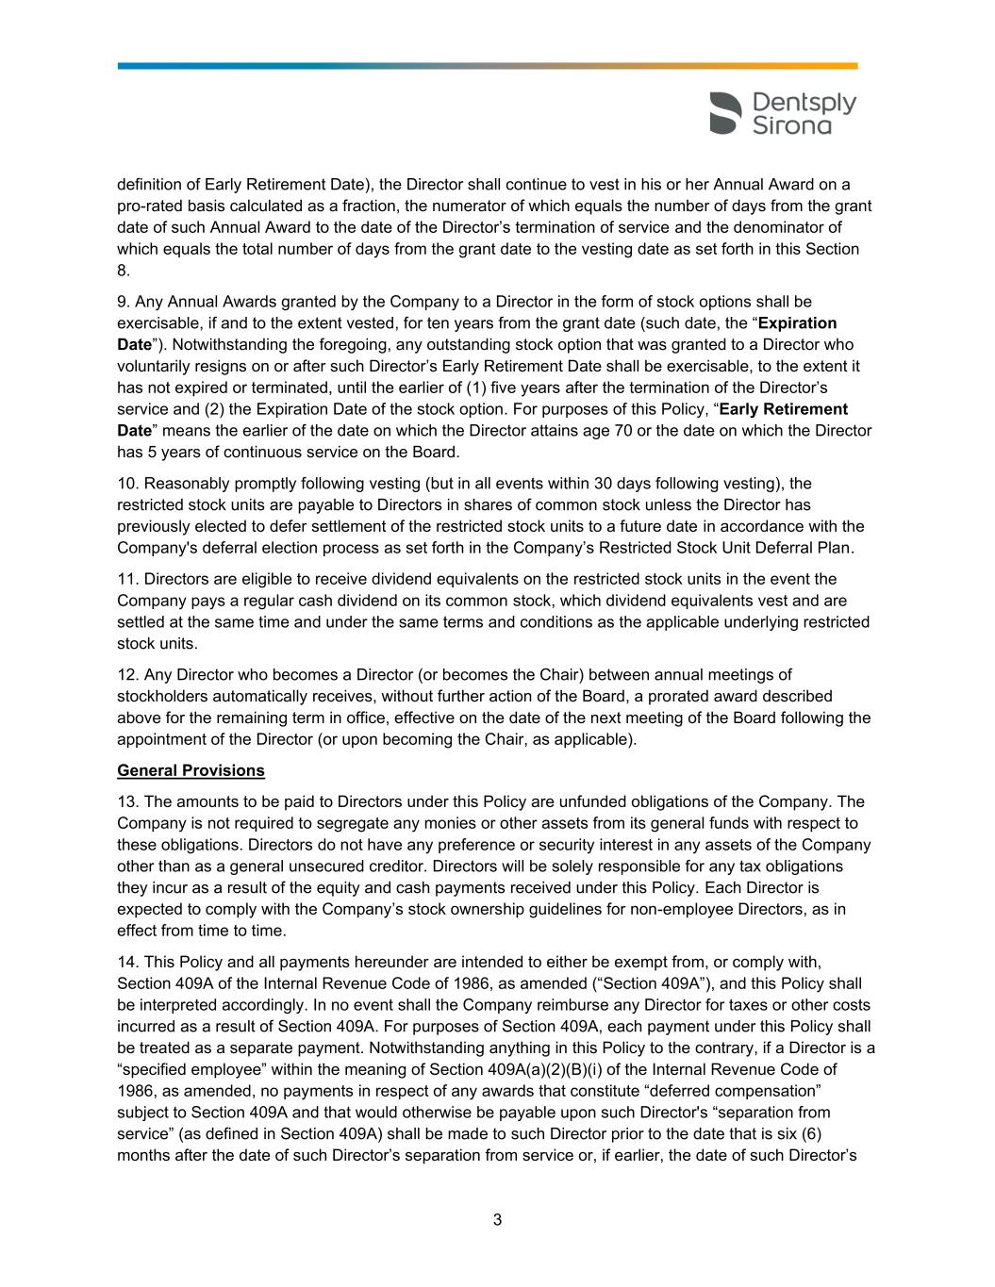
3 definition of Early Retirement Date), the Director shall continue to vest in his or her Annual Award on a pro-rated basis calculated as a fraction, the numerator of which equals the number of days from the grant date of such Annual Award to the date of the Director’s termination of service and the denominator of which equals the total number of days from the grant date to the vesting date as set forth in this Section 8. 9. Any Annual Awards granted by the Company to a Director in the form of stock options shall be exercisable, if and to the extent vested, for ten years from the grant date (such date, the “Expiration Date”). Notwithstanding the foregoing, any outstanding stock option that was granted to a Director who voluntarily resigns on or after such Director’s Early Retirement Date shall be exercisable, to the extent it has not expired or terminated, until the earlier of (1) five years after the termination of the Director’s service and (2) the Expiration Date of the stock option. For purposes of this Policy, “Early Retirement Date” means the earlier of the date on which the Director attains age 70 or the date on which the Director has 5 years of continuous service on the Board. 10. Reasonably promptly following vesting (but in all events within 30 days following vesting), the restricted stock units are payable to Directors in shares of common stock unless the Director has previously elected to defer settlement of the restricted stock units to a future date in accordance with the Company's deferral election process as set forth in the Company’s Restricted Stock Unit Deferral Plan. 11. Directors are eligible to receive dividend equivalents on the restricted stock units in the event the Company pays a regular cash dividend on its common stock, which dividend equivalents vest and are settled at the same time and under the same terms and conditions as the applicable underlying restricted stock units. 12. Any Director who becomes a Director (or becomes the Chair) between annual meetings of stockholders automatically receives, without further action of the Board, a prorated award described above for the remaining term in office, effective on the date of the next meeting of the Board following the appointment of the Director (or upon becoming the Chair, as applicable). General Provisions 13. The amounts to be paid to Directors under this Policy are unfunded obligations of the Company. The Company is not required to segregate any monies or other assets from its general funds with respect to these obligations. Directors do not have any preference or security interest in any assets of the Company other than as a general unsecured creditor. Directors will be solely responsible for any tax obligations they incur as a result of the equity and cash payments received under this Policy. Each Director is expected to comply with the Company’s stock ownership guidelines for non-employee Directors, as in effect from time to time. 14. This Policy and all payments hereunder are intended to either be exempt from, or comply with, Section 409A of the Internal Revenue Code of 1986, as amended (“Section 409A”), and this Policy shall be interpreted accordingly. In no event shall the Company reimburse any Director for taxes or other costs incurred as a result of Section 409A. For purposes of Section 409A, each payment under this Policy shall be treated as a separate payment. Notwithstanding anything in this Policy to the contrary, if a Director is a “specified employee” within the meaning of Section 409A(a)(2)(B)(i) of the Internal Revenue Code of 1986, as amended, no payments in respect of any awards that constitute “deferred compensation” subject to Section 409A and that would otherwise be payable upon such Director's “separation from service” (as defined in Section 409A) shall be made to such Director prior to the date that is six (6) months after the date of such Director’s separation from service or, if earlier, the date of such Director’s

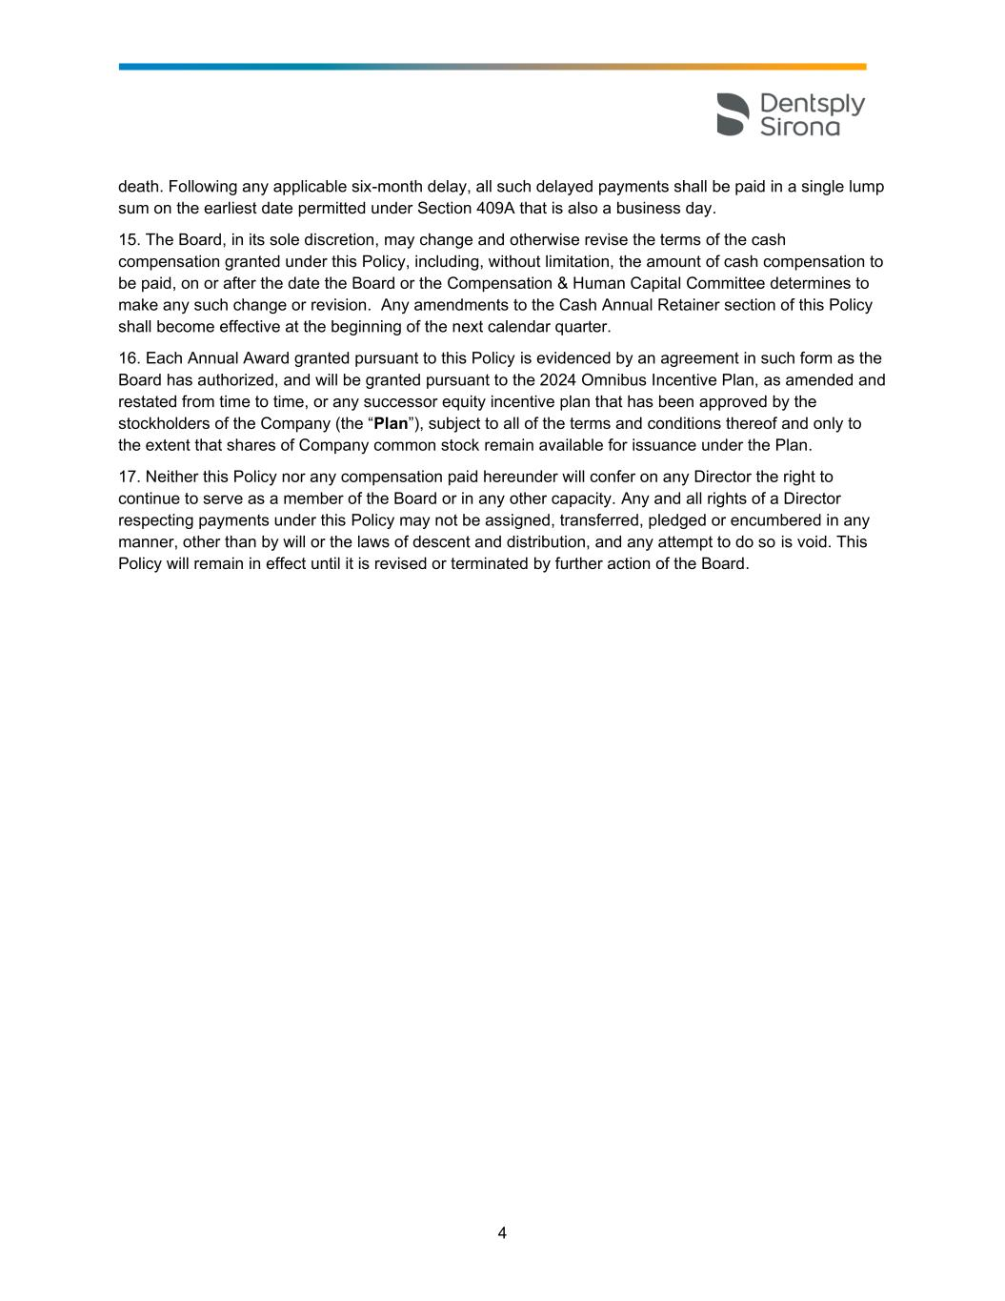
4 death. Following any applicable six-month delay, all such delayed payments shall be paid in a single lump sum on the earliest date permitted under Section 409A that is also a business day. 15. The Board, in its sole discretion, may change and otherwise revise the terms of the cash compensation granted under this Policy, including, without limitation, the amount of cash compensation to be paid, on or after the date the Board or the Compensation & Human Capital Committee determines to make any such change or revision. Any amendments to the Cash Annual Retainer section of this Policy shall become effective at the beginning of the next calendar quarter. 16. Each Annual Award granted pursuant to this Policy is evidenced by an agreement in such form as the Board has authorized, and will be granted pursuant to the 2024 Omnibus Incentive Plan, as amended and restated from time to time, or any successor equity incentive plan that has been approved by the stockholders of the Company (the “Plan”), subject to all of the terms and conditions thereof and only to the extent that shares of Company common stock remain available for issuance under the Plan. 17. Neither this Policy nor any compensation paid hereunder will confer on any Director the right to continue to serve as a member of the Board or in any other capacity. Any and all rights of a Director respecting payments under this Policy may not be assigned, transferred, pledged or encumbered in any manner, other than by will or the laws of descent and distribution, and any attempt to do so is void. This Policy will remain in effect until it is revised or terminated by further action of the Board.

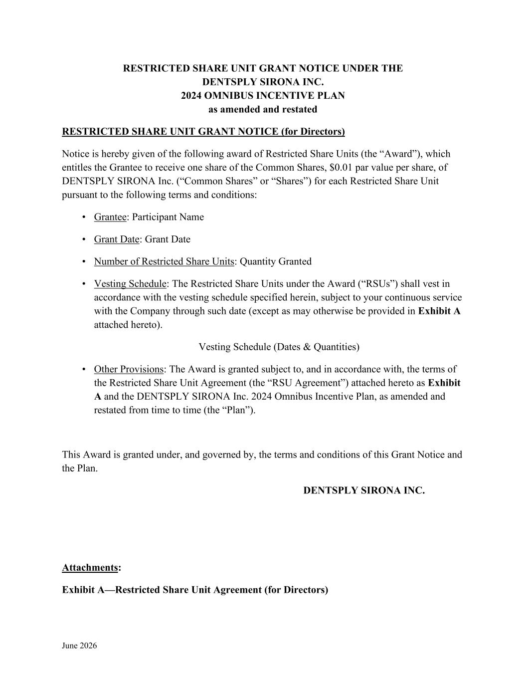
June 2026 RESTRICTED SHARE UNIT GRANT NOTICE UNDER THE DENTSPLY SIRONA INC. 2024 OMNIBUS INCENTIVE PLAN as amended and restated RESTRICTED SHARE UNIT GRANT NOTICE (for Directors) Notice is hereby given of the following award of Restricted Share Units (the “Award”), which entitles the Grantee to receive one share of the Common Shares, $0.01 par value per share, of DENTSPLY SIRONA Inc. (“Common Shares” or “Shares”) for each Restricted Share Unit pursuant to the following terms and conditions: • Grantee: Participant Name • Grant Date: Grant Date • Number of Restricted Share Units: Quantity Granted • Vesting Schedule: The Restricted Share Units under the Award (“RSUs”) shall vest in accordance with the vesting schedule specified herein, subject to your continuous service with the Company through such date (except as may otherwise be provided in Exhibit A attached hereto). Vesting Schedule (Dates & Quantities) • Other Provisions: The Award is granted subject to, and in accordance with, the terms of the Restricted Share Unit Agreement (the “RSU Agreement”) attached hereto as Exhibit A and the DENTSPLY SIRONA Inc. 2024 Omnibus Incentive Plan, as amended and restated from time to time (the “Plan”). This Award is granted under, and governed by, the terms and conditions of this Grant Notice and the Plan. DENTSPLY SIRONA INC. Attachments: Exhibit A—Restricted Share Unit Agreement (for Directors)

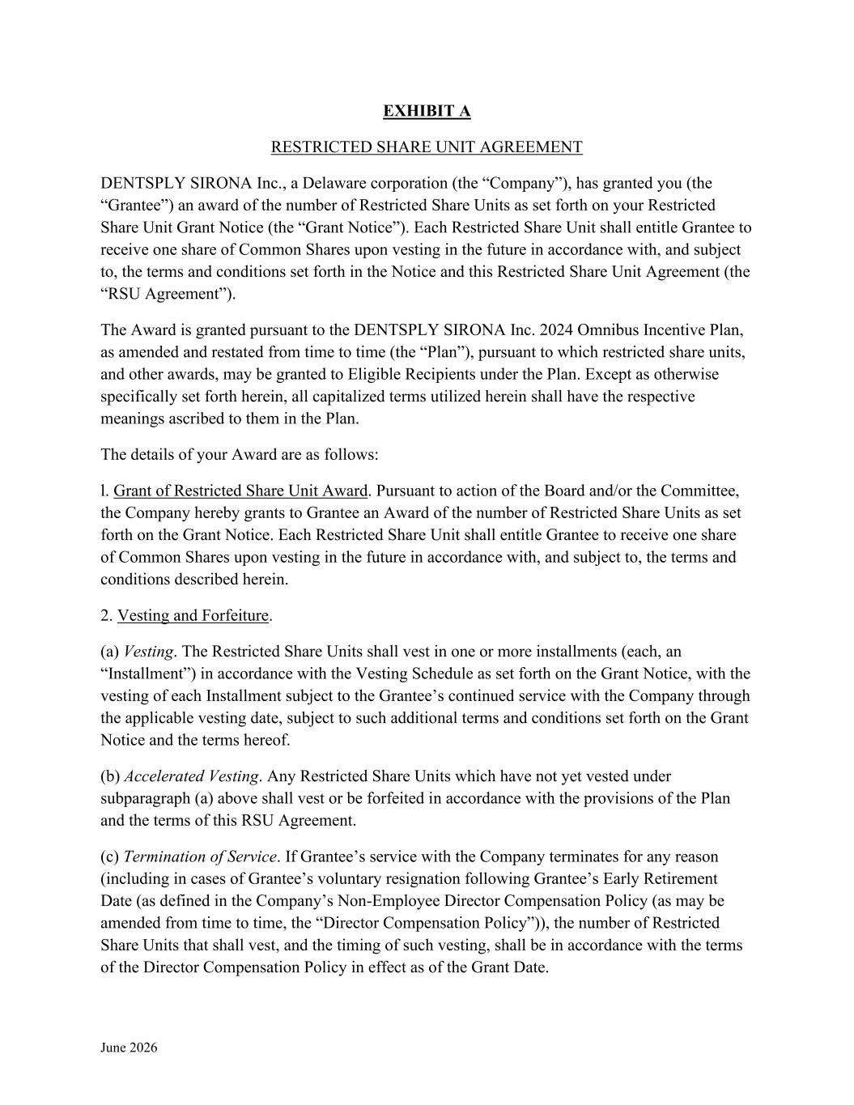
June 2026 EXHIBIT A RESTRICTED SHARE UNIT AGREEMENT DENTSPLY SIRONA Inc., a Delaware corporation (the “Company”), has granted you (the “Grantee”) an award of the number of Restricted Share Units as set forth on your Restricted Share Unit Grant Notice (the “Grant Notice”). Each Restricted Share Unit shall entitle Grantee to receive one share of Common Shares upon vesting in the future in accordance with, and subject to, the terms and conditions set forth in the Notice and this Restricted Share Unit Agreement (the “RSU Agreement”). The Award is granted pursuant to the DENTSPLY SIRONA Inc. 2024 Omnibus Incentive Plan, as amended and restated from time to time (the “Plan”), pursuant to which restricted share units, and other awards, may be granted to Eligible Recipients under the Plan. Except as otherwise specifically set forth herein, all capitalized terms utilized herein shall have the respective meanings ascribed to them in the Plan. The details of your Award are as follows: l. Grant of Restricted Share Unit Award. Pursuant to action of the Board and/or the Committee, the Company hereby grants to Grantee an Award of the number of Restricted Share Units as set forth on the Grant Notice. Each Restricted Share Unit shall entitle Grantee to receive one share of Common Shares upon vesting in the future in accordance with, and subject to, the terms and conditions described herein. 2. Vesting and Forfeiture. (a) Vesting. The Restricted Share Units shall vest in one or more installments (each, an “Installment”) in accordance with the Vesting Schedule as set forth on the Grant Notice, with the vesting of each Installment subject to the Grantee’s continued service with the Company through the applicable vesting date, subject to such additional terms and conditions set forth on the Grant Notice and the terms hereof. (b) Accelerated Vesting. Any Restricted Share Units which have not yet vested under subparagraph (a) above shall vest or be forfeited in accordance with the provisions of the Plan and the terms of this RSU Agreement. (c) Termination of Service. If Grantee’s service with the Company terminates for any reason (including in cases of Grantee’s voluntary resignation following Grantee’s Early Retirement Date (as defined in the Company’s Non-Employee Director Compensation Policy (as may be amended from time to time, the “Director Compensation Policy”)), the number of Restricted Share Units that shall vest, and the timing of such vesting, shall be in accordance with the terms of the Director Compensation Policy in effect as of the Grant Date.

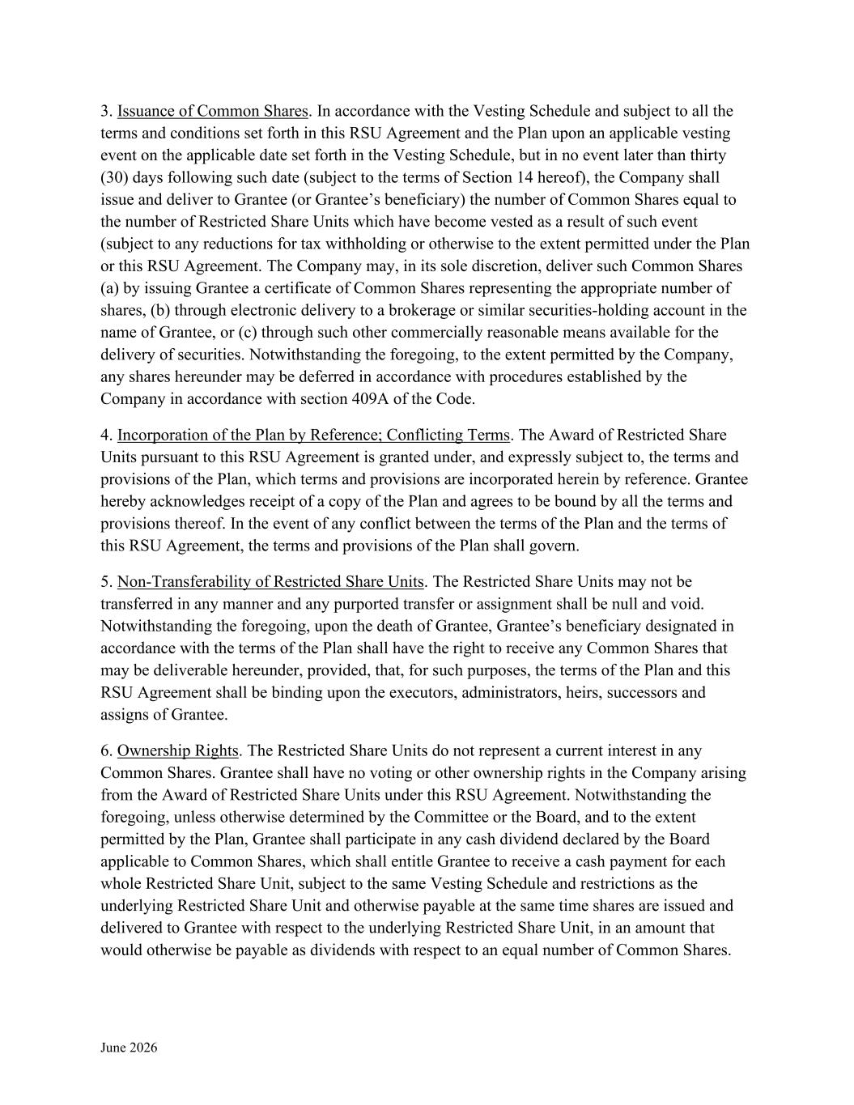
June 2026 3. Issuance of Common Shares. In accordance with the Vesting Schedule and subject to all the terms and conditions set forth in this RSU Agreement and the Plan upon an applicable vesting event on the applicable date set forth in the Vesting Schedule, but in no event later than thirty (30) days following such date (subject to the terms of Section 14 hereof), the Company shall issue and deliver to Grantee (or Grantee’s beneficiary) the number of Common Shares equal to the number of Restricted Share Units which have become vested as a result of such event (subject to any reductions for tax withholding or otherwise to the extent permitted under the Plan or this RSU Agreement. The Company may, in its sole discretion, deliver such Common Shares (a) by issuing Grantee a certificate of Common Shares representing the appropriate number of shares, (b) through electronic delivery to a brokerage or similar securities-holding account in the name of Grantee, or (c) through such other commercially reasonable means available for the delivery of securities. Notwithstanding the foregoing, to the extent permitted by the Company, any shares hereunder may be deferred in accordance with procedures established by the Company in accordance with section 409A of the Code. 4. Incorporation of the Plan by Reference; Conflicting Terms. The Award of Restricted Share Units pursuant to this RSU Agreement is granted under, and expressly subject to, the terms and provisions of the Plan, which terms and provisions are incorporated herein by reference. Grantee hereby acknowledges receipt of a copy of the Plan and agrees to be bound by all the terms and provisions thereof. In the event of any conflict between the terms of the Plan and the terms of this RSU Agreement, the terms and provisions of the Plan shall govern. 5. Non-Transferability of Restricted Share Units. The Restricted Share Units may not be transferred in any manner and any purported transfer or assignment shall be null and void. Notwithstanding the foregoing, upon the death of Grantee, Grantee’s beneficiary designated in accordance with the terms of the Plan shall have the right to receive any Common Shares that may be deliverable hereunder, provided, that, for such purposes, the terms of the Plan and this RSU Agreement shall be binding upon the executors, administrators, heirs, successors and assigns of Grantee. 6. Ownership Rights. The Restricted Share Units do not represent a current interest in any Common Shares. Grantee shall have no voting or other ownership rights in the Company arising from the Award of Restricted Share Units under this RSU Agreement. Notwithstanding the foregoing, unless otherwise determined by the Committee or the Board, and to the extent permitted by the Plan, Grantee shall participate in any cash dividend declared by the Board applicable to Common Shares, which shall entitle Grantee to receive a cash payment for each whole Restricted Share Unit, subject to the same Vesting Schedule and restrictions as the underlying Restricted Share Unit and otherwise payable at the same time shares are issued and delivered to Grantee with respect to the underlying Restricted Share Unit, in an amount that would otherwise be payable as dividends with respect to an equal number of Common Shares.

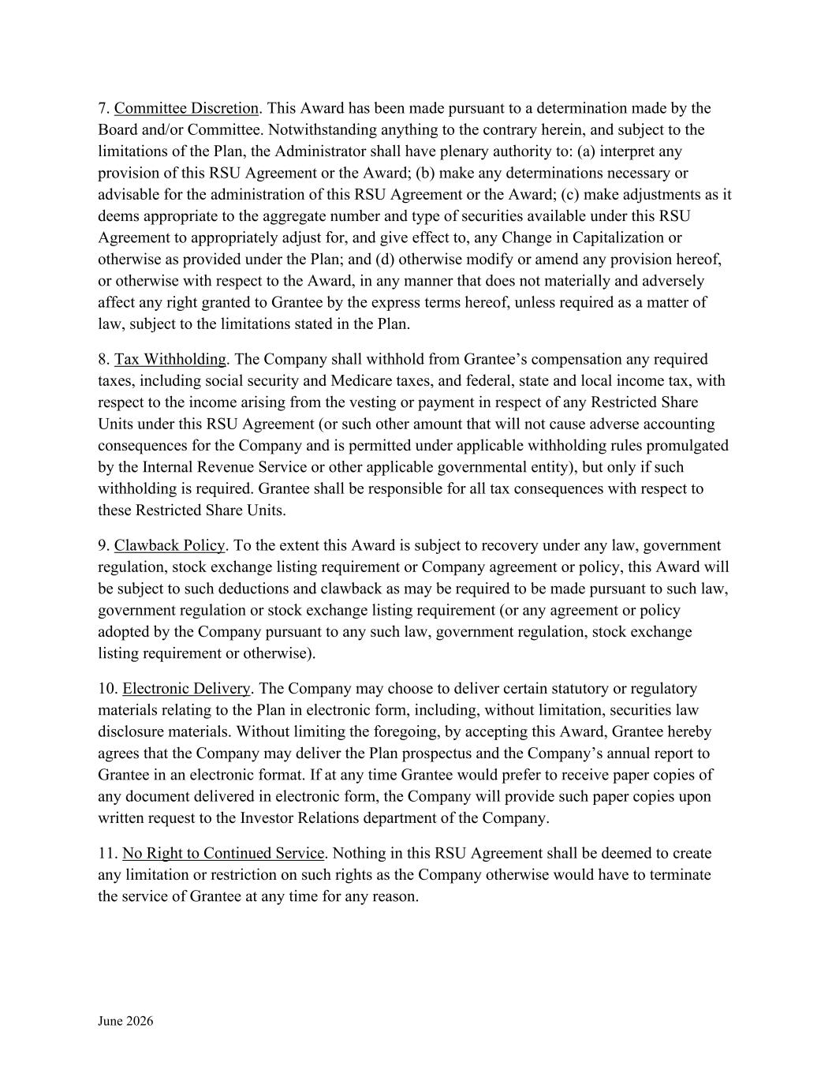
June 2026 7. Committee Discretion. This Award has been made pursuant to a determination made by the Board and/or Committee. Notwithstanding anything to the contrary herein, and subject to the limitations of the Plan, the Administrator shall have plenary authority to: (a) interpret any provision of this RSU Agreement or the Award; (b) make any determinations necessary or advisable for the administration of this RSU Agreement or the Award; (c) make adjustments as it deems appropriate to the aggregate number and type of securities available under this RSU Agreement to appropriately adjust for, and give effect to, any Change in Capitalization or otherwise as provided under the Plan; and (d) otherwise modify or amend any provision hereof, or otherwise with respect to the Award, in any manner that does not materially and adversely affect any right granted to Grantee by the express terms hereof, unless required as a matter of law, subject to the limitations stated in the Plan. 8. Tax Withholding. The Company shall withhold from Grantee’s compensation any required taxes, including social security and Medicare taxes, and federal, state and local income tax, with respect to the income arising from the vesting or payment in respect of any Restricted Share Units under this RSU Agreement (or such other amount that will not cause adverse accounting consequences for the Company and is permitted under applicable withholding rules promulgated by the Internal Revenue Service or other applicable governmental entity), but only if such withholding is required. Grantee shall be responsible for all tax consequences with respect to these Restricted Share Units. 9. Clawback Policy. To the extent this Award is subject to recovery under any law, government regulation, stock exchange listing requirement or Company agreement or policy, this Award will be subject to such deductions and clawback as may be required to be made pursuant to such law, government regulation or stock exchange listing requirement (or any agreement or policy adopted by the Company pursuant to any such law, government regulation, stock exchange listing requirement or otherwise). 10. Electronic Delivery. The Company may choose to deliver certain statutory or regulatory materials relating to the Plan in electronic form, including, without limitation, securities law disclosure materials. Without limiting the foregoing, by accepting this Award, Grantee hereby agrees that the Company may deliver the Plan prospectus and the Company’s annual report to Grantee in an electronic format. If at any time Grantee would prefer to receive paper copies of any document delivered in electronic form, the Company will provide such paper copies upon written request to the Investor Relations department of the Company. 11. No Right to Continued Service. Nothing in this RSU Agreement shall be deemed to create any limitation or restriction on such rights as the Company otherwise would have to terminate the service of Grantee at any time for any reason.

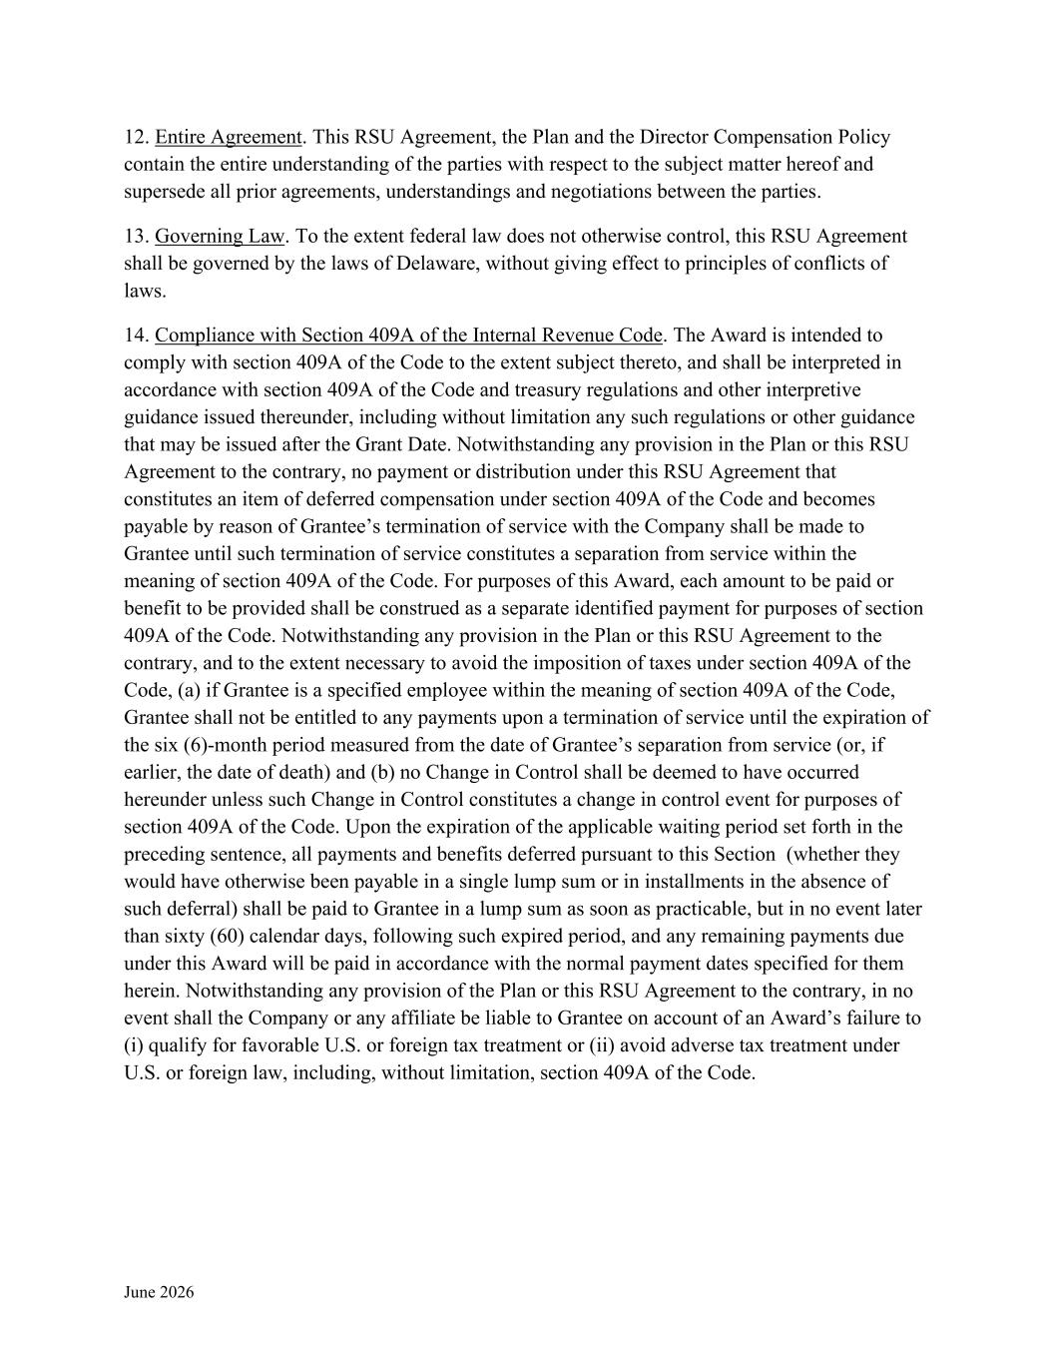
June 2026 12. Entire Agreement. This RSU Agreement, the Plan and the Director Compensation Policy contain the entire understanding of the parties with respect to the subject matter hereof and supersede all prior agreements, understandings and negotiations between the parties. 13. Governing Law. To the extent federal law does not otherwise control, this RSU Agreement shall be governed by the laws of Delaware, without giving effect to principles of conflicts of laws. 14. Compliance with Section 409A of the Internal Revenue Code. The Award is intended to comply with section 409A of the Code to the extent subject thereto, and shall be interpreted in accordance with section 409A of the Code and treasury regulations and other interpretive guidance issued thereunder, including without limitation any such regulations or other guidance that may be issued after the Grant Date. Notwithstanding any provision in the Plan or this RSU Agreement to the contrary, no payment or distribution under this RSU Agreement that constitutes an item of deferred compensation under section 409A of the Code and becomes payable by reason of Grantee’s termination of service with the Company shall be made to Grantee until such termination of service constitutes a separation from service within the meaning of section 409A of the Code. For purposes of this Award, each amount to be paid or benefit to be provided shall be construed as a separate identified payment for purposes of section 409A of the Code. Notwithstanding any provision in the Plan or this RSU Agreement to the contrary, and to the extent necessary to avoid the imposition of taxes under section 409A of the Code, (a) if Grantee is a specified employee within the meaning of section 409A of the Code, Grantee shall not be entitled to any payments upon a termination of service until the expiration of the six (6)-month period measured from the date of Grantee’s separation from service (or, if earlier, the date of death) and (b) no Change in Control shall be deemed to have occurred hereunder unless such Change in Control constitutes a change in control event for purposes of section 409A of the Code. Upon the expiration of the applicable waiting period set forth in the preceding sentence, all payments and benefits deferred pursuant to this Section (whether they would have otherwise been payable in a single lump sum or in installments in the absence of such deferral) shall be paid to Grantee in a lump sum as soon as practicable, but in no event later than sixty (60) calendar days, following such expired period, and any remaining payments due under this Award will be paid in accordance with the normal payment dates specified for them herein. Notwithstanding any provision of the Plan or this RSU Agreement to the contrary, in no event shall the Company or any affiliate be liable to Grantee on account of an Award’s failure to (i) qualify for favorable U.S. or foreign tax treatment or (ii) avoid adverse tax treatment under U.S. or foreign law, including, without limitation, section 409A of the Code.

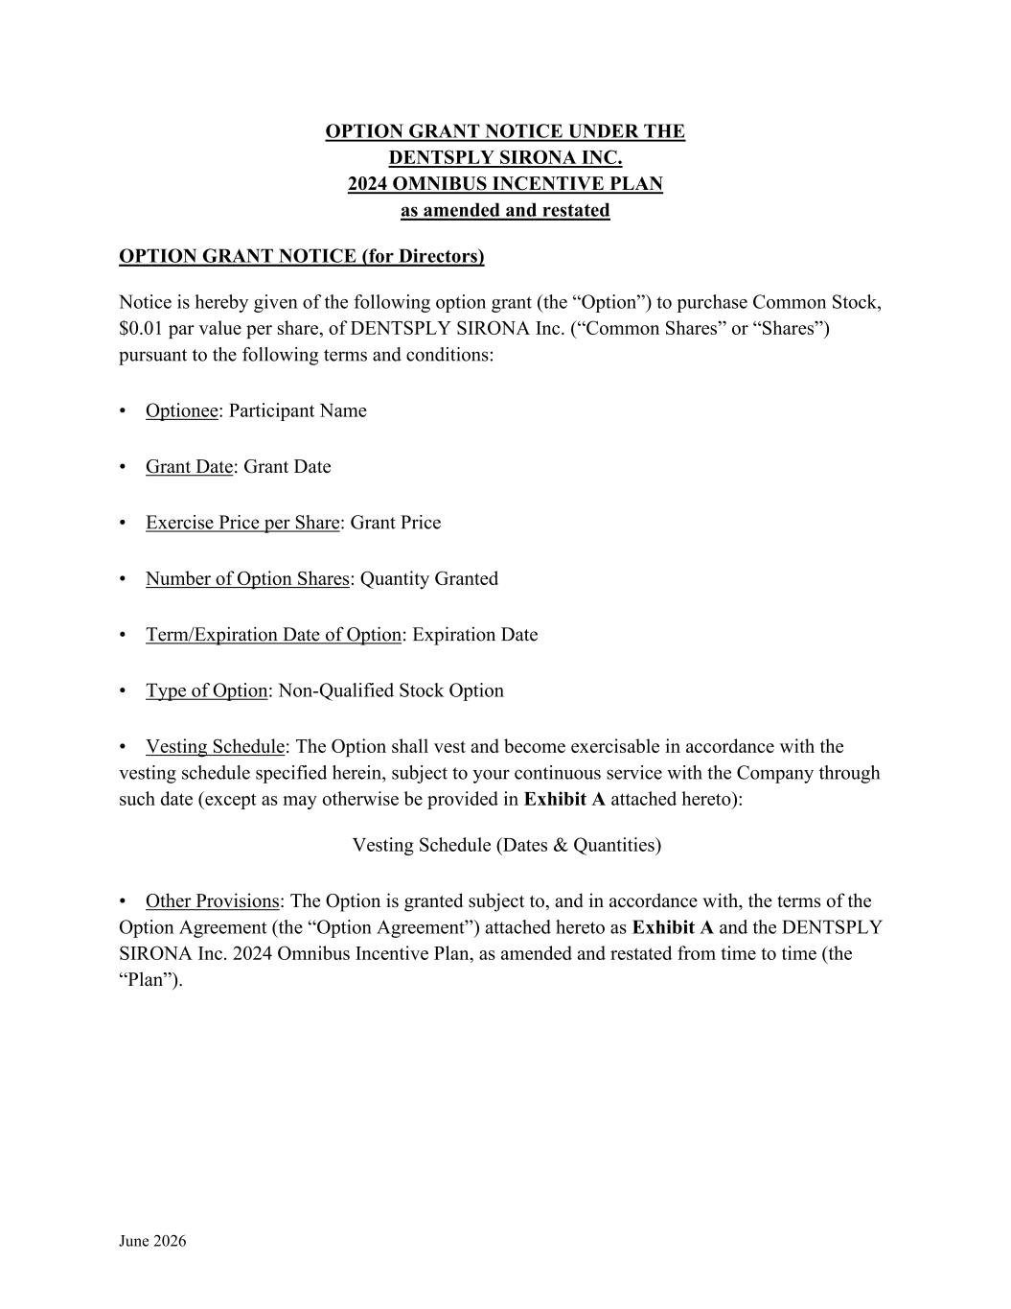
June 2026 OPTION GRANT NOTICE UNDER THE DENTSPLY SIRONA INC. 2024 OMNIBUS INCENTIVE PLAN as amended and restated OPTION GRANT NOTICE (for Directors) Notice is hereby given of the following option grant (the “Option”) to purchase Common Stock, $0.01 par value per share, of DENTSPLY SIRONA Inc. (“Common Shares” or “Shares”) pursuant to the following terms and conditions: • Optionee: Participant Name • Grant Date: Grant Date • Exercise Price per Share: Grant Price • Number of Option Shares: Quantity Granted • Term/Expiration Date of Option: Expiration Date • Type of Option: Non-Qualified Stock Option • Vesting Schedule: The Option shall vest and become exercisable in accordance with the vesting schedule specified herein, subject to your continuous service with the Company through such date (except as may otherwise be provided in Exhibit A attached hereto): Vesting Schedule (Dates & Quantities) • Other Provisions: The Option is granted subject to, and in accordance with, the terms of the Option Agreement (the “Option Agreement”) attached hereto as Exhibit A and the DENTSPLY SIRONA Inc. 2024 Omnibus Incentive Plan, as amended and restated from time to time (the “Plan”).

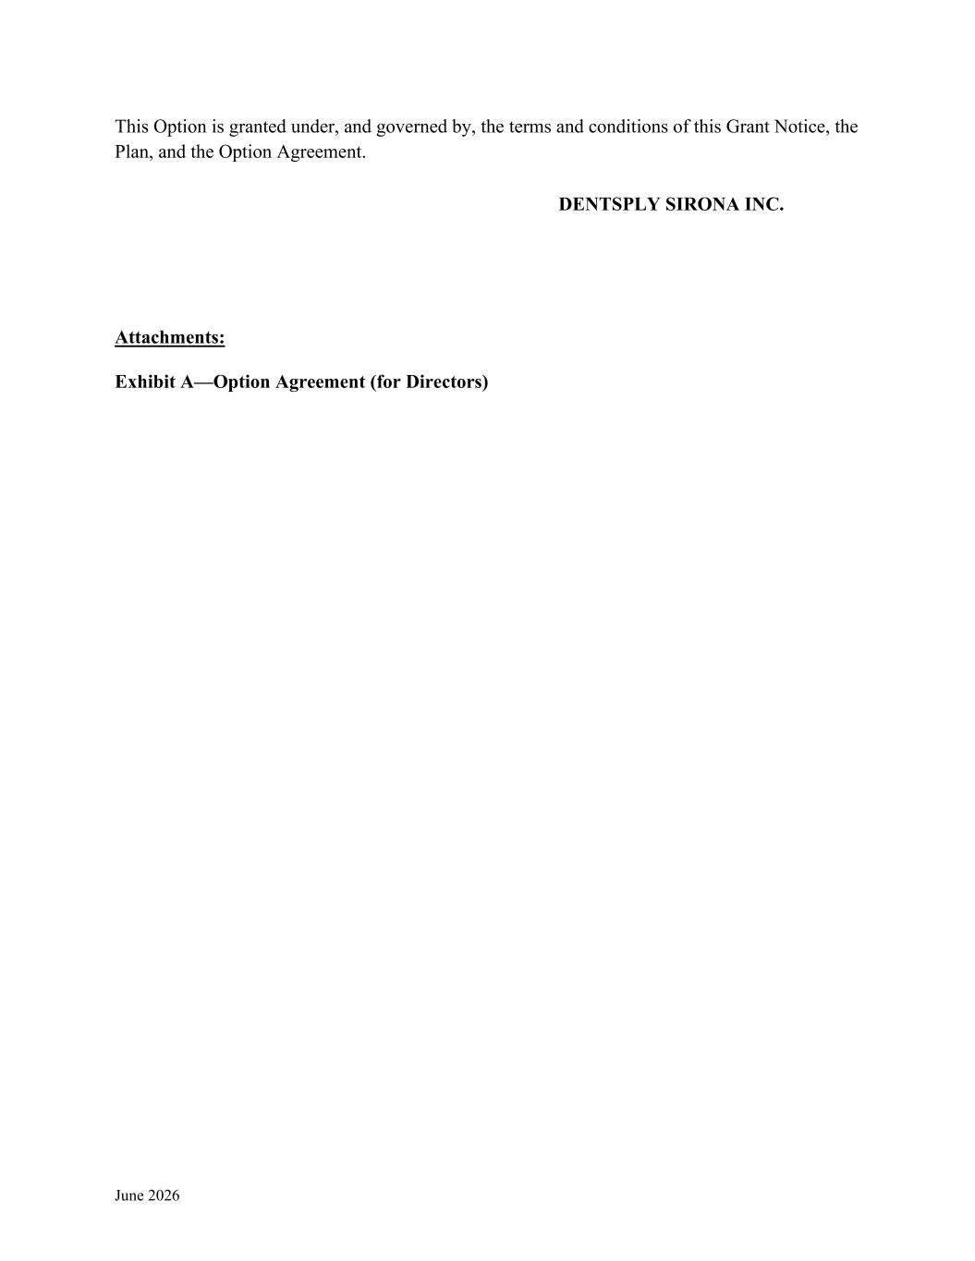
June 2026 This Option is granted under, and governed by, the terms and conditions of this Grant Notice, the Plan, and the Option Agreement. DENTSPLY SIRONA INC. Attachments: Exhibit A—Option Agreement (for Directors)

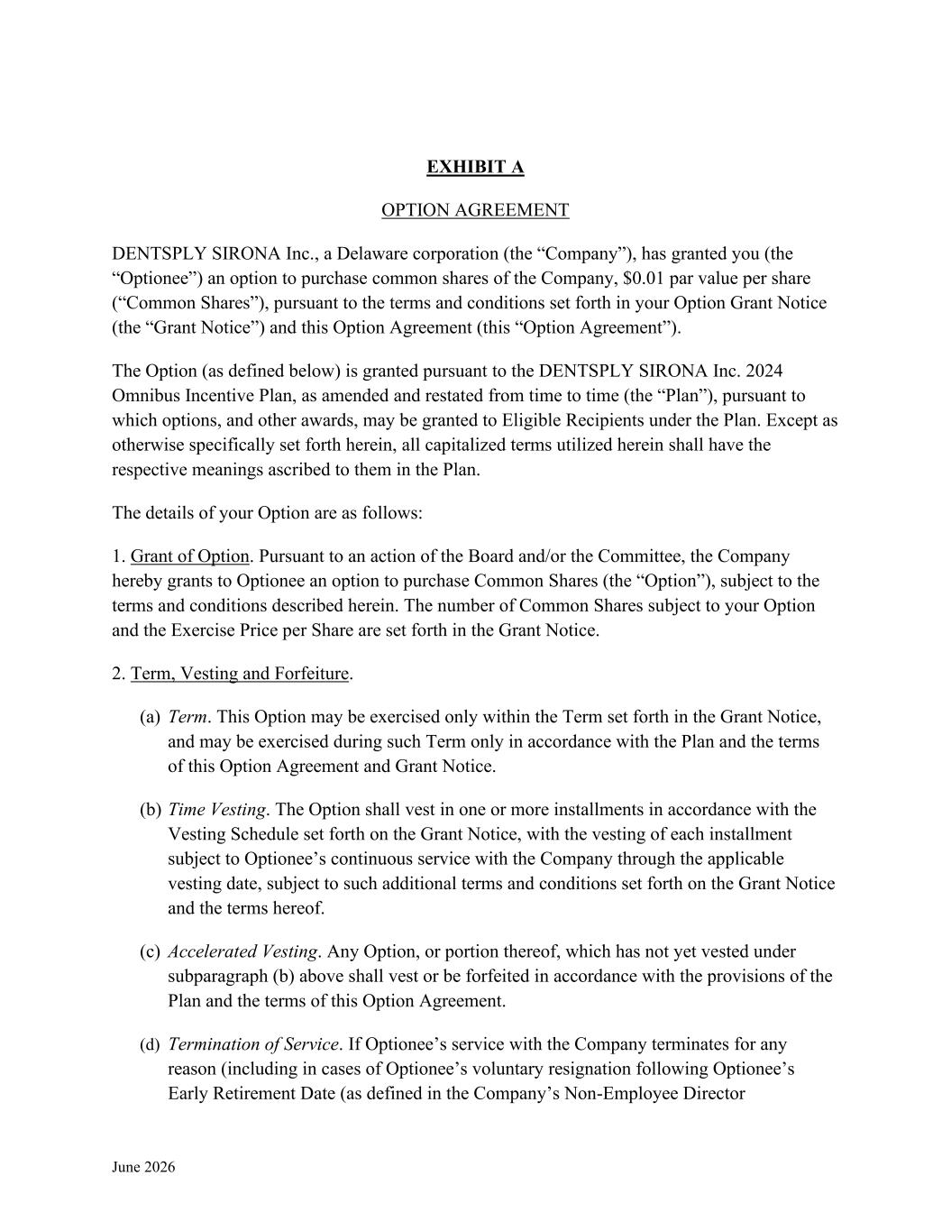
June 2026 EXHIBIT A OPTION AGREEMENT DENTSPLY SIRONA Inc., a Delaware corporation (the “Company”), has granted you (the “Optionee”) an option to purchase common shares of the Company, $0.01 par value per share (“Common Shares”), pursuant to the terms and conditions set forth in your Option Grant Notice (the “Grant Notice”) and this Option Agreement (this “Option Agreement”). The Option (as defined below) is granted pursuant to the DENTSPLY SIRONA Inc. 2024 Omnibus Incentive Plan, as amended and restated from time to time (the “Plan”), pursuant to which options, and other awards, may be granted to Eligible Recipients under the Plan. Except as otherwise specifically set forth herein, all capitalized terms utilized herein shall have the respective meanings ascribed to them in the Plan. The details of your Option are as follows: 1. Grant of Option. Pursuant to an action of the Board and/or the Committee, the Company hereby grants to Optionee an option to purchase Common Shares (the “Option”), subject to the terms and conditions described herein. The number of Common Shares subject to your Option and the Exercise Price per Share are set forth in the Grant Notice. 2. Term, Vesting and Forfeiture. (a) Term. This Option may be exercised only within the Term set forth in the Grant Notice, and may be exercised during such Term only in accordance with the Plan and the terms of this Option Agreement and Grant Notice. (b) Time Vesting. The Option shall vest in one or more installments in accordance with the Vesting Schedule set forth on the Grant Notice, with the vesting of each installment subject to Optionee’s continuous service with the Company through the applicable vesting date, subject to such additional terms and conditions set forth on the Grant Notice and the terms hereof. (c) Accelerated Vesting. Any Option, or portion thereof, which has not yet vested under subparagraph (b) above shall vest or be forfeited in accordance with the provisions of the Plan and the terms of this Option Agreement. (d) Termination of Service. If Optionee’s service with the Company terminates for any reason (including in cases of Optionee’s voluntary resignation following Optionee’s Early Retirement Date (as defined in the Company’s Non-Employee Director

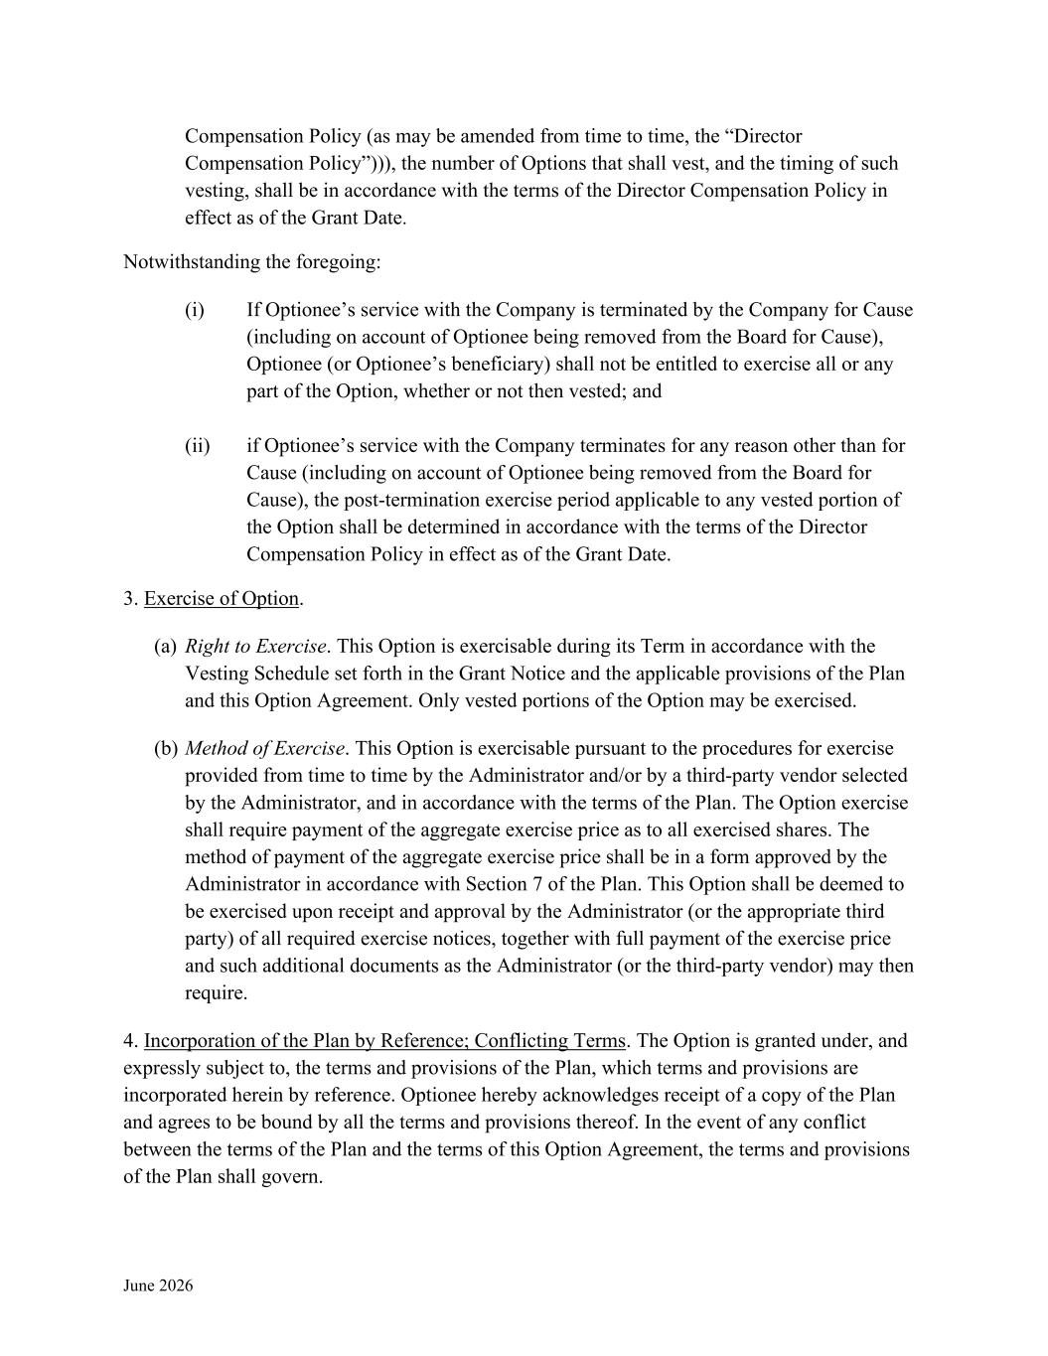
June 2026 Compensation Policy (as may be amended from time to time, the “Director Compensation Policy”))), the number of Options that shall vest, and the timing of such vesting, shall be in accordance with the terms of the Director Compensation Policy in effect as of the Grant Date. Notwithstanding the foregoing: (i) If Optionee’s service with the Company is terminated by the Company for Cause (including on account of Optionee being removed from the Board for Cause), Optionee (or Optionee’s beneficiary) shall not be entitled to exercise all or any part of the Option, whether or not then vested; and (ii) if Optionee’s service with the Company terminates for any reason other than for Cause (including on account of Optionee being removed from the Board for Cause), the post-termination exercise period applicable to any vested portion of the Option shall be determined in accordance with the terms of the Director Compensation Policy in effect as of the Grant Date. 3. Exercise of Option. (a) Right to Exercise. This Option is exercisable during its Term in accordance with the Vesting Schedule set forth in the Grant Notice and the applicable provisions of the Plan and this Option Agreement. Only vested portions of the Option may be exercised. (b) Method of Exercise. This Option is exercisable pursuant to the procedures for exercise provided from time to time by the Administrator and/or by a third-party vendor selected by the Administrator, and in accordance with the terms of the Plan. The Option exercise shall require payment of the aggregate exercise price as to all exercised shares. The method of payment of the aggregate exercise price shall be in a form approved by the Administrator in accordance with Section 7 of the Plan. This Option shall be deemed to be exercised upon receipt and approval by the Administrator (or the appropriate third party) of all required exercise notices, together with full payment of the exercise price and such additional documents as the Administrator (or the third-party vendor) may then require. 4. Incorporation of the Plan by Reference; Conflicting Terms. The Option is granted under, and expressly subject to, the terms and provisions of the Plan, which terms and provisions are incorporated herein by reference. Optionee hereby acknowledges receipt of a copy of the Plan and agrees to be bound by all the terms and provisions thereof. In the event of any conflict between the terms of the Plan and the terms of this Option Agreement, the terms and provisions of the Plan shall govern.

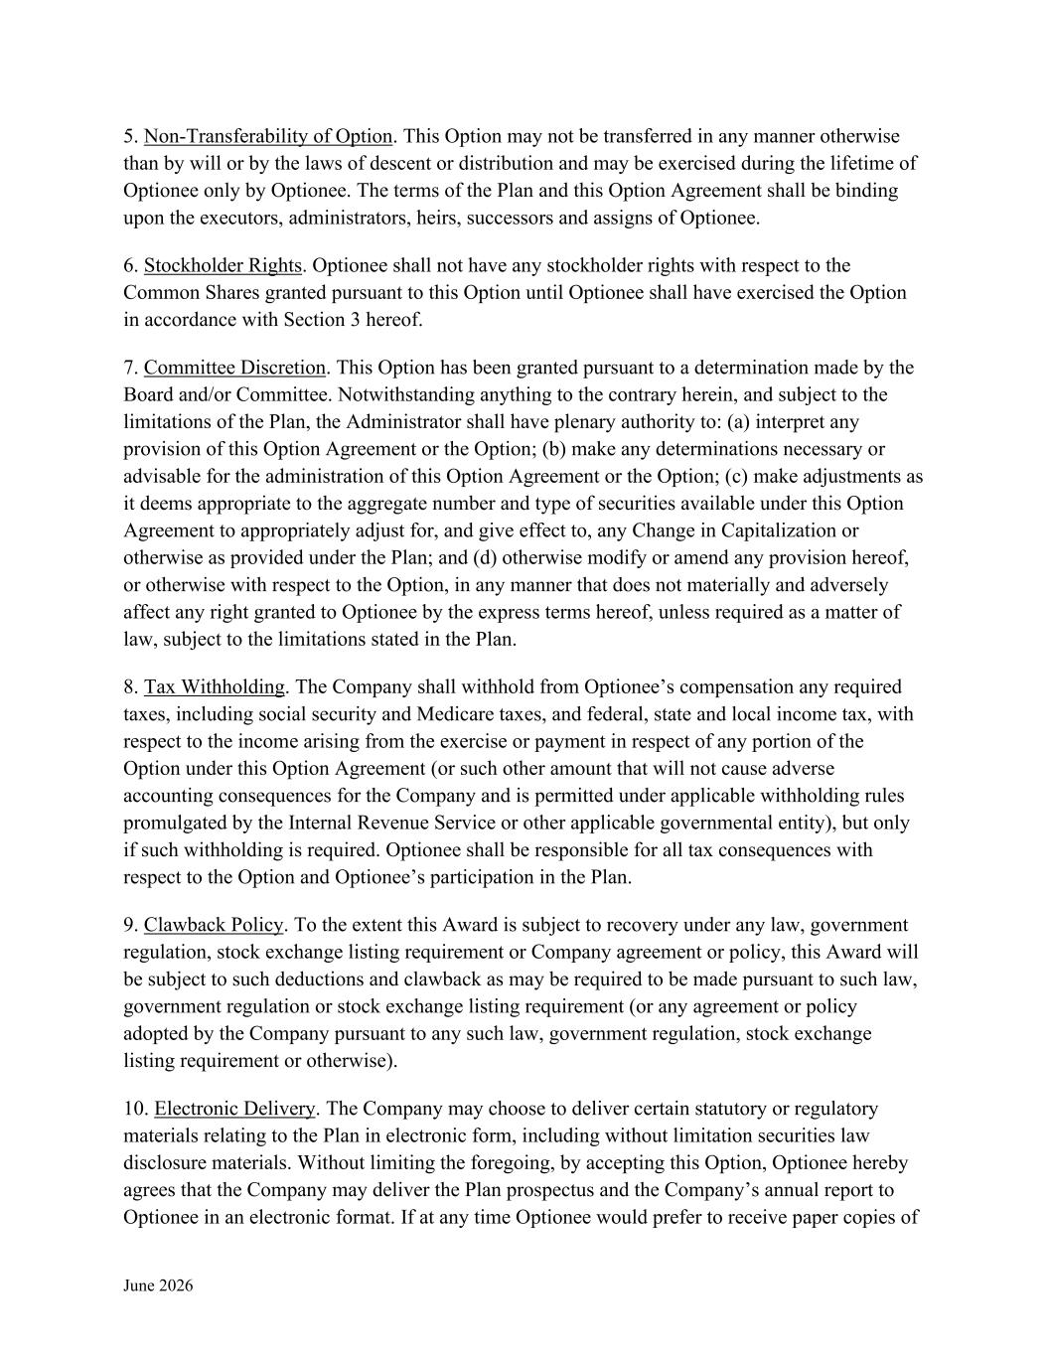
June 2026 5. Non-Transferability of Option. This Option may not be transferred in any manner otherwise than by will or by the laws of descent or distribution and may be exercised during the lifetime of Optionee only by Optionee. The terms of the Plan and this Option Agreement shall be binding upon the executors, administrators, heirs, successors and assigns of Optionee. 6. Stockholder Rights. Optionee shall not have any stockholder rights with respect to the Common Shares granted pursuant to this Option until Optionee shall have exercised the Option in accordance with Section 3 hereof. 7. Committee Discretion. This Option has been granted pursuant to a determination made by the Board and/or Committee. Notwithstanding anything to the contrary herein, and subject to the limitations of the Plan, the Administrator shall have plenary authority to: (a) interpret any provision of this Option Agreement or the Option; (b) make any determinations necessary or advisable for the administration of this Option Agreement or the Option; (c) make adjustments as it deems appropriate to the aggregate number and type of securities available under this Option Agreement to appropriately adjust for, and give effect to, any Change in Capitalization or otherwise as provided under the Plan; and (d) otherwise modify or amend any provision hereof, or otherwise with respect to the Option, in any manner that does not materially and adversely affect any right granted to Optionee by the express terms hereof, unless required as a matter of law, subject to the limitations stated in the Plan. 8. Tax Withholding. The Company shall withhold from Optionee’s compensation any required taxes, including social security and Medicare taxes, and federal, state and local income tax, with respect to the income arising from the exercise or payment in respect of any portion of the Option under this Option Agreement (or such other amount that will not cause adverse accounting consequences for the Company and is permitted under applicable withholding rules promulgated by the Internal Revenue Service or other applicable governmental entity), but only if such withholding is required. Optionee shall be responsible for all tax consequences with respect to the Option and Optionee’s participation in the Plan. 9. Clawback Policy. To the extent this Award is subject to recovery under any law, government regulation, stock exchange listing requirement or Company agreement or policy, this Award will be subject to such deductions and clawback as may be required to be made pursuant to such law, government regulation or stock exchange listing requirement (or any agreement or policy adopted by the Company pursuant to any such law, government regulation, stock exchange listing requirement or otherwise). 10. Electronic Delivery. The Company may choose to deliver certain statutory or regulatory materials relating to the Plan in electronic form, including without limitation securities law disclosure materials. Without limiting the foregoing, by accepting this Option, Optionee hereby agrees that the Company may deliver the Plan prospectus and the Company’s annual report to Optionee in an electronic format. If at any time Optionee would prefer to receive paper copies of

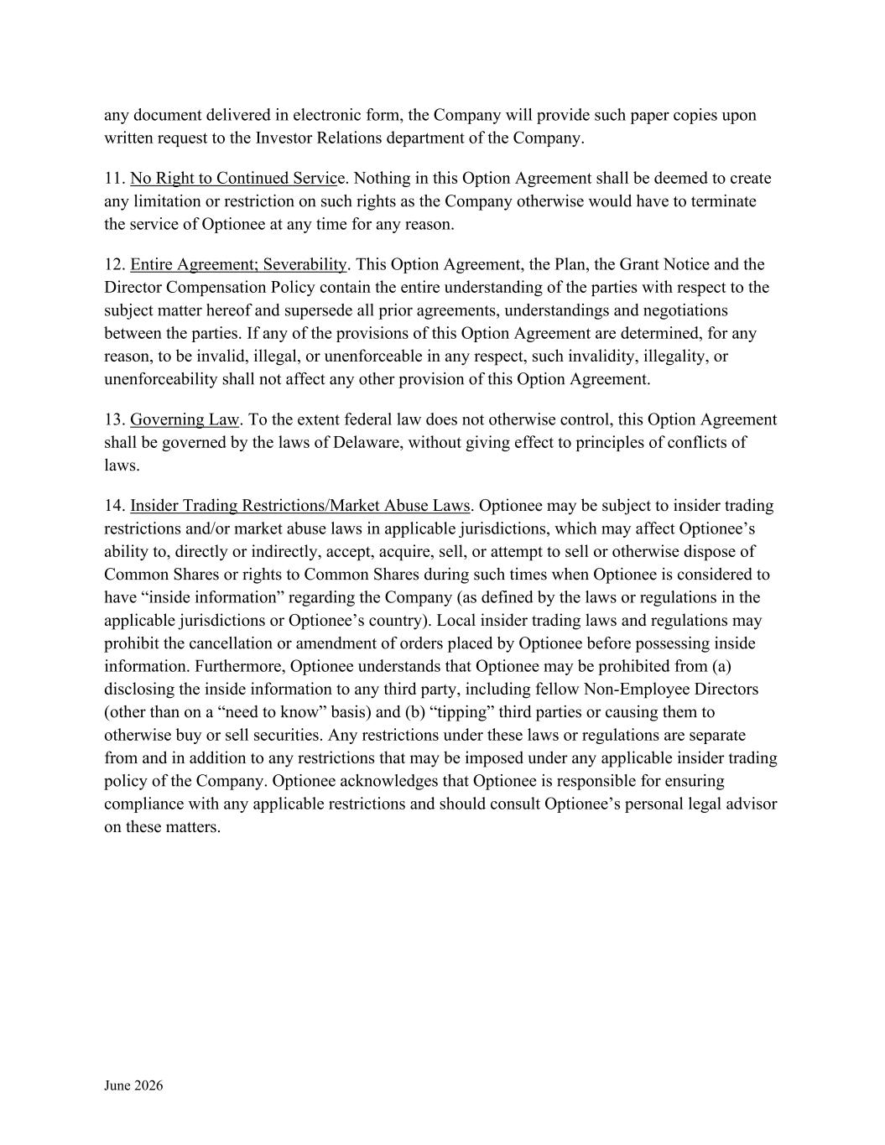
June 2026 any document delivered in electronic form, the Company will provide such paper copies upon written request to the Investor Relations department of the Company. 11. No Right to Continued Service. Nothing in this Option Agreement shall be deemed to create any limitation or restriction on such rights as the Company otherwise would have to terminate the service of Optionee at any time for any reason. 12. Entire Agreement; Severability. This Option Agreement, the Plan, the Grant Notice and the Director Compensation Policy contain the entire understanding of the parties with respect to the subject matter hereof and supersede all prior agreements, understandings and negotiations between the parties. If any of the provisions of this Option Agreement are determined, for any reason, to be invalid, illegal, or unenforceable in any respect, such invalidity, illegality, or unenforceability shall not affect any other provision of this Option Agreement. 13. Governing Law. To the extent federal law does not otherwise control, this Option Agreement shall be governed by the laws of Delaware, without giving effect to principles of conflicts of laws. 14. Insider Trading Restrictions/Market Abuse Laws. Optionee may be subject to insider trading restrictions and/or market abuse laws in applicable jurisdictions, which may affect Optionee’s ability to, directly or indirectly, accept, acquire, sell, or attempt to sell or otherwise dispose of Common Shares or rights to Common Shares during such times when Optionee is considered to have “inside information” regarding the Company (as defined by the laws or regulations in the applicable jurisdictions or Optionee’s country). Local insider trading laws and regulations may prohibit the cancellation or amendment of orders placed by Optionee before possessing inside information. Furthermore, Optionee understands that Optionee may be prohibited from (a) disclosing the inside information to any third party, including fellow Non-Employee Directors (other than on a “need to know” basis) and (b) “tipping” third parties or causing them to otherwise buy or sell securities. Any restrictions under these laws or regulations are separate from and in addition to any restrictions that may be imposed under any applicable insider trading policy of the Company. Optionee acknowledges that Optionee is responsible for ensuring compliance with any applicable restrictions and should consult Optionee’s personal legal advisor on these matters.

Exhibit 31.1

Section 302 Certifications Statement

I, Daniel T. Scavilla, certify that:

1.I have reviewed this Form 10-Q of DENTSPLY SIRONA Inc.;

2.Based on my knowledge, this report does not contain any untrue statement of a material fact or omit to state a material fact necessary to make the statements made, in light of the circumstances under which such statements were made, not misleading with respect to the period covered by this report;

3.Based on my knowledge, the financial statements, and other financial information included in this report, fairly present in all material respects the financial condition, results of operations and cash flows of the registrant as of, and for, the periods presented in this report;

4.The registrant's other certifying officer and I are responsible for establishing and maintaining disclosure controls and procedures (as defined in Exchange Act Rules 13a-15(e) and 15d-15(e)) and internal control over financial reporting (as defined in Exchange Act Rules 13a-15(f) and 15d-15(f)) for the registrant and have:

(a) Designed such disclosure controls and procedures, or caused such disclosure controls and procedures to be designed under our supervision, to ensure that material information relating to the registrant, including its consolidated subsidiaries, is made known to us by others within those entities, particularly during the period in which this report is being prepared;

(b) Designed such internal control over financial reporting, or caused such internal control over financial reporting to be designed under our supervision, to provide reasonable assurance regarding the reliability of financial reporting and the preparation of financial statements for external purposes in accordance with generally accepted accounting principles;

(c) Evaluated the effectiveness of the registrant's disclosure controls and procedures and presented in this report our conclusions about the effectiveness of the disclosure controls and procedures, as of the end of the period covered by this report based on such evaluation; and

(d) Disclosed in this report any change in the registrant's internal control over financial reporting that occurred during the registrant's most recent fiscal quarter (the registrant’s fourth fiscal quarter in the case of an annual report) that has materially affected, or is reasonably likely to materially affect, the registrant's internal control over financial reporting; and

5.The registrant's other certifying officer and I have disclosed, based on our most recent evaluation of internal control over financial reporting, to the registrant's auditors and the audit committee of the registrant's board of directors (or persons performing the equivalent functions):

(a) All significant deficiencies and material weaknesses in the design or operation of internal control over financial reporting which are reasonably likely to adversely affect the registrant's ability to record, process, summarize and report financial information; and

(b) Any fraud, whether or not material, that involves management or other employees who have a significant role in the registrant's internal control over financial reporting.

Date: August 6, 2026

/s/ |  |  | Daniel T. Scavilla
 |  |  | Daniel T. Scavilla
 |  |  | President and
 |  |  | Chief Executive Officer

Exhibit 31.2

Section 302 Certifications Statement

I, John C. Fortson, certify that:

1.I have reviewed this Form 10-Q of DENTSPLY SIRONA Inc.;

2.Based on my knowledge, this report does not contain any untrue statement of a material fact or omit to state a material fact necessary to make the statements made, in light of the circumstances under which such statements were made, not misleading with respect to the period covered by this report;

3.Based on my knowledge, the financial statements, and other financial information included in this report, fairly present in all material respects the financial condition, results of operations and cash flows of the registrant as of, and for, the periods presented in this report;

4.The registrant's other certifying officer and I are responsible for establishing and maintaining disclosure controls and procedures (as defined in Exchange Act Rules 13a-15(e) and 15d-15(e)) and internal control over financial reporting (as defined in Exchange Act Rules 13a-15(f) and 15d-15(f)) for the registrant and have:

(a) Designed such disclosure controls and procedures, or caused such disclosure controls and procedures to be designed under our supervision, to ensure that material information relating to the registrant, including its consolidated subsidiaries, is made known to us by others within those entities, particularly during the period in which this report is being prepared;

(b) Designed such internal control over financial reporting, or caused such internal control over financial reporting to be designed under our supervision, to provide reasonable assurance regarding the reliability of financial reporting and the preparation of financial statements for external purposes in accordance with generally accepted accounting principles;

(c) Evaluated the effectiveness of the registrant's disclosure controls and procedures and presented in this report our conclusions about the effectiveness of the disclosure controls and procedures, as of the end of the period covered by this report based on such evaluation; and

(d) Disclosed in this report any change in the registrant's internal control over financial reporting that occurred during the registrant's most recent fiscal quarter (the registrant’s fourth fiscal quarter in the case of an annual report) that has materially affected, or is reasonably likely to materially affect, the registrant's internal control over financial reporting; and

5.The registrant's other certifying officer and I have disclosed, based on our most recent evaluation of internal control over financial reporting, to the registrant's auditors and the audit committee of the registrant's board of directors (or persons performing the equivalent functions):

(a) All significant deficiencies and material weaknesses in the design or operation of internal control over financial reporting which are reasonably likely to adversely affect the registrant's ability to record, process, summarize and report financial information; and

(b) Any fraud, whether or not material, that involves management or other employees who have a significant role in the registrant's internal control over financial reporting.

Date: August 6, 2026

/s/ |  |  | John C. Fortson
 |  |  | John C. Fortson
 |  |  | Executive Vice President and
 |  |  | Chief Financial Officer

Exhibit 32

CERTIFICATION PURSUANT TO
18 U.S.C. SECTION 1350,
AS ADOPTED PURSUANT TO
SECTION 906 OF THE SARBANES-OXLEY ACT OF 2002

In connection with the Quarterly Report of DENTSPLY SIRONA Inc. (the “Company”) on Form 10-Q for the period ended June 30, 2026 as filed with the Securities and Exchange Commission on the date hereof (the “Report”), we, Daniel T. Scavilla, President and Chief Executive Officer of the Company, and John C. Fortson, Executive Vice President and Chief Financial Officer of the Company, certify, pursuant to 18 U.S.C. 1350, as adopted pursuant to Section 906 of the Sarbanes-Oxley Act of 2002, that, to the best of our knowledge and belief:

1.The Report fully complies with the requirements of Sections 13(a) or 15(d) of the Securities Exchange Act of 1934; and
2.The information contained in the Report fairly presents, in all material respects, the financial condition and result of operations of the Company as of the date of the Report.

/s/ |  |  | Daniel T. Scavilla
 |  |  | Daniel T. Scavilla
 |  |  | President and
 |  |  | Chief Executive Officer
/s/ |  |  | John C. Fortson
 |  |  | John C. Fortson
 |  |  | Executive Vice President and
 |  |  | Chief Financial Officer

August 6, 2026

